**The Australian Olive Industry**

**Michael Southan PhD**

**CEO, Australian Olive Association Ltd**

The Australian Olive Industry produces around 20 million L of predominantly Extra Virgin Olive Oil (EVOO) and 3000 tonnes of table olives (TO) per year. Olive groves are distributed nationally and cover 33,000 ha. The main production states are Victoria, WA and NSW. In addition to the local production, over 40 million L of olive oil (OO; mostly from Spain) and 17,000 tonnes of TO are imported per year (mostly from Greece).

Annual consumption of locally produced EVOO and imported OO per capita is around 2.4L and 0.8 kg, respectively. The Australian product is positioned in the market as an ultra-premium product based on quality and the fact that we are a high-cost producer.

Olive trees are important to agriculture because they are carbon sequestering making the olive industry truly sustainable.

EVOO is a healthy food being the juice of the olive fruit and well documented for underpinning the health benefits of the Mediterranean diet. EVOO quality is paramount and directly related to its health benefits – refining or further processing produces olive oil which is not EVOO quality and lacking nutrition that is beneficial to human health.

Interestingly, the only Australian Standard that exists for food is for Olive Oil (AS 5264 -2011) which defines the chemical composition and quality for all grades of olive oil from EVOO to lampante (industrial grade) olive oil.

The proposed mine site is located in the centre of the Mid-Western local government area (LGA). This LGA contains 44,400 olive trees over 336 ha. Importantly, a significant olive business which has won awards for its EVOO nationally and internationally is only 4-5 km from the mine.

The Australian Olive Industry benchmarks itself through local, state and international competitions and its results in these competitions underpins its reputation for premium flavour, freshness and health attributes.

However, our great reputation is at risk of being destroyed and there are forces willing this to happen – here’s why.

At the end of last year, importers of olive oil initiated a strategic campaign to promote imported olive oil over Australian product. These importers are not supporting Extra Virgin Olive Oil because this is what Australia mostly produces and the rest of the world produces lesser quality making it harder for them to sell a lesser product in the Australian market. Importers will latch onto any reason why Australian EVOO should not be consumed to promote their position, and a lead mine in an olive growing region gives the importers that reason!

With specific reference to the NSW Department of Planning and Environment (DPE) report, under Agricultural Impacts on page 78, the report states:

*“enRiskS also determined that* ***contributions of lead to soil and water would be negligible****, with the incremental increase in lead in agricultural soil at the maximum impacted receptor as a result of the project predicted to be below the detection limit for lead in soil (and deposition decreasing with increasing distance from the mine site). enRiskS also noted that* ***lead is poorly taken up into plants, so impacts on crops are unlikely****”.*

enRiskS’ report indicated the bioaccessibility of lead was 33% - this was from soil samples taken mostly at 0-5 cm with only 1 sample taken from 30-60 cm. How representative is this of the mine? The enRiskS report says on page 71 that this value “..*only relates the ingestion of soil or dust, not the ingestion of lead from any other media such as water or food products”*.

They also showed (in the table below) that there was significantly more lead at site 67 at 5-15 and 30-60 cm depth compared with all other sites samples at 0-5 cm depth, in their testing for lead.



With regard the uptake of lead by plants, enRiskS’ report indicated modelling was via the uptake of “persistent chemical substances” into edible crops following atmospheric deposition and via the roots. These models *calculated the potential accumulation of persistent and bioaccumulative chemical substances in soil (relevant to Project emissions), which may be the result of* ***deposition from a number of air emissions sources.***

**HOWEVER-**

Acid Mine Drainage (AMD) is a significant risk in this project as outlined by the reports. Low pH or acidic water created by AMD solubilizes heavy metals such as Copper, Zinc and Lead.* Solubilised Lead reaching the water table and water water courses presents a significant pathway for Lead to be taken up by plants (olives) from soil water and irrigation water from bores, dams, and creek water. The enRiskS report did not address this significant pathway for Lead to enter local food production.

Lead is absorbed by plants mainly through the roots from soil solution and causes lipid peroxidation (ie in the case of olive trees **destroys the quality of olive oil!**)**

Figure 1.

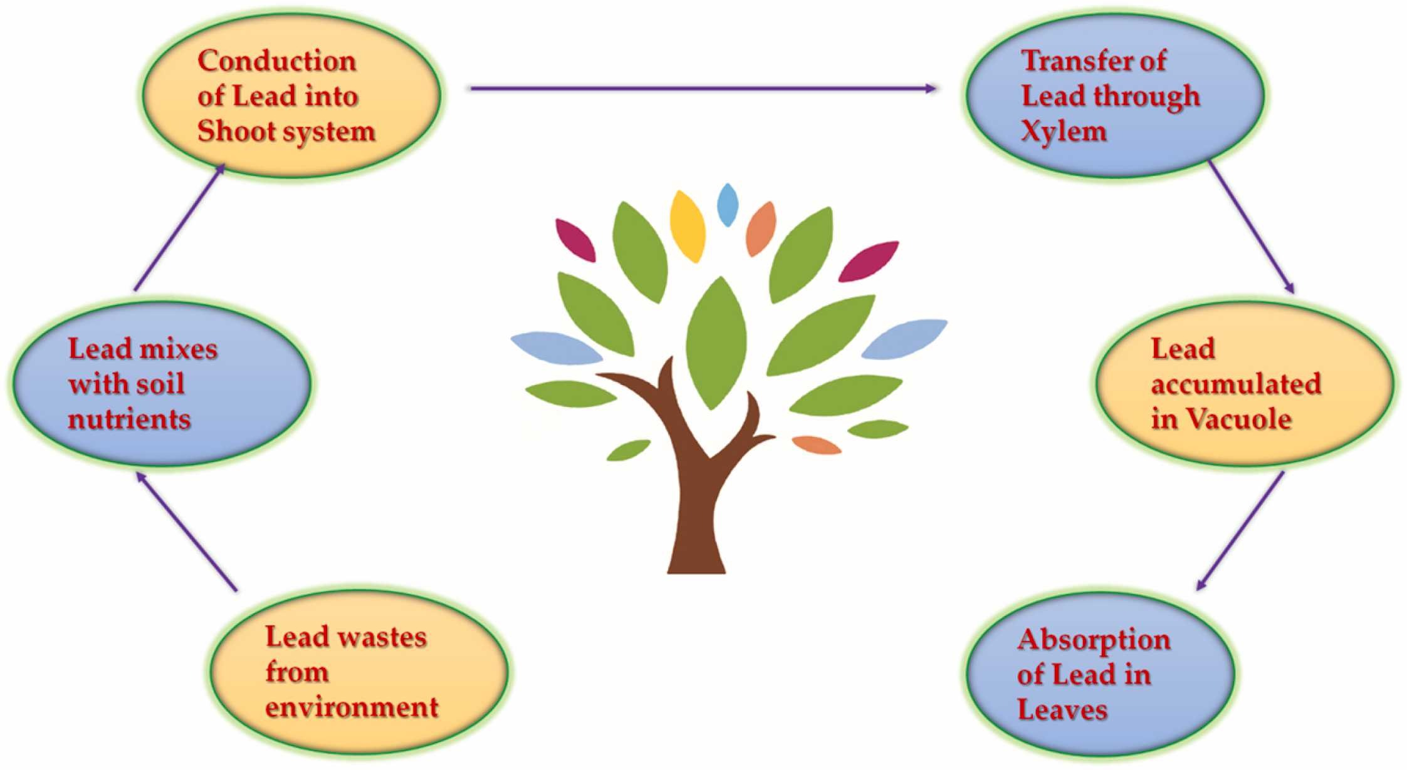

Figure 1 from Samuel Collin, Amritha Baskar, Deepthi Mariam Geevarghese, Mohamed Niyaz Vellala Syed Ali, Praveena Bahubali, Rajan Choudhary, Vladislav Lvov, Gabriel Ibrahin Tovar, Fedor Senatov, Sivasankar Koppala, Sasikumar Swamiappan, Bioaccumulation of lead (Pb) and its effects in plants: A review, Journal of Hazardous Materials Letters, Volume 3, 2022, 100064, ISSN 2666-9110, <https://doi.org/10.1016/j.hazl.2022.100064>. (<https://www.sciencedirect.com/science/article/pii/S266691102200017X>)

**Australian Olive Industry Message**

The **reputation** of the Australian olive industry for producing the highest quality Extra Virgin Olive Oil is at risk, because:-

Lead will be released during the mining operation with the greatest potential for plant and crop uptake via the roots from the soil water (not covered in the assessment report)

This will give the olive oil importers the opportunity to position imported product as superior to the Australian product

How will this project protect the reputation and profitability of the Australian olive and other agricultural industries?

*Reddy, K.J., Wang, L. & Gloss, S.P. Solubility and mobility of copper, zinc and lead in acidic environments. *Plant Soil* **171**, 53–58 (1995). <https://doi.org/10.1007/BF00009564>

**Pourrut B, Shahid M, Dumat C, Winterton P, Pinelli E. Lead uptake, toxicity, and detoxification in plants. Rev Environ Contam Toxicol. 2011;213:113-36. doi: 10.1007/978-1-4419-9860-6_4. PMID: 21541849.