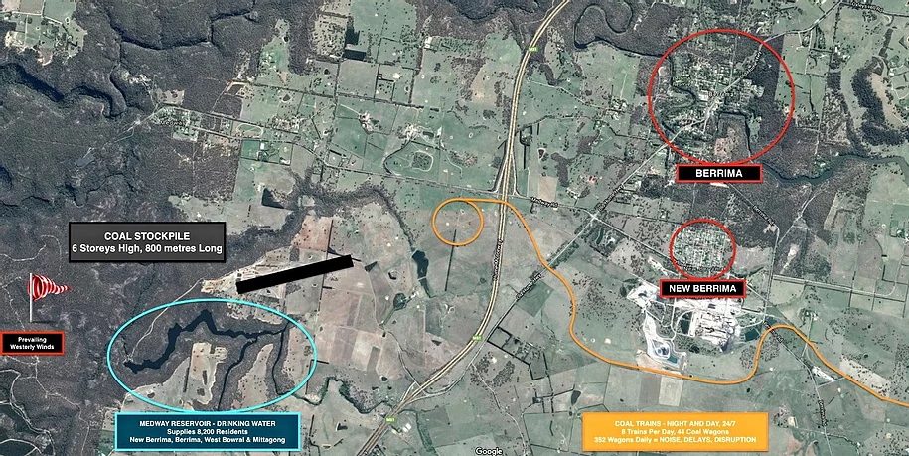
Misleading Map – Displayed on Battle of Berrima Website and Berrima Village
Note Misinformation:
1) Medway reservoir does not supply any drinking water.
2) Prevailing winds are North Easterly.
3) Stock pile is correct in meters however not drawn to and almost twice as long – 1.3km long.
Accompanying misleading text:
- A fall in local groundwater in excess of 100 metres over an area that could be as large as 300 sq. km

Also people have reported that they were shown a photo of an open cut mine before they signed the petition.

