1 May 2021

Mark Constantine
1002/50 Murray Street
SYDNEY NSW 2000
e. markconstantine001@gmail.com

Mr Lindsey Blecher
Senior Planning Officer
Independent Planning Commission NSW
GPO Box 3415
SYDNEY NSW 2001
Dear Sir
Harbourside Shopping Centre Redevelopment (Planning NSW SSDA-7874)

I OBJECT to the harbourside redevelopment.

The current Harbourside proposal has unreasonable adverse impacts on the amenity and heritage of the area due to the bulk and scale of the northern podium envelope.

My primary concerns about the development are

- The podium envelope is not sensitive to the State Heritage listed Pyrmont Bridge
- There is insufficient public benefit
- The view sharing analysis with ‘One Darling Harbour’ is misleading
- The podium height is not appropriate for Darling Harbour

My reasons are

PYRMONT BRIDGE (State Heritage listed)

The redeveloped ‘Harbourside’ building has a gap no more than 3 metres (approx) from Pyrmont Bridge.

A precedent was set by Cockle Bay Wharf Development on the eastern side of Pyrmont Bridge which was approved with a setback of 30m.

The Cockle Bay Wharf Redevelopment, on the east side of Pyrmont Bridge, has a podium envelope with an approved RL of 12 at the harbour’s edge and RL of 19 over the road and provides a large family, pram & disabled friendly single-level ‘park’ behind Pyrmont Bridge linking in with the existing ‘Crescent Garden’. There is a 12-metre walkway separating the water edge from the podium and as mentioned above the podium is set at RL12.

By comparison the northern podium envelope of the Harbourside Proposal is not commensurate in bulk and scale with the neighbouring Cockle Bay Wharf Redevelopment, particularly adjacent to Pyrmont Bridge. This creates inconsistency in the character of the Cockle Bay basin, and a lack of coherence in the developments at the start and end of the State Heritage listed Pyrmont Bridge.

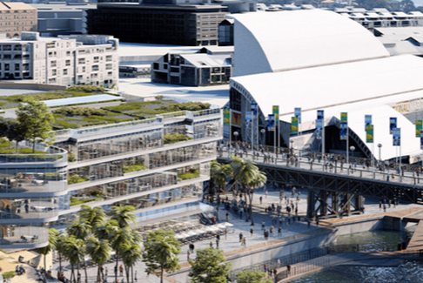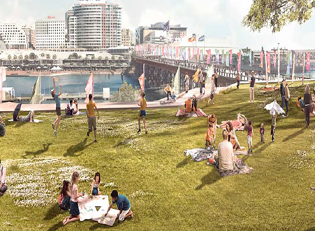
Visual Impact on the east and west side of Pyrmont Bridge

The building envelope proposed for the ‘Harbourside’ podium will totally dominate the bridge. With an average overall height of RL26m spread across 3-tiers, the height and dominance were not previously addressed or assessed.

PODIUM

If the Podium Envelope is to remain separated from Pyrmont Bridge by a mere 3 metres, the podium should be no higher than RL13.75, or the same height as the Bridge, and become a publicly trafficable one-level tier that extends no less than 165 metres to the ‘tower’ base or the northern point of the existing glass-dome.

Looking at the plans for both the ‘podium’ and ‘tower’ I question if the proposed siting of the ‘tower’ represents a true and accurate depiction as to where the ‘tower’ will end up, hence my reference above to the ‘tower’ base being located no less than the ‘northern point of the existing glass-dome’.

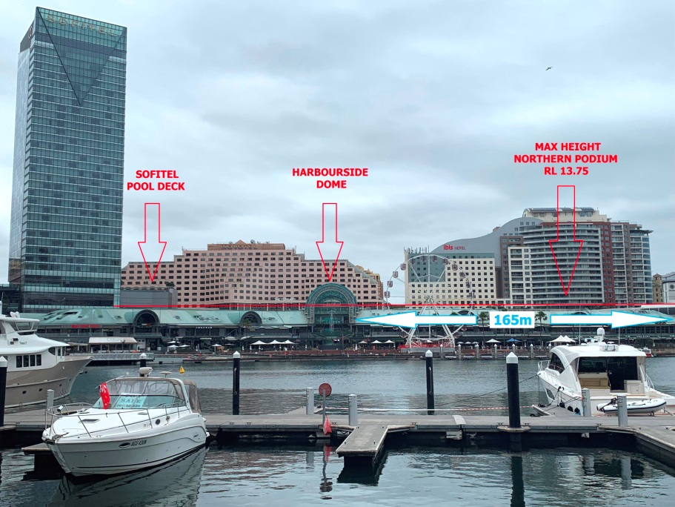
The ‘red’ line shows RL13.75

The bulk and scale of the proposed ‘podium’ reduces the amenity of the public walkway, being twice the height of the bridge platform (RL12.5), and unreasonably obstructs views of the bridge and water from surrounding buildings, especially ‘One Darling Harbour’ and is inconsistent with the Cockle Bay Wharf Redevelopment.

As well, roof features, awnings, parapets, open space plantings, business and building identification signage and structures should be contained wholly within the reduced height of the building envelope as such features can be substantial in size & bulk and may have additional unexpected visual and amenity impacts on the already proposed significant height of the podiums.

PODIUM HEIGHTS

Previously the Department of Planning & Environment concluded that ‘podium’ heights should not challenge the visual dominance adjacent to the foreshore.

To ensure coherence at both ends of ‘Harbourside’ I contend that by reducing both the northern podium to RL13.75 & the southern podium to a single-level RL15.5 the waterfront foreshore will have more natural light, create a visual effect of a wider walkway and reduce the impact of a ‘concrete wall’ around Cockle Bay.

In saying the above, I hope the decision makers within the Independent Planning Commission are already aware of the recent addition on the waters of Cockle Bay by the intrusion (some 18m at its’ widest point) of the over-water walkway in front of ‘Harbourside’.

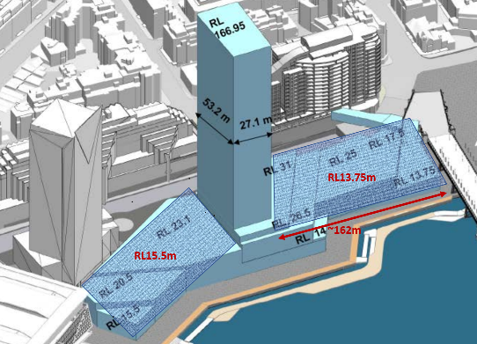
Recommended podium heights - north 13.75m & south 15.5m

Harbourside Redevelopment proposes RL25 for the northern portion of the podium rising to RL26.5 and then RL31.

The objective of providing high ceiling commercial space attractive to technology companies especially in the ‘northern podium’ is meaningless when the impacts of COVID into the future have forever changed the work-scape. Therefore the ‘northern podium’ should be entirely reduced to RL13.75.

VIEW SHARING ANALYSIS

Water views from ‘One Darling Harbour’ over the whole of Cockle Bay will be entirely taken away
from Level 9 down by the ‘Harbourside’ proposal. Many owners will suffer financial ruin. The visual assessment impact was done based on balcony views, however, most residents spend much more time inside the apartment as the views are enjoyed from the living room and bedrooms. Water views are highly valued in assessing the price of property.

I contend the view sharing analysis was done incompetently and misleadingly as many apartment view impacts are incorrectly categorised and contradictory as many apartments with the same impact are varyingly categorised as ‘moderate’ to ‘minor’ and I reiterate, the same impact, different categorisation.

INSUFFICIENT PUBLIC BENEFIT

In contradiction to the Pyrmont Peninsula Strategy Plan which requires publicly available access to all rooftop areas, the southern podium is not accessible. The Harbourside Proposal should at least provide the same amount of publicly accessible open space as the Cockle Bay Wharf Development if not more, which should be 6,500m2 which is 85% more than the proposed 3,500m2.

Further the public space offered discriminates against those using prams or those who require wheel-chair assistance as the proposed publicly accessible area is spread across three different levels which is a deterrent from using them. The design benefits from being 1-tier will make a substantial difference.

These requests above will still provide the Applicant with similar development potential.

By adopting the RL levels recommended above, further objection from ‘One Darling harbour’ owners and residents will be negated.

The benefits of the recommendation:

- The northern podium no longer dominates the State Heritage listed Pyrmont Bridge.
- Similar treatment of area adjacent to both ends of Pyrmont Bridge, creating
coherence and harmony, podiums at both ends will be of similar height.
- Negate view sharing issues with ODH as majority of northern podium will be similar
height as Bridge Platform & the existing shopping centre.
- A large fully useable single-level ‘park’ creates significant public amenity which is family, pram & disabled friendly.
- The applicants proposal is not unduly impacted while still being able to create some 2-3 storeys of commercial space and build a 400 (approx.) residential apartment tower.

Name of submitter: Mark Constantine
Relationship to Application: Owner Unit 1002, 50 Murray Street Pyrmont.
Email: markconstantine001@gmail.com
Declaration of political donations: Nil

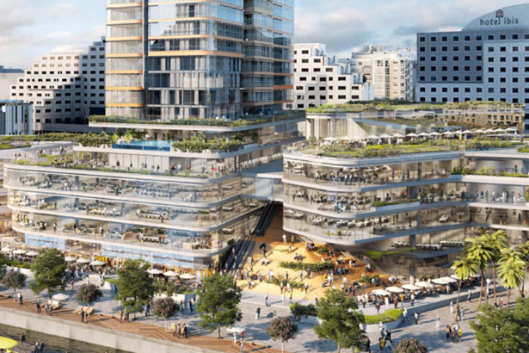
Current ‘Harbourside’ proposal

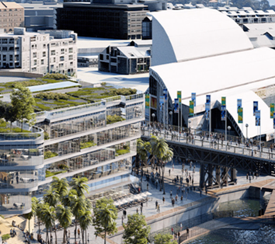
Impact of the podium on Pyrmont Bridge

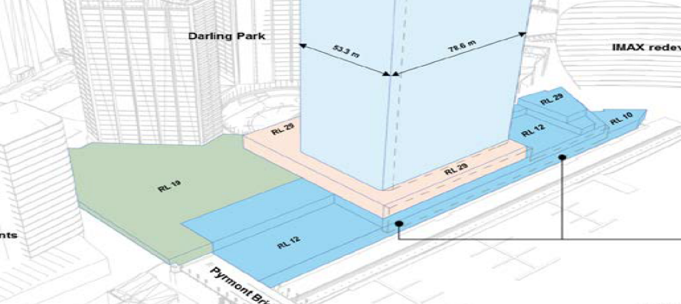
Cockle Bay Wharf Development approved RLs

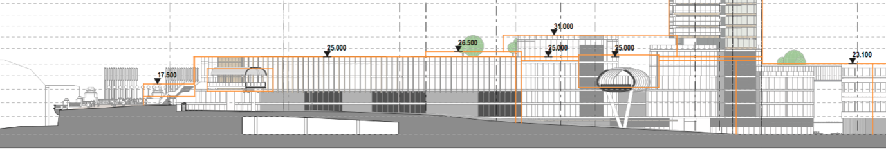
Harbourside Shopping Centre Redevelopment Amended Proposal

