I OBJECT to the Harbourside redevelopment.
My primary concerns with the development are that:
- The northern podium envelope of the Harbourside Proposal is not commensurate in bulk and scale with the neighbouring Cockle Bay redevelopment, particularly adjacent to the Pyrmont Bridge. This creates inconsistency in the character of the Cockle Bay basin, and a lack of coherence in the developments at the start and end of the Heritage Pyrmont Bridge.
- The podium envelope is not sensitive to the State Heritage listed Pyrmont Bridge, being set too close to the Pyrmont Bridge at an elevation twice the height of the bridge platform that would dominate the structure. The impact of the Podium Envelope being 30m setback at an average overall height of RL 26m from the Pyrmont Bridge was not addressed or assessed. T The Podium envelope should be reduced to RL13.75 or the same height as the bridge, and become a publicly trafficable one-level tier that extends 100m south to the tower along the waterfront.
- Insufficient Public benefit has been provided, in contradiction to the Pyrmont Peninsula Place Strategy (PPPS) which requires publicly available access to all rooftop areas, and the southern podium is not accessible. The Harbourside Proposal should at least provide the same amount of publicly accessible open space as the Cockle Bay Wharf Development if not more, which would be 6,500sqm which is 85% more than the proposed 3,500sqm. Further the public space offered discriminates against those use prams or those who require wheelchair assistance as the proposed publicly accessible area is spread across three different levels which is a deterrent from using them. There is no design besides from being 1 tier that will make a substantial difference. To be in line with the PPS, both the Southern and Northern Podiums should be publicly accessible. There are no plans to maintain current site permeability where the public is able to walk through the entire length of the shopping centre in inclement weather.
- That it does not sufficiently support view sharing with existing residential buildings. The curvature of the ODH building means that the Northern Corridor does not enable view sharing, as the apartments face due east. The height of the Northern Podium at RL26.5 blocks all or the majority of valuable whole water views of Cockle Bay, for many apartments, including levels above level 7/8.
- The objective of providing high ceiling commercial space attractive to technology companies in the Northern Podium is meaningless when the impacts of COVID on work from home arrangements are taken into account as the District Plan was released in May 2018, before COVID. Commercial space has oversupply and reduced demand. Therefore the Northern Podium should be entirely reduced to RL 13.75.
- The size and bulk of the tower and podium are not appropriate to the Western Side of Darling Harbour and does not provide a positive contribution to the skyline as the Western Side of Darling Harbour is not characterised by high rise buildings. However given the PPPS allows the tower of 170m, I reluctantly accede to it so long as all other aspects of the PPPS are strictly complied with including sufficient public benefit to all rooftops, that are genuinely useful to all members of the public including young children and the infirm by having podiums to be flat and easily traversable by the public for 100 plus metres all the way to the tower, have activated and appealing back of house boundaries and most importantly that the Northern Podium has an appropriate built form outcome that respects the Heritage Bridge by remaining at the same height as the bridge for 100 plus metres along the waterfront.

- The northern podium envelope of the Harbourside Proposal is not commensurate in bulk and scale with the neighbouring Cockle Bay redevelopment, particularly adjacent to the Pyrmont Bridge. This creates inconsistency in the character of the Cockle Bay basin, and a lack of coherence in the developments at the start and end of the Heritage Pyrmont Bridge.
  - A bridge exhibits symmetry and it is basic design principle that what is appropriate for one area must be considered appropriate for a similar area. In fact it is arguable that the Cockle Bay redevelopment has set a precedent for modern treatment of the waterfront areas directly adjacent to the Heritage Bridge. Otherwise the applicants references to the ICCC and Sofitel heights are moot, especially since the ICC and Sofitel are not located near and therefore did not have to adjust for the Heritage Pyrmont Bridge.
  - The Cockle bay wharf redevelopment is the most similar area to the proposed redevelopment. They sit opposite each other, they both are located at the same distance to the same Heritage item, the Pyrmont Bridge, and are both located in the same Cockle Bay basin, which itself is a symmetrical body of water. The other reference points used by the Applicant are not as similar and therefore do not provide as strong a precedent.
- The podium envelope is not sensitive to the State Heritage listed Pyrmont Bridge, being set too close to the Pyrmont Bridge at an elevation that would dominate the structure. The impact of the Podium Envelope being 30m set back at an average overall height of RL 26m from the Pyrmont Bridge was not addressed or assessed. The Podium envelope should be reduced to RL13.75 or the same height as the bridge, and become a publicly trafficable one-level tier that extends for 75m along the waterfront.
  - The Cockle Bay Wharf Development appropriately considered the distance of the Tower Base Envelope from the Pyrmont Bridge while the Harbourside Proposal does not even assess the effect of the Podium Envelope’s proximity to the Heritage Pyrmont Bridge.
    - The Cockle Bay Wharf Development increased the Tower Base Envelope distance from Pyrmont Bridge from 30m to 65m. And has an elevation of RL12 for the podium where it runs along the waterfront.
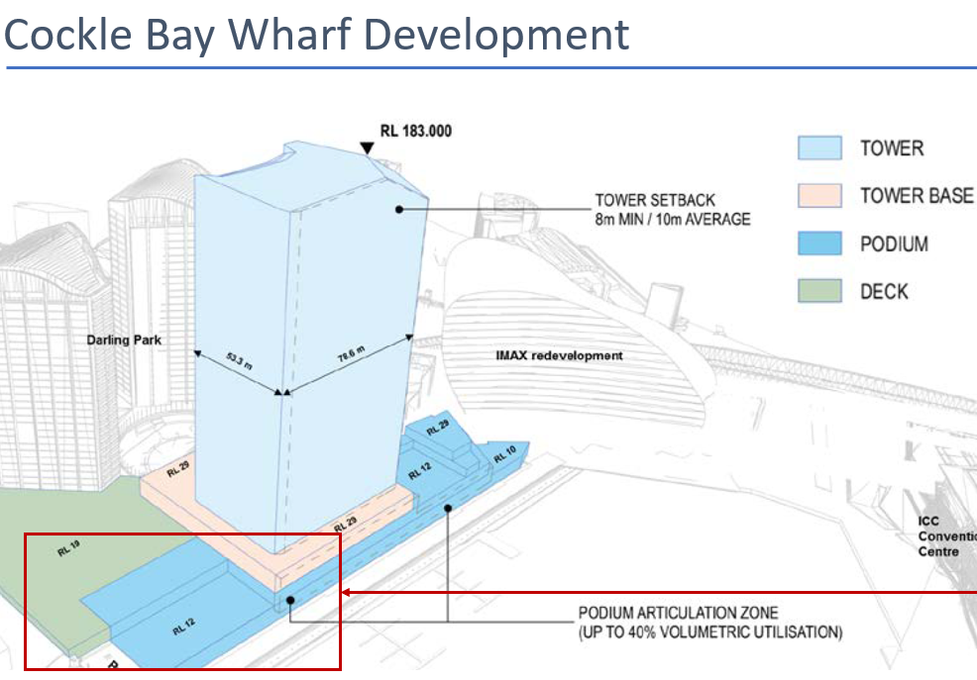

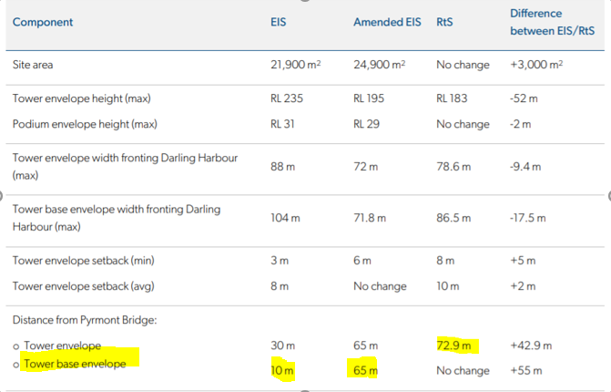
In comparison, the Harbourside Development has not appropriately considered the distance of the Podium Envelope/Tower Base Envelope from Pyrmont Bridge. Currently, in the Harbourside Proposal, the minimum podium distance to Pyrmont Bridge is only some 25 meters where the RL rises from 13.75 to RL 25 which still significantly overpowers the State listed Pyrmont Bridge. Further the Harbourside proposes an RL26.5 for ~75m along the waterfront. Contrast the Cockle Bay side of the Pyrmont Bridge has an RL of 12 for 65 meters. The Cockle Bay development is much more respectful of the public amenity of the foreshore walk, as an RL12 along the water provides more openness and development on a human scale along the water.
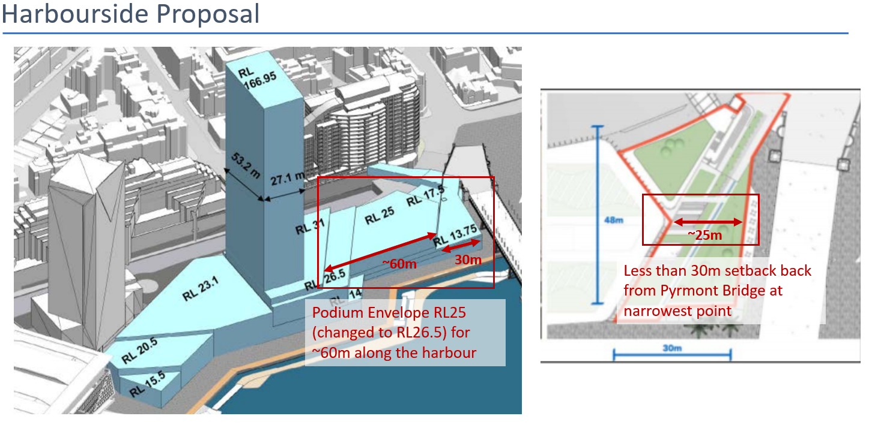
    - For the Cockle Bay Wharf development, it was required that “stepped terraces are provided north and south of the tower providing for a varied podium height and relatable scale of development adjacent to the foreshore • the podium height would not challenge the visual dominance and heritage significance of Pyrmont Bridge • the tower base height differentiates it from the main podium and creates an appropriate plinth for the tower”. The podium height for the Harbourside Development
      - Compare the stepping down vs the domination of the bridge via a multi storey building built only 25m away from the heritage listed Pyrmont Bridge.
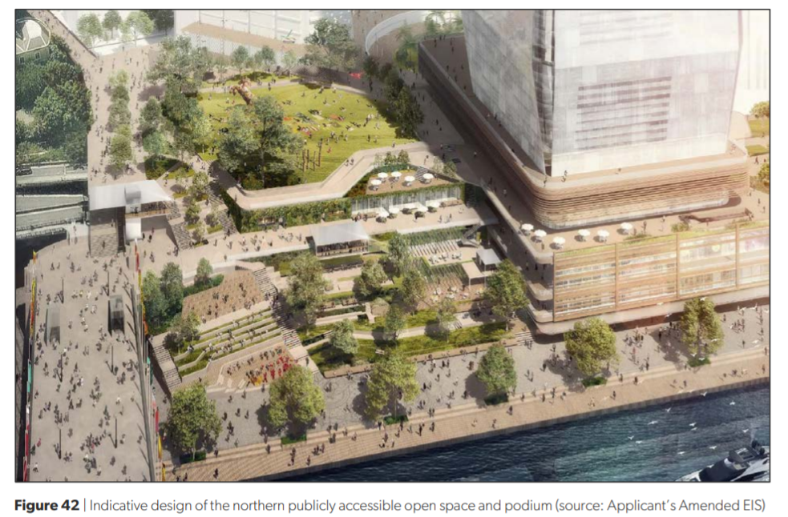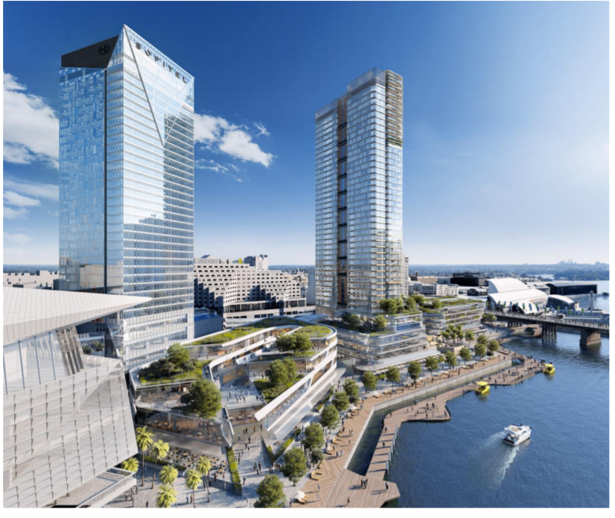
    - The Cockle Bay wharf development was also required to ensure that “the Podium envelope has an appropriate setback from the podium edge / promenade as discussed at Section 6.4, which ensures the tower is suitably recessive and does not have an overly dominant impact on the promenade“. The Harbourside development will seriously dominate the promenade, being twice the height of the existing building structure, making the “public space” become reduced to a walkway.
    - The image below shows how, the envelope obscures part of the bridge and crowds the Pyrmont Bridge.
    - Cockle Bay Wharf has a RL12 for the area that is the closest to the bridge and along the waterfront. This is an appropriate elevation between new development and the heritage Pyrmont bridge that is not reflected in the Harbourside Proposal
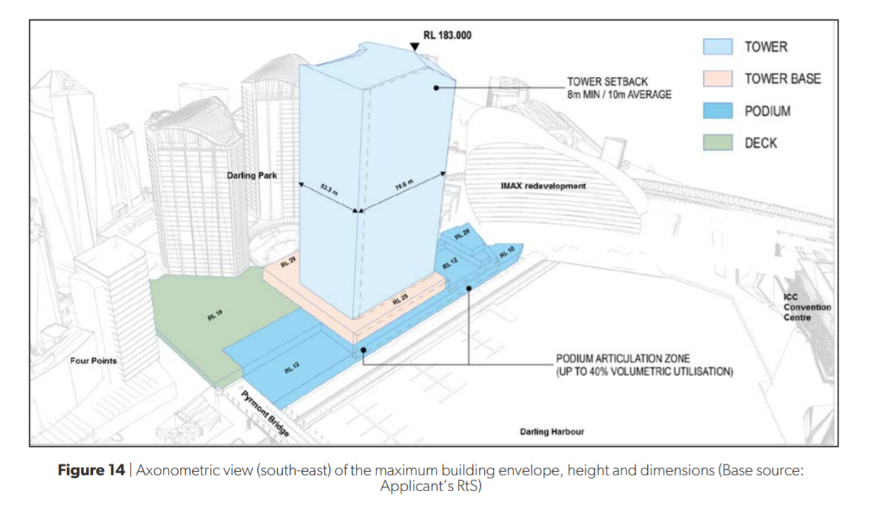
  - The Podium envelope should be reduced as follows, to 13.75 to achieve an appropriate relationship to the height of the Pyrmont Bridge and maintain openness to sky and sunshine along the foreshorewalk. 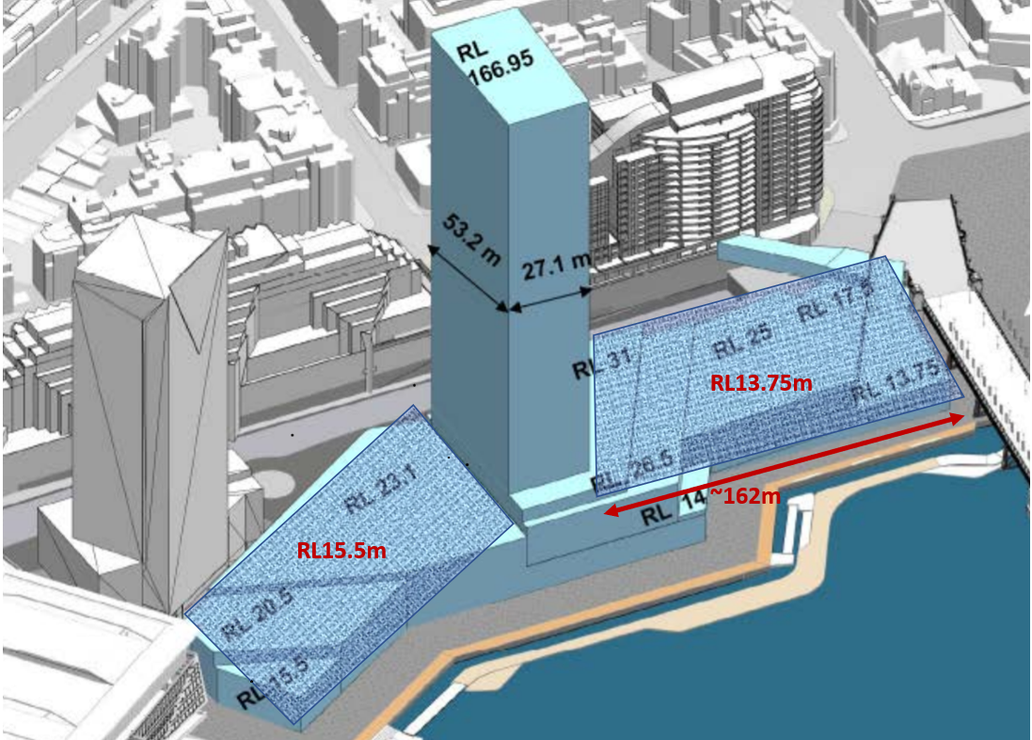
- Insufficient Public benefit has been provided, in contradiction to the Pyrmont Peninsula Strategy which requires publicly available access to rooftop areas, among other items. The Harbourside Proposal should at least provide the same amount of publicly accessible open space as the Cockle Bay Wharf Development if not more, which would be 6,500sqm, 85% more than the proposed 3,500sqm, on both the northern and southern podiums.
- 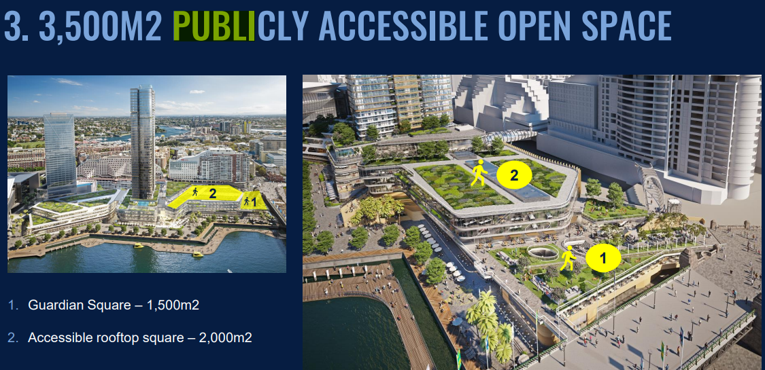
  - Cockle Bay wharf development essentially provides almost double the amount of publicly accessible open space and improves site permeability (6,500sqm vs 3,500sqm), while the Harbourside Development provides tokenistic publicly accessible open space, much of which was already available to the public. Furthermore, the Harbourside Development does not create any significant additional site permeability and connection. In fact the due to the residential tower and the commercial block in the Northern podium, public access in terms of site permeability is reduced, as currently pedestrians often walk through the shopping center as a through link to and from the bridge. The proposal does not account for how pedestrians will be able to walk through the entire length of the building like they currently do, particularly during bad weather. Therefore the proposal reduces site permeability.
Cockle Bay Wharf: assessment-report.pdf (nsw.gov.au)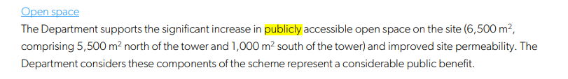
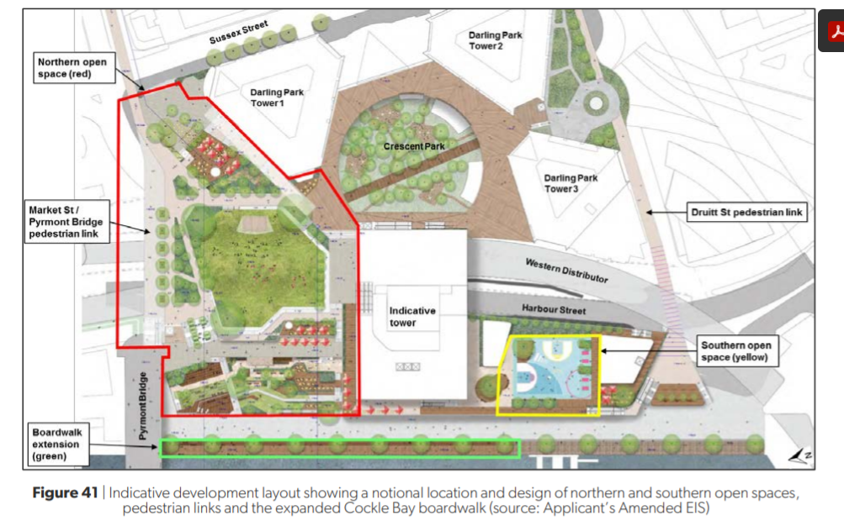
Harbourside Proposal:
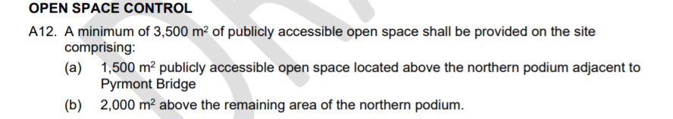
https://www.ipcn.nsw.gov.au/resources/pac/media/files/pac/projects/2021/04/harbourside-shopping-centre--darling-harbour/referral-from-the-department-of-planning-industry-and-environment/dpie-recommended-conditions-of-consent.pdf

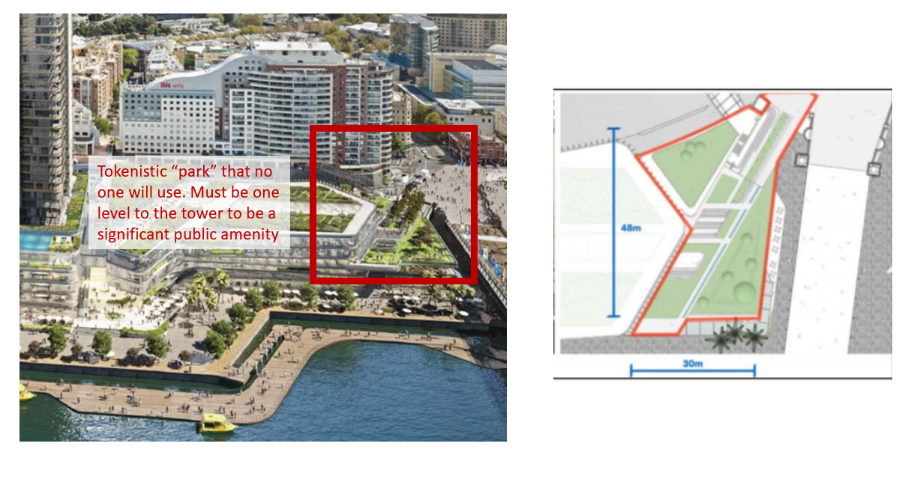
Half the “park” is nothing more than a walkway to channel pedestrians into the shopping centre.
  - The Harbourside proposal is not in line with the Pyrmont Peninsula Place strategy as it:
    - Does not provide publicly accessible open space to all roof top areas as the southern podium is not accessible to the public. Further, the Northern podium publicly open space is not wheel chair and pram friendly given that the space is spread over three tiers and difficult for families to traverse and use the space given inevitable choke points due to elevator and ramp accesses particularly at times when New Years fireworks and other public events are held in the area.
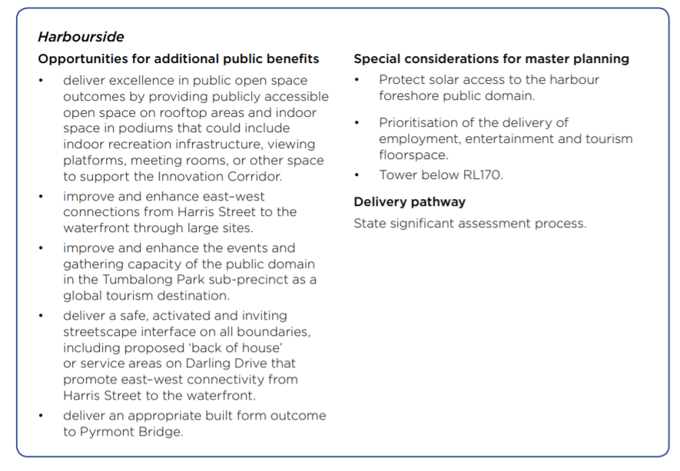
Figure 1 Slide 83 of PPPS https://www.planning.nsw.gov.au/-/media/Files/DPE/Strategy-documents/Plans-for-your-area/Planning-for-local-communities/Pyrmont-Peninsula/Pyrmont-Peninsula-Place-Strategy-2020-12-11.pdf?la=en
    - Reduces the event and gathering capacity of the Tumbalong Park Sub-precinct area, as it reduces the longest and widest part of the boulevard almost by half and creates a walkway only. The proposal to add a few steps is not sufficient to replace a space where many congregate to listen to live music by the water. In the image below, you can see the previous old view which faces the beautiful lights on water from Cockle Bay Wharf, to Event steps that face the unattractive underside of the bridge. This is a loss to public enjoyment and reduces public enjoyment of a previously enjoyable space.
    - 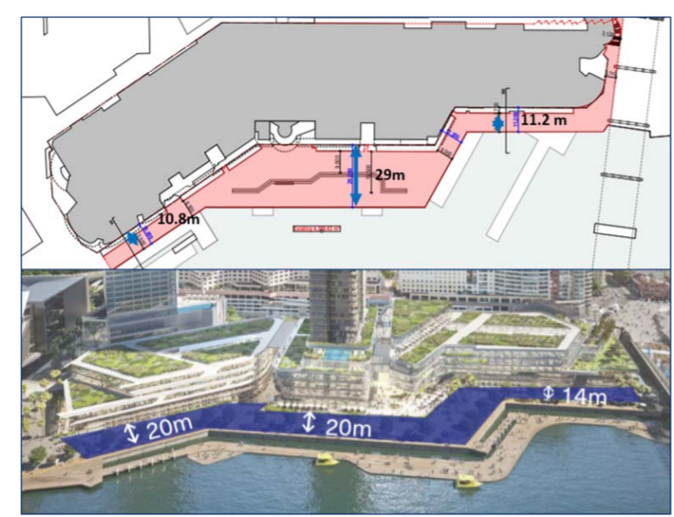
    - Again, does not deliver appropriate built form outcome to Pyrmont bridge as the Podium envelope is twice the height of the existing building, and too close to the Pyrmont Bridge.
    - Also there is no “safe, activated and inviting streetscape interface on all boundaries including proposed ‘back of house’ service areas” that is proposed as required by the Pyrmont Peninsula strategy. It is more akin to a carpark with zero activation. To activated, there should be retail and dining options and plenty of street lighting.
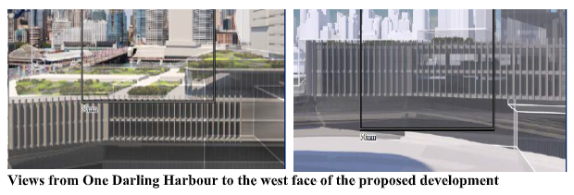
  - The northern podium should made into a publicly trafficable, one tier park as that would introduce significant public open space at RL13.75 including landscaping. This would essentially widen the tiny Guardian Square into a real, one tier park that would be enjoyed by the public that doesn’t dominate the Heritage Pyrmont Bridge. Also a 3-tier publicly open space is not pram-friendly and other persons who require wheelchairs would also find a three tier park of no use and would be discriminated against as they would be deterred from using the publicly open space.
- That it does not sufficiently support view sharing with existing residential buildings. The curvature of the ODH building means that the Northern Corridor does not enable view sharing, as the apartments face due east. The height of the Northern Podium at RL26.5 blocks all or the majority of valuable whole water views of Cockle Bay, for many apartments, including levels above level 7/8. That it does not sufficiently support view sharing with existing residential buildings, the view sharing analysis was done misleadingly as many apartment view impacts are incorrectly categorised and contradictory as many apartments with the same extent of impact are varyingly categorised as “moderate” to “minor”. I reiterate, the same impact, different categorisation.
  - The proposed “Northern corridor” does not achieve View Sharing as The provision of a northern ‘corridor’ in the Harbourside Proposal does not facilitate view sharing given the curved nature of the ODH building. It does not in any way benefit the many apartments who will experience a total or majority loss of valuable whole water Cockle Bay views which is devastating in impact to the amenity of the pre-existing residential apartments.
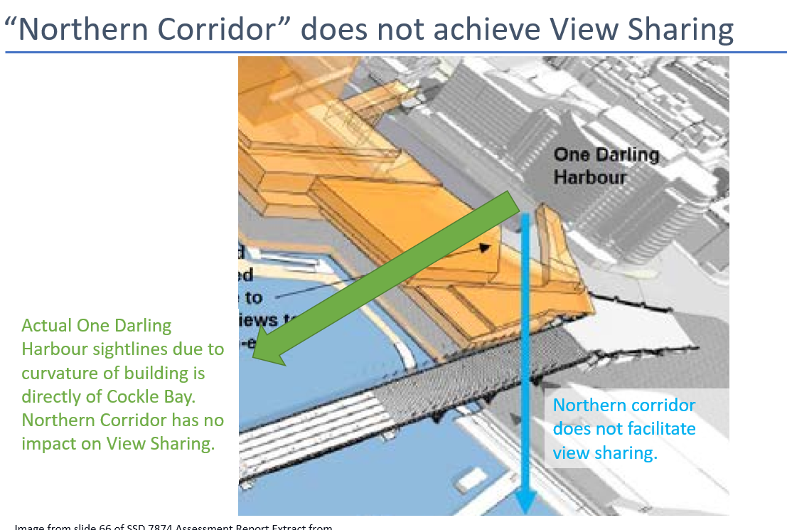
  - 701 is categorised as “moderate” while a quick sample of 801, 901, 1001 and 1014 have the same impact description but are described as “minor”. The difference between 601 (Moderate-severe) and 701 (Moderate), is a supposed “improvement in views of Pyrmont Bridge”. This is not demonstrated and there is a much greater reduction in the view to the Pyrmont Bridge (loss of 1/3) than any suppose improvement. Therefore all apartments should be categorised as “moderate-severe”. Further note how 614 (moderate-severe) has the same impact assessed as 702 (moderate) and 703 (moderate) but is differently classified
  - 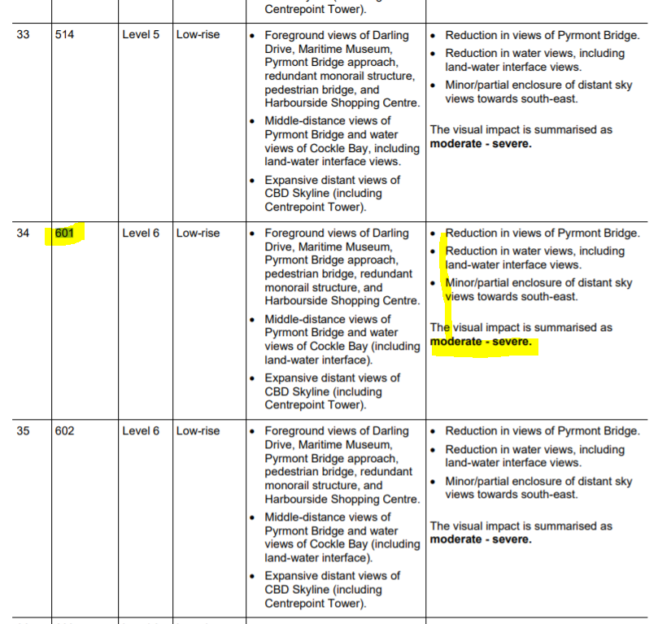
  - 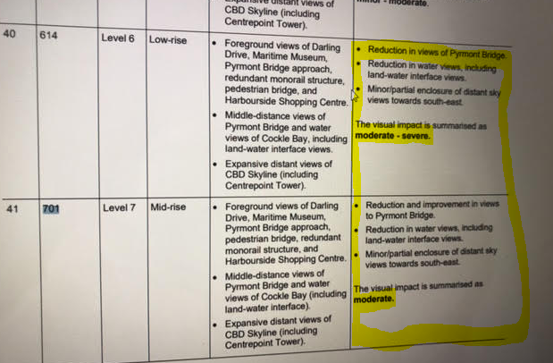
  - 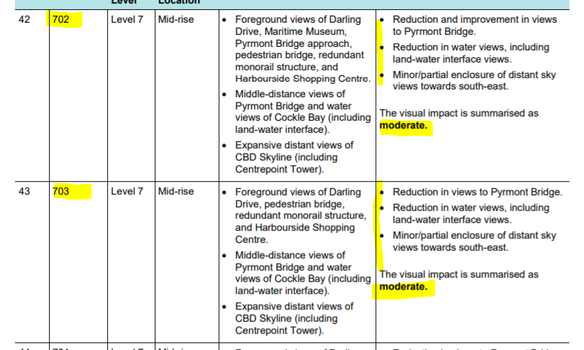
  - 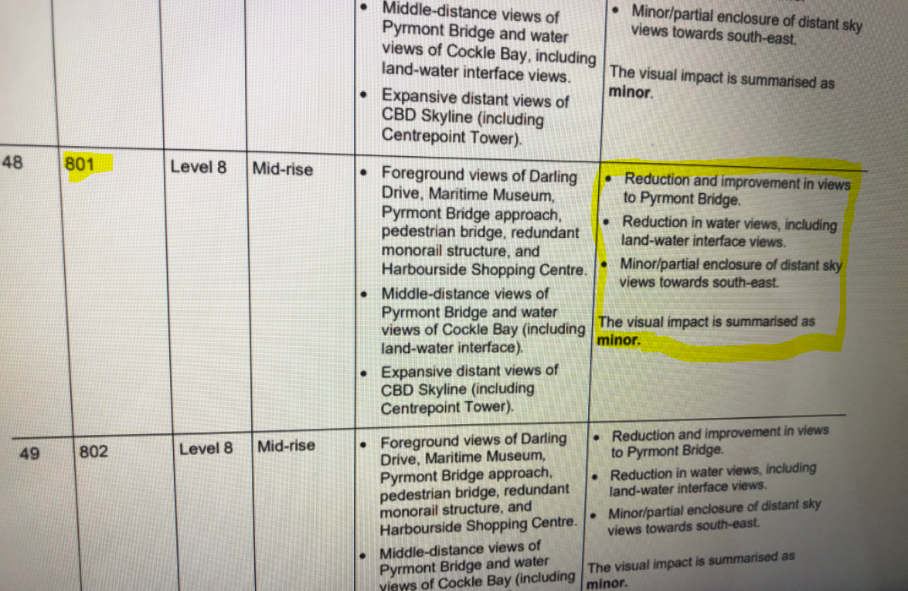
  - 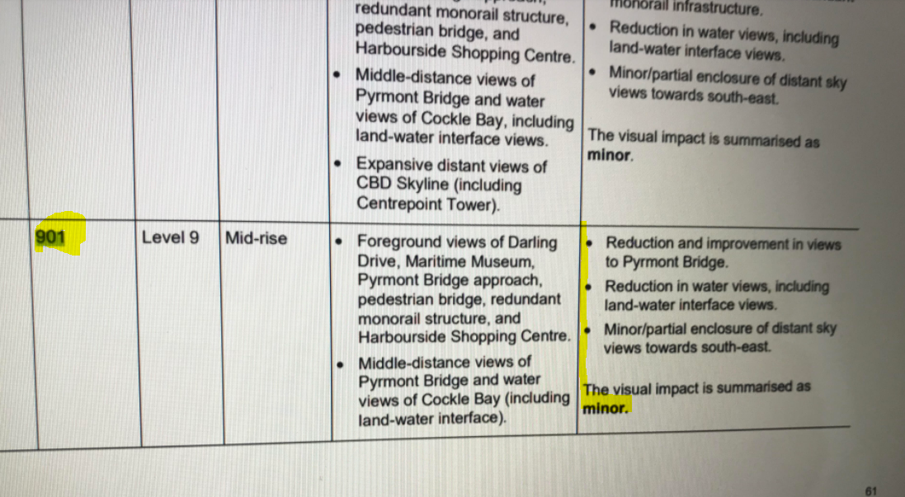
  - 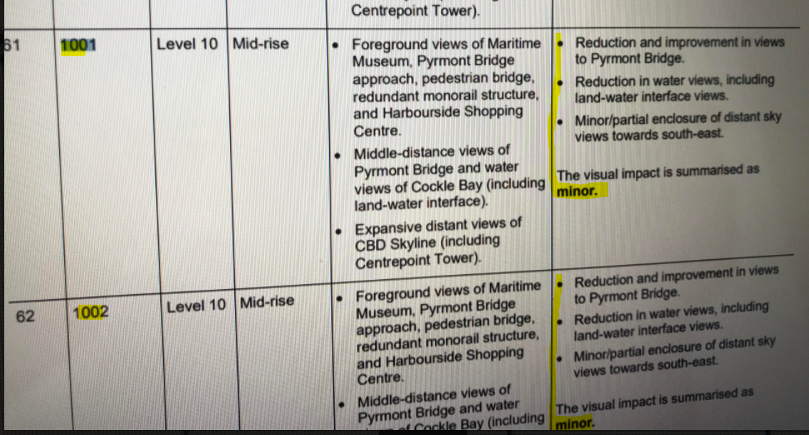
  - 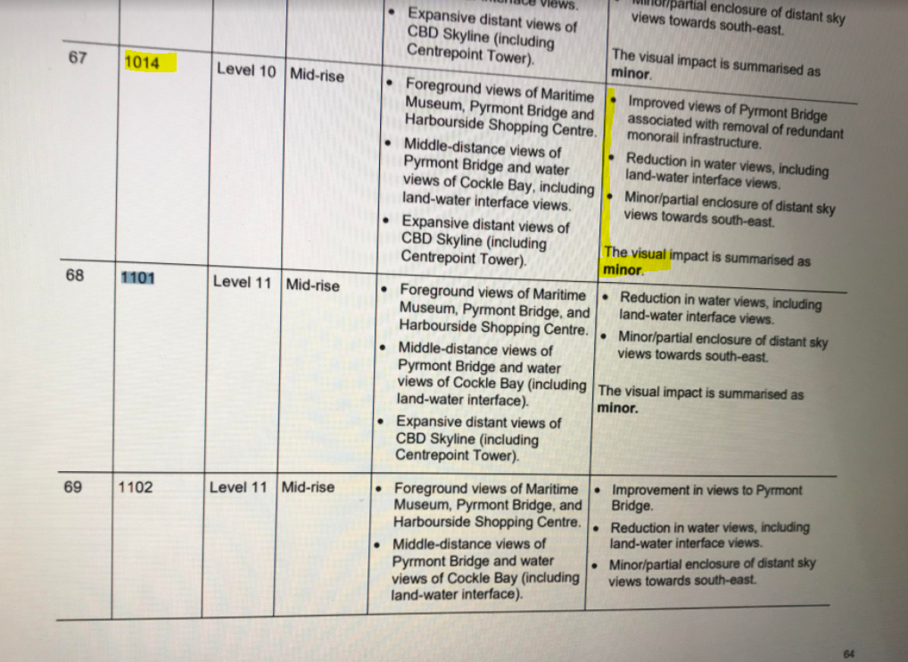
      - Note how view to the bridge from 701 is crowded and there is a much greater reduction in the view to the bridge in that the supporting piers (1/3 of the bridge) are now totally obstructed. The “Extent of Impact” is inaccurate. There is no improvement to the view of the bridge.
    - 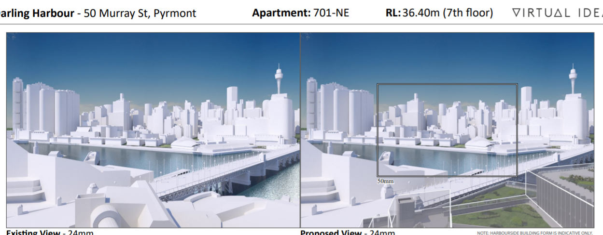

    - 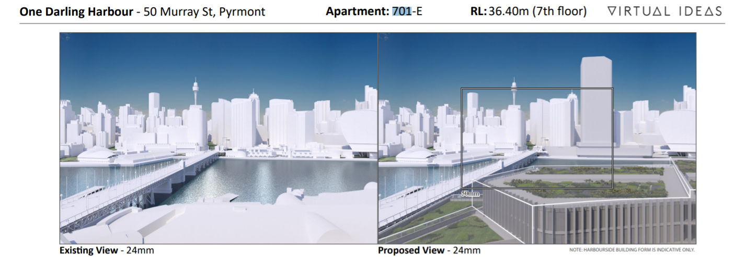
- The objective of providing high ceiling commercial space attractive to technology companies in the Northern Podium is meaningless when the impacts of COVID on work from home arrangements are taken into account. Therefore the Northern Podium should be entirely reduced to RL 13.75.
  - The Harbourside proposal states the 4 levels in the Northern podium “…enables large campus sized commercial floor plates that are favoured by large multinational tech, finance and professional services companies.” The University of Sydney has indicated that there is a growing trend of WFH with some permanent impacts, including that we could see a 20% reduction in the level of office workers in the CBD and that large enterprises no longer see the need for large commercial space which the development proposes. Taking into consideration that 200m+ commercial tower has been approved in Cockle Bay Wharf and that current office tower CBD space supply exceeds demand, there appears to be no justification for a four level commercial podium, a two level commercial podium is more appropriate.
https://www.sydney.edu.au/business/news-and-events/news/2020/12/07/what-might-the-changing-incidence-of-working-from-home--wfh--tel.html
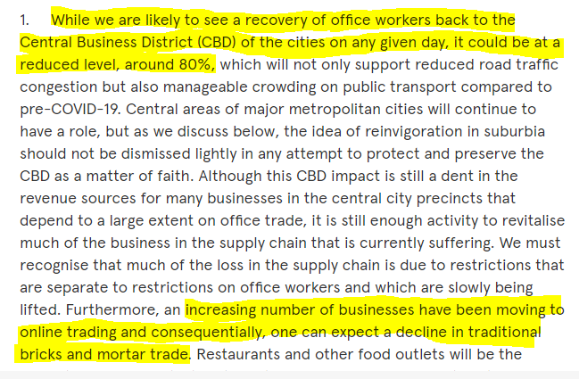
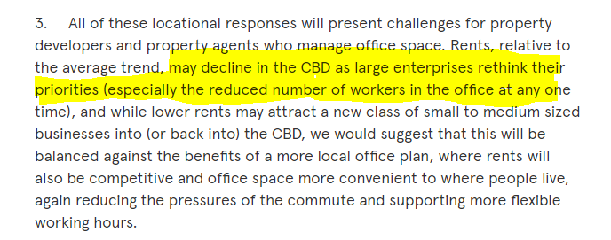
- The size and bulk of the tower and podium are not appropriate to the Western Side of Darling Harbour. It does not provide a positive contribution to the skyline as the Western Side of Darling Harbour is not characterised by high rise buildings.
  - However given the PPPS allows the tower of 170m, I reluctantly accede to it so long as all other aspects of the PPPS are strictly complied with including sufficient public benefit to all rooftops, that are genuinely useful to all members of the public both young and infirm by having podiums to be flat and easily traversable by the public for 100 plus metres all the way to the tower, have activated and appealing back of house boundaries and most importantly has an appropriate built form outcome that respects the Heritage Bridge by remaining at the same height as the bridge for 100 plus metres along the waterfront.

Slide 49 of https://www.ipcn.nsw.gov.au/resources/pac/media/files/pac/projects/2019/01/cockle-bay-wharf-redevelopment-concept-proposal/department-of-planning-and-environment-assessment-report/assessment-report.pdf
https://www.planning.nsw.gov.au/-/media/Files/DPE/Strategy-documents/Plans-for-your-area/Planning-for-local-communities/Pyrmont-Peninsula/Pyrmont-Peninsula-Place-Strategy-2020-12-11.pdf?la=en
October 2020 - Appendix E - Visual Impact Analysis - Part 1 -https://majorprojects.planningportal.nsw.gov.au/prweb/PRRestService/mp/01/getContent?AttachRef=EXH-2778%2120201012T104556.363%20GMT

