Chair
Independent Planning Commission

Dear Chairperson.

Harbourside Shopping Centre Redevelopment SSD-7874

I live at Unit 707 50 Murray Street Pyrmont.

I object to the project.

I contend that the proposed development unreasonably impacts on the surrounding area and is not commensurate in bulk and scale with neighbouring Cockle Bay redevelopment providing two inconsistent character of addressing the Cockle Bay basin as well as an inconsistent
start and end of the Pyrmont Bridge.

The Darling Harbour Development Plan No.1 is the environmental planning instrument which
provides land use controls for land within the Darling Harbour precinct which includes the
Harbourside Shopping Centre. The development of the Daring Harbour and the Cockle Bay development should all have a similar strategy to ensure good urban design; consistency in building envelopes and setbacks in regard to the heritage Pyrmont Bridge and the water; as well as meeting the needs of all stakeholders.

The Cockle Bay redevelopment has a podium with an approved RL of 12 at the harbour’s edge providing a on level park some 65m wide. This podium extends for 65m away from Pyrmont Bridge before increasing to RL 29 which is only 7.9m before the tower commences.
In contrast, the Harbourside Shopping Centre Redevelopment proposal has a podium starting at RL of 13.75 and extends 25m from Pyrmont Bridge before rising to RL 25 for about 60m

The State Heritage listed Pyrmont Bridge defines the termination of Cockle Bay. The bulk and scale of the podium at its nearest point to the State Heritage listed Pyrmont Bridge is RL 13.75 and after 25m rises to RL 26.5 or nearly twice the height of the RL of the bridge being RL 12.5.This overpowering podium is inappropriate, unsympathetic and unacceptable response to this iconic site and to the State Heritage listed Pyrmont Bridge. The Cockle Bay side of the Pyrmont Bridge has an RL of 12 for 65 meters. That’s 65m for Cockle Bay development
and only 25m for this development.

The current envelope does not include the height of landscaping or amenites which will further add to the bulk and scale of the northern podium. Trees for example can be several meters high and they should be included in the envelope as it relates to my loss of amenity by blocking my views.

The west side of the development facing One Darling Harbour, which the east side of One Darling Harbour will replace their views of Cockle Bay, has no design element at all. Not only has Mirvac taken views away but replaced it with a very low amenity outlook.

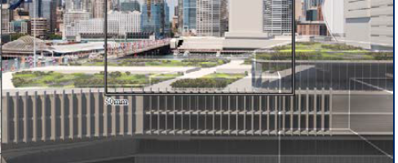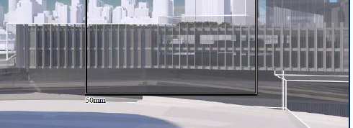
Views from One Darling Harbour to the west face of the proposed development

Recommended Amendment to address my objection

-the proposed envelope from the Pyrmont bridge commence with the current RL of 13.75 for 65m rising to an RL of 17.60 extending south 75m from the Pyrmont Bridge; and

- the landscaping and any proposed amenities be withing the envelope.

Igor Shpanlinski

