Chair
Independent Planning Commission

Dear Chairperson.

Harbourside Shopping Centre Redevelopment SSD-7874

I object to the project.

I live at Unt 501 One Darling Harhour and enjoy the view of Cockle Bay and land water interface views.

I contend that the bulk and scale of the podium, particularly the northern end, is not acceptable. My views from One Darling Harbour over Cockle Bay (unit 501 One Darling Harbour) will be taken away from me by the development for its own enjoyment. I have views from several parts of my apartment not just at the end of the balcony viewing the waters of Cockle Bay. When it comes to my highly valued water views, it will not be ‘view sharing’ but total loss of views and I will look into what looks like a massive brick wall – see blow.

The west side of the development facing One Darling Harbour, which will replace my views of Cockle Bay, has no design element at all. It looks more like a car park façade rather than high quality design claimed both by the applicant and the Department of Planning. Not only have taken my view but replaced it with a very low amenity outlook.

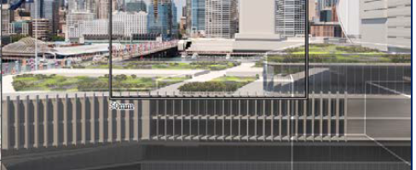
New views from Unit 501 ODH

The provision of a northern ‘corridor’ by the Applicant ignores the fact that my water views are of Cockle Bay and that the building is curved and you can only take advantage of the ‘corridor’ if you are only looking over the balcony.

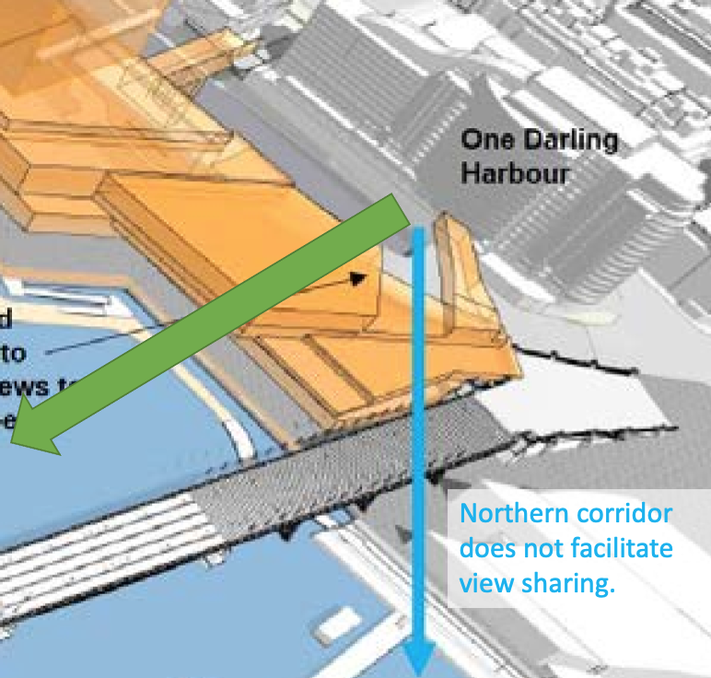

Further, the current envelope does not include the height of landscaping or amenites which will further add to the bulk and scale of the northern podium. Trees for example can be several meters high and they should be included in the envelope as it relates to my loss of amenity by blocking my views.

Norman lockett
Unit 501 One Darling Harbour

