Chair
Independent Planning Commission

Dear Chairperson.

Harbourside Shopping Centre Redevelopment SSD-7874

I object to the project.

I live in Unit 203 One Darling Harbour.

The podium on the northern edge of the development is far too bulky. I have views of Cockle Bay and beyond from all aspects of my apartment and the massive podium of the development will reduce those views . The proposed design of west side of the podium, see below, is certainly not an inviting streetscape. No doubt this will be where all the service areas of this massive development will be and there has been no attempt to provide any design excellence for this part of the development and yet this will be what I will now see. Not only will it be visually ugly but will be where all the noise will be created further reducing my amenity.

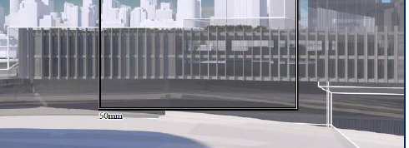

West façade of the proposed development wil be my views

The proposed development is not consistent with the setback and heights of the approved Cockle Bay Development. The podium of the Cockle bay development was approved at RL 12 and extended away from the Pyrmont Bridge for some 65m, whereas the podium for the Harbourside Development is being proposed at RL 13.75 for 25m before climbing to RL 25.00 over twice that of the podium at Cockle Bay. The podium for the Harbourside development should be of similar heights meaning the podium should be RL 12.00 for some 65m. Such a reduction in height of the podium would allow much better view sharing for the people who live in the east facing apartments at One Darling Harbour.

Further the envelope should include any landscaping.

I recommend that the panel request the applicant to reduce the height of the northern podium to RL 12.0 for some 60-70m away from the Bridge and the envelope include landscaping.

Ian Richardson

