TO: Independent Planning Commission

Project: Harbourside Shopping Centre Redevelopment SSD-7874

I object to the development.

I live at Unit 703, 50 Murray Street Pyrmont and enjoy excellent views over cockle Bay. The proposed development is just too bulky particularly at the northern end as it will impose dramatically on the Pyrmont Bridge and I will totally loose my views. Mirvac should not be able to totally take away these views and allow Mirvac to pass them on to potential buyers of the development. Further they have replaced them with what looks like a faced you would find for a car park.

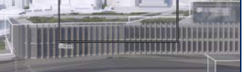
Instead of water views this is what I will be looking at

This is company whose values includes creating great communities but does not mind taking from other communities to do so. We should share what we have. The development is massive with 87,000sqm gross floor area surely they can lower the northern podium to allow a win-win for all of us.

Lower the northern podium and let us all enjoy the beautiful Cockle Bay.

Submitter: Marcel Joukhador
Political Interest: Nil
Contact: 703/50 Murray Street Pyrmont

