Chair
Independent Planning Commission

Harbourside Shopping Centre Redevelopment SSD-7874

I write to object to the proposal.

I live at Unit 803, 50 Murray Street Pyrmont. I have lived there for many years and watched the redevelopment of Darling Harbour with interest.

To date I have had excellent views over cockle Bay. I value these views very highly. The proposed development will take all these views away from me for the benefit of Mirvac. Not only have they taken my views of Cockle Bay water away they have replaced them with a very low quality design befitting a car park façade.
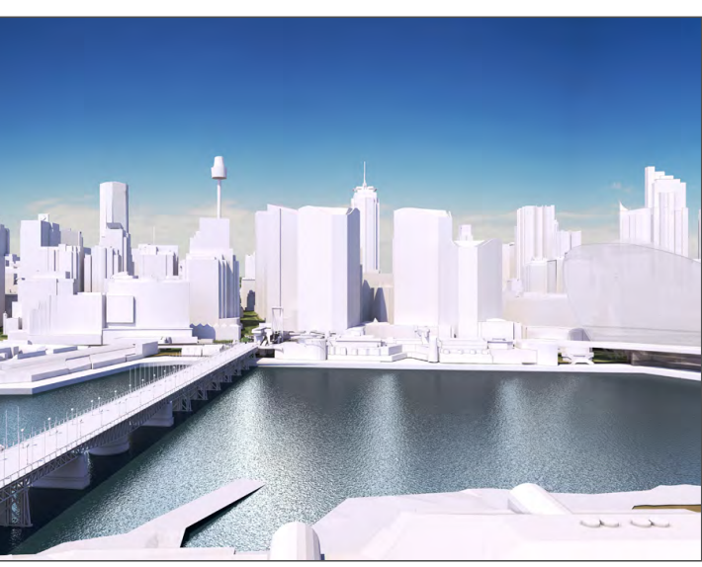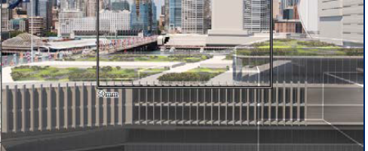
My current views My views under the Mirvac proposal

They claim I am compensated by a view channel north up the harbour. The building is curved and my balcony faces 112 SE which a north facing view is not helpful..

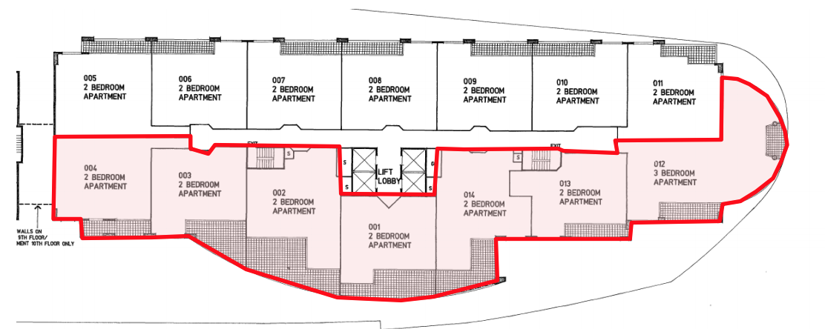

Further, it is the Cockle Bay views that I have all of which will be lost. A small decrease in the height of the podium would allow views to be shared between myself and the Mirvac. I do not think this is too much to ask from such a massive development that Mirvac are proposing of some 87,000 Gross Floor Area.

I note the new proposal is proposing a ‘Guardian Park’ on top of the concrete roof over two levels. I wonder what the disabled and mothers think of this. I do not know a park that is on top of a building over different levels. I think it is an attempt to cover up an bulky podium by putting some grass on a concrete roof and claiming it is a park of great benefit to the community. There are some great parks in the area and we should continue this quality by providing a unobstructed space to allow children to play.

I would like to see the podium be reduced in height to the height of the bridge for say 65m providing a sharing of views and a flat space for a decent park.

Submitter: Linda Joukhador
Political Interest: Nil
Contact: 803/50 Murray Street Pyrmont

