Chair
Independent Planning Commission

Dear Chairperson.

Harbourside Shopping Centre Redevelopment SSD-7874

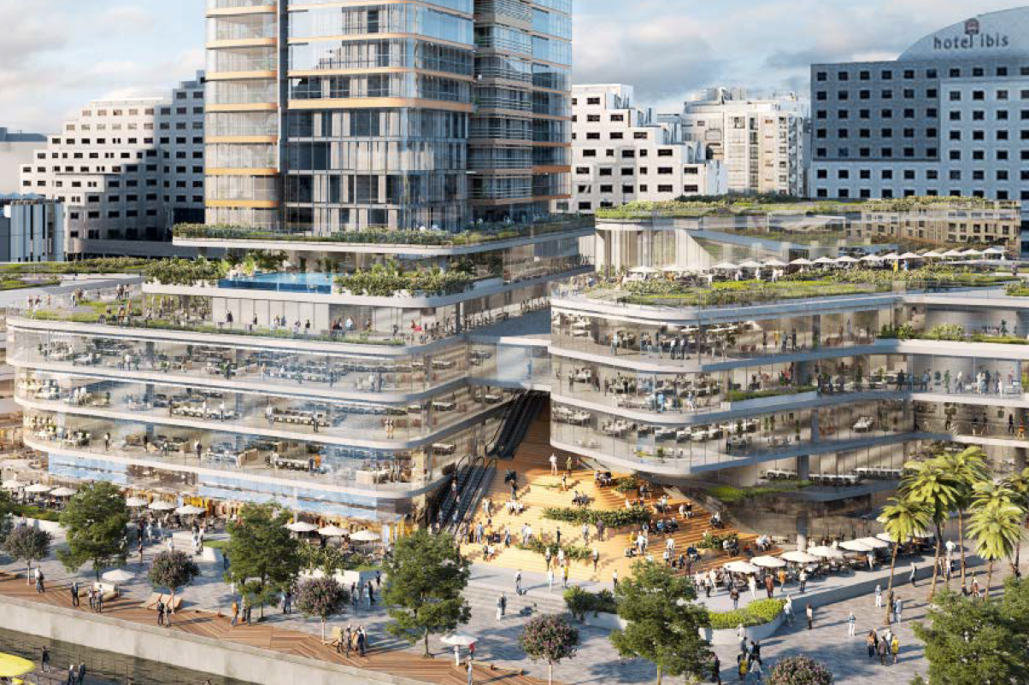

I object to the project.

I contend that the bulk and scale of the podium, particularly the northern end, is not acceptable and offer several considerations for the Panel’s assessment:

POINT 1:the proposed development unreasonably impacts on the surrounding area and is not commensurate in bulk and scale with neighbouring Cockle Bay redevelopment providing two inconsistent character of addressing the Cockle Bay basin as well as an inconsistent
start and end of the Pyrmont Bridge.

The Darling Harbour Development Plan No.1 is the environmental planning instrument which
provides land use controls for land within the Darling Harbour precinct which includes the
Harbourside Shopping Centre. The development of the Daring Harbour and the Cockle Bay development should all have a similar strategy to ensure good urban design; consistency in building envelopes and setbacks in regard to the heritage Pyrmont Bridge and the water; as well as meeting the needs of all stakeholders.

The Cockle Bay redevelopment has a podium with an approved RL of 12 at the harbour’s edge providing a on level park some 65m wide. This podium extends for 65m away from Pyrmont Bridge before increasing to RL 29 which is only 7.9m before the tower commences.
In contrast, the Harbourside Shopping Centre Redevelopment proposal has a podium starting at RL of 13.75 and extends 25m from Pyrmont Bridge before rising to RL 25 for about 60m
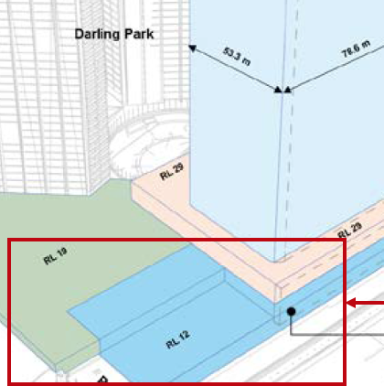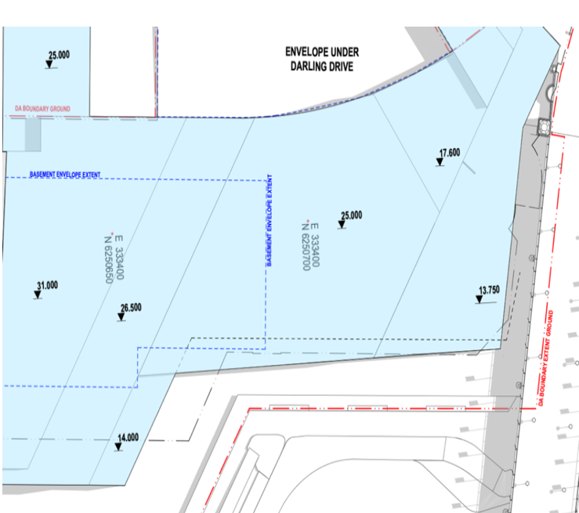
RL’s Cockle Bay development RL’s Harbourside Development
RL12.00 95m from Pyrmont Bridge RL 13.75 25m then RL 25.00 from Pyrmont Bridge

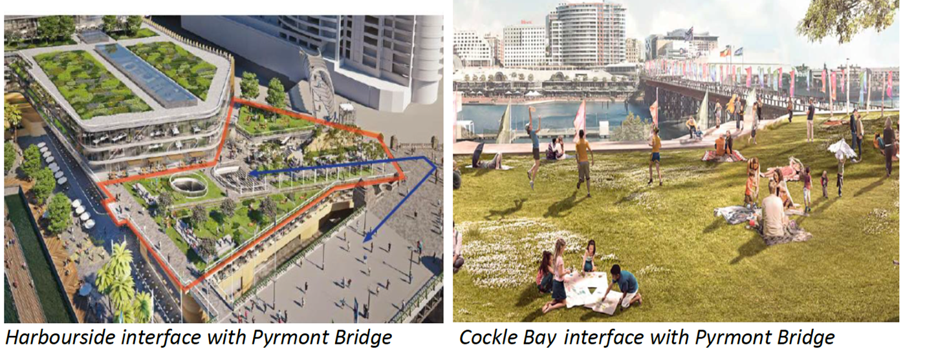

POINT 2:The State Heritage listed Pyrmont Bridge defines the termination of Cockle Bay.
The bulk and scale of the podium at its nearest point to the State Heritage listed Pyrmont Bridge is RL 13.75 and after 25m rises to RL 26.5 or nearly twice the height of the RL of the bridge being RL 12.5.This overpowering podium is inappropriate, unsympathetic and unacceptable response to this iconic site and to the State Heritage listed Pyrmont Bridge. The Cockle Bay side of the Pyrmont Bridge has an RL of 12 for 65 meters. That’s 65m for Cockle Bay development
and only 25m for this development.

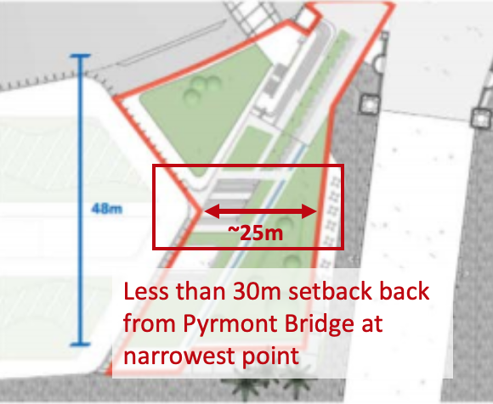

POINT 3:My views from One Darling Harbour over Cockle Bay (unit 803 One Darling Harbour) will be taken away from me by the development for its own enjoyment. I have views from several parts of my apartment not just at the end of the balcony viewing the waters of Cockle Bay. When it comes to my highly valued water views, it will not be ‘view sharing’ but total lost of views and I will look into what looks like a massive brick wall. The provision of a northern ‘corridor’ by the Applicant ignors the fact that my water views are of Cockle Bay and that the building is curved and you can only take advantage of the ‘corridor’ if you are only looking over the balcony.

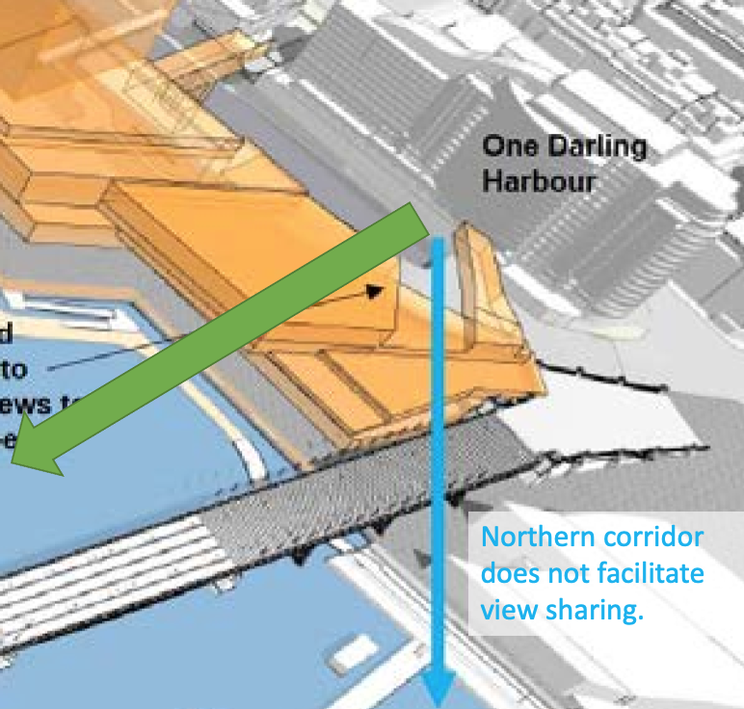

POINT 4:

The current envelope does not include the height of landscaping or amenites which will further add to the bulk and scale of the northern podium. Trees for example can be several meters high and they should be included in the envelope as it relates to my loss of amenity by blocking my views.

POINT 5:

The west side of the development facing One Darling Harbour, which will replace my views of Cockle Bay, has no design element at all. It looks more like a car park façade rather than high quality design claimed both by the applicant and the Department of Planning. Not only have taken my view but replaced it with a very low amenity outlook.

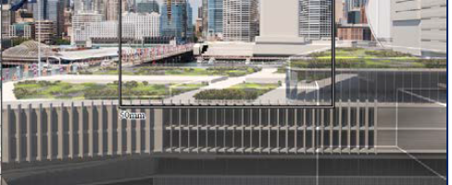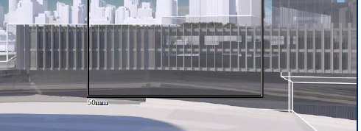
Views from One Darling Harbour to the west face of the proposed development

POINT 6
The Guardian Park of 1,500 sqm is proposed to be on two levels on the northern podium– a real challenge for mothers trying to keep their children safe. The park on one level is no more than a site through link through which all the people from Pyrmont Bridge, the light rail and new metro and Pyrmont peninsular will access Harbourside. Rather than a planned park it appears to be an attempt to green over of an unacceptable bulky podium.

A park in my mind should have:
-a play space
-be flat and unobstructed;
-a kick around space for informal games (30m x30m);
-landscaping;
-furniture.

Extending the RL 13.75 for 65m away from the Bridge will provide for an adequate aprk.

Recommended Amendment to address my objection

-the proposed envelope from the Pyrmont bridge commence with the current RL of 13.75 for 65m rising to an RL of 17.60 extending south 75m from the Pyrmont Bridge; and

- the landscaping and any proposed amenities be withing the envelope.

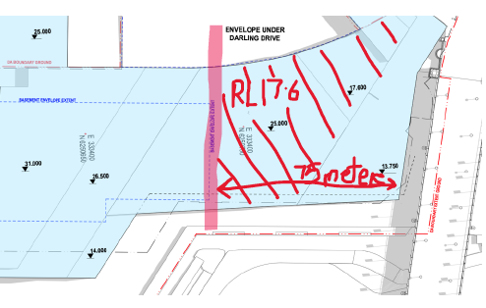

Name of submitter: Kerry Keogh
Relationship to Application: owner of unit 803, 50 Murray Street Pyrmont.
Declaration of political donations: Nil
Contact: kskeogh@optusnet.com.au

