Eve Timms
Hornsby NSW 2077
Blue Gum Community School SSD-10444
Objection to proposal
Dear Mr Duncan and Mr Pilton,
I am writing to object to the development of a school in the heritage estate of 1 Rosemead Rd Hornsby. Such a development would degrade the quality of life of the inhabitants of the Mount Errington area, taint the integrity of the Mount Errington estate, reduce the biodiversity of the area and exaggerate existing safety risks and traffic issues, according to the reasons listed below:
- William Street, Dural Street and Rosemead Road are already congested roads, especially on weekdays when commuters park along the streets, even outside our house which is 850m away from the train station. The addition of hundreds of car movements each day to transport 80 children plus staff would increase congestion on the surrounding streets, which are already effectively one way roads. And if students and staff are not allowed to travel to the school by car for the sake of the community, the distance to the train station is very far for young children to walk.
- The noise impact of the development cannot be prevented, as revealed by the revised acoustic report by NSS which states that noise levels will be significantly increased due to children at play and traffic. The peace and serenity that characterises the Mount Errington area will be disrupted, therefore changing the character of the area which first attracted its residents.
- As a heritage building, its use for commercial gain would only undermine its legacy and the purpose for which it was built, as a residence. The adaptations to the building and the removal and manipulation of the flora on the land sacrifices its cultural significance and does not preserve the history of the building as a foundation of Hornsby. As the developer mentioned in the Public Meeting, she was not looking for a heritage building to develop the school in, yet this should be the main reason for purchasing such a property. It does not need to be an “adaptive reuse,” as there is no need to adapt or reuse 1 Rosemead Road when it is in demand as a heritage home.
- The introduction of a school in the Mount Errington area would increase the foot traffic on the footpaths on Dural Street, William Street and Rosemead Road, which would increase the current safety risks on the narrow streets and blind corners. The blind corner on Dural Street and Rosemead Road is especially dangerous, as often vehicles do not reduce speed and would be likely to cause an accident with young children crossing the road or playing at the playground opposite 1 Rosemead Road.
- The construction of a 1.8m high timber fence along our boundaries with the Mount Errington estate would completely change the appearance and environment of our property, closing us off to the views of vegetation that we have enjoyed for many years and creating a restrictive environment as if we were living in a gaol. See the photo below of the view of vegetation from our back yard.
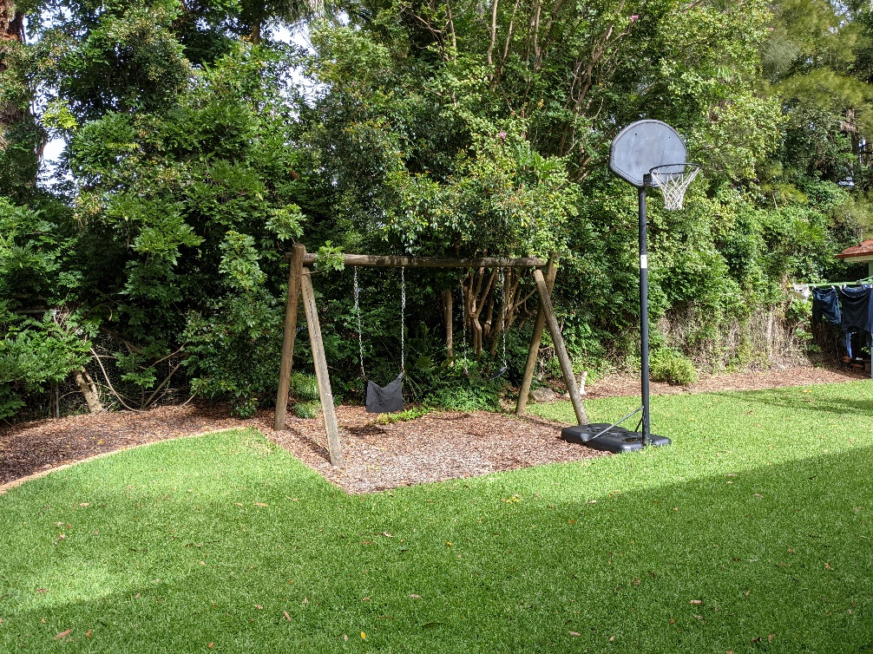
- The increase in noise, traffic and human activity would severely impact the wildlife in the Mount Errington area, changing the habitat of animals such as echidnas and wallabies, sightings of which are already decreasing in number.
- Hornsby Shire does not need another school. There are 65 primary schools within 10km of Hornsby.
- Residents will lose their car parking spaces. Many residents do not have garages and park their cars on the road. Extra cars parked on Dural Street, Rosemead Road and William Street will take away the parking from residents and cause further congestion.
- In the Public Meeting the developer says the property “shouldn’t be a private jewel locked away for a privileged few.” Statements like this only highlight the disconnect between the developer and the community, as events such as gardening clubs have been held at 1 Rosemead Road with the previous owners. Turning the property into a school does not open it up to the community – the neighbours would not have any access and only the “privileged few” school children would be allowed in.
- The developer also said that those on the eastern side of the block have not objected to the proposal which is false. I do not know anyone in the immediate vicinity of the property who supportive of the proposal.
- Representatives of Hornsby Shire (Philip Ruddock and Joe Nicita) have objected to the plan. Objection to this proposal reaches from residents to our leaders.
- The developer has already shown that the gardens of the property will not be properly maintained. The views of the garden from our property have changed drastically in 2020, with many plants along the footpath already removed. The remaining plants have not been properly maintained and are overgrown with weeds that are creeping onto our property.
- If the plan goes ahead without the approval of the community, no compensation for the neighbours has been discussed.
The developer should know that if the plan does go ahead, they will not have the support of the community nor will the school be welcomed. It is disrespectful to claim that such a development would be a “joy” to the community, according to the Blue Gum school website, when they have ignored the community.
For these reasons, I believe that Mount Errington is an inappropriate site for the development of a school and the application should be refused.
Yours sincerely,
Eve Timms

