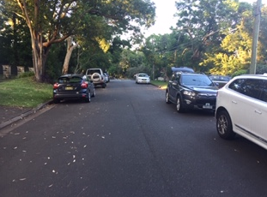 Facing South Friday Friday 12th Feb. 7.30 am 6 Vehicles (White car not included )
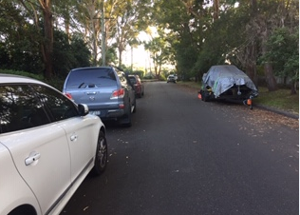Facing North Friday 12thth Feb. 7.30 am 4 Vehicles Plus Trailer. The far one is from the aged care in Dural Street.

