To the IPC Board
Re: Support for the Jindera Solar project.
I am passionate about renewable energy. I believe that we should not keep taking fossil fuels from the earth. Our farm is currently powered by our solar panels and batteries, and I am keen to build a passive house using geothermal heating and cooling alongside our solar array. Regarding the Jindera Solar farm, I am passionate about giving it my complete support for the following reasons:
- The more solar farms we have feeding into the grid, the less we will need to continue with fossil fuel. I envision a future where renewable energies will completely replace fossil fuel, and that energy creation will become part of the fabric of our society. There are already a lot of businesses as well as houses that create their own energy through solar panels on their roofs. I believe that all new houses should be required to have solar panels (not just solar water). I think the future will be full of innovative ideas of using solar, wind such as carparks that use solar panels to shade cars, small wind turbines that utilise the wind created by cars.

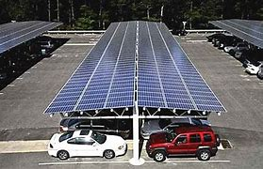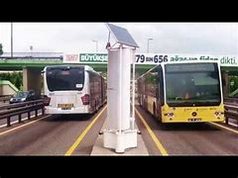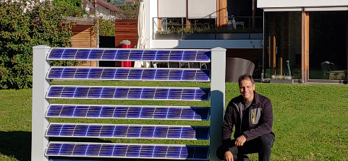
Car park road turbine Solar fence

A lot of current objections I have read are not against Solar power, they are against Solar power here in our area. In my research into the viability of solar, I was interested to find out that Solar farms need to be near the grid to be viable. As with any energy creator, it needs to be close to the grid to be able to feed in without massive loss. The Riverina is a prime place for Solar to be able to feed into the grid between Melbourne & Sydney, and until the government invests in the infrastructure to extend the grid out to the outback, I believe that the Jindera Solar farm is a vital link to build energy stability.

- The Jindera solar farm is still maintaining agricultural use. In all the negotiations between Jindera Solar farm and the farmer, the prime objective has been to continue with grazing.
The farmland in question is already primarily used for grazing, so nothing will change. A lot of people have said that it is on “Prime agricultural” land. This is true, in the fact that it is currently being used for grazing. The specific pocket of land the Jindera Solar farm is on is not good for cropping. It is too wet, and the crops come in too late, meaning that by the time it is ready to be harvested, all the local silos are full, meaning that the farmer has to freight it further, making it financially less appealing. As already stated, NOTHING WILL CHANGE. Grazing will still be done. The solar panels will give protection and shade, and the fence will provide protection from foxes. It is a mutually profitable solution, as with managed grazing, the Solar company will not need to use harsh chemicals to keep the grass down. The solar panels will also ensure that grass grows longer and stays green longer because of the moisture retention due to the solar panel water runoff and shading.

In the wider area around this projected solar farm are “hobby” farms. These are good agricultural lots that has been sliced up into small acreages so people can feel like they live in the country. This is agricultural land that is NEVER going to be used for agriculture again. In 30 years’, time the Solar farm can be pulled out of the ground and returned to complete agricultural use. The panels are not concreted in. This is a win-win situation for the farmer, as it provides a steady income from the lease, AND the benefit of still grazing the land.

- Job creation. This Project will bring hundreds of jobs into the area through all stages of production. The Solar company is very keen to use local contractors, meaning gainful employment of transporters, electricians, plumbers etc. At the end of the building stage, there will be at least 4 fulltime staff to run the project. This is an INCREASE in employment for the land area, as it is currently employing only the family that has owned it for the past 35 years.

- The Solar farm has also earmarked a substantial amount of money for the local Council to put towards projects in the area.

In summing up. I believe that this project will be an asset to the region. It will not only provide power, but it will also provide jobs, it will provide continued agricultural use, and most of all will return to FULL agricultural use at the end of its lease.

Thankyou,
Sonya Salzke

