I object to the Illawarra Coal’s Proposed Mine Extension for Dendrobium. Project SSD-8194.
I was born in Wollongong, not far from Cordeaux Dam. I have been a resident of Sydney for 35 years. I am appalled that this project impacts on my water supply, in that the ability of the Avon, Cordeaux and Nepean Reservoirs to collect water is reduced (especially in this age of climate change and period of drought). This is because Dendrobium’s longwall mining is causing subsidence of up to 3 metres in the protected “Special Areas” of the water catchment for Sydney, Macarthur and Illawarra. When the land subsides due to longwall mining underneath, cracks in the earth appear, and water that would normally be collected in the dams drains underground into these voids.
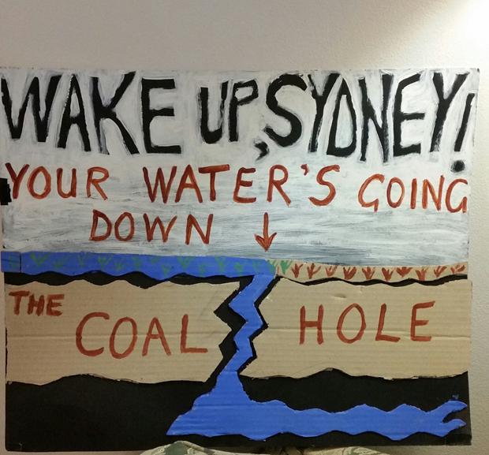
I am an ex-infants’ school teacher and a grandmother and I can tell you that the kids in my life have no trouble grasping the idea that the above scenario is a very bad idea. I just hope that the decision-makers in the Department of Planning, Industry and Environment have the same good sense.
I ask that you reject this application from Illawarra Coal and commence a process to close the mine at Dendrobium permanently.
With best regards,
Bronwyn Vost.

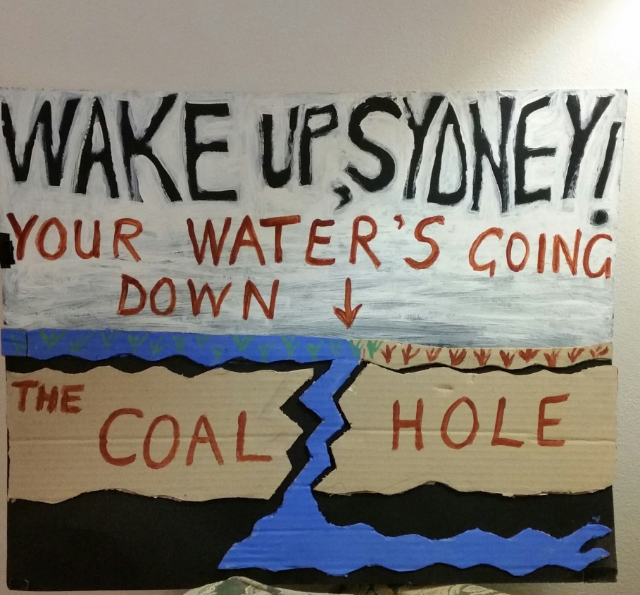
Subsidence caused by Dendrobium’s mining underneath the Sydney water supply causes cracking of the

