60 Clarence Road,
Indooroopilly, Qld 4068
14 October 2020
The Commissioner
Office of the Independent Planning Commission NSW
Level 3, 201 Elizabeth Street
SYDNEY NSW 2000
Dear Commissioner,
I wish to lodge an objection to Wollongong Coal Ltd’s Russell Vale Revised Underground Expansion Project (Major Project 09-0013)
Rather than object on the proponent’s history of regulatory non-compliance, perilous financial state and the projects lack of economic viability, I will focus on the health concerns that relate to the proposal.
My first concern is for the workers who are to work underground. In addition to the occupational risk of coal miner’s pneumoconiosis there exists an increased probability of collapse (associated with triple seam mining) thus exposing the mine workers to unacceptable risk.
My second concern relates to the residents of Russel Vale whose health and property values will be impacted. The increased mine activity, especially that to do with on-site coal processing and subsequent trucking, can be expected to reduce amenity and expose residents to increased particulate, noise, and perhaps also light pollution. Consequences of these will include an increase in stress related conditions, mental health issues and their organic sequelae. In addition, particulate pollution may be expected to lead to higher morbidity and mortality rates from respiratory and cardiovascular disease.
My third concern relates to reduced water availability to the Macarthur and Illawarra regions, the Wollondilly Shire and metropolitan Sydney consequent on likely ill effects on the Cataract Reservoir water catchment. With a changing climate and an increasing population water, an essential of life is becoming increasingly scarce.
My fourth concern relates to greenhouse gas emissions. Leaving aside the projects expected disproportionate contribution to the state’s greenhouse inventory through Scope 1 and 2 emissions the total greenhouse gas contribution once scope 3 emissions are also considered, will add unacceptably to the global greenhouse gas burden. The WHO and medical experts worldwide have declared that climate change already constitutes a global health emergency.
On health grounds alone the proposed mine extension should not proceed.
Yours sincerely,
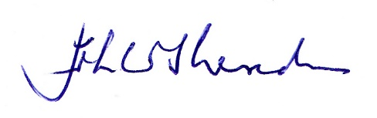
John W Sheridan.
PSM, BSc(Med), MB, BS, PhD, FAFPHM

