Submission to the Independent Planning Commission

Project: Brandy Hill Quarry Expansion SSD5859
My name is James Moore.
I am a multi-discipline engineer, in the fields of Marine, Mechanical, Process, and Project Engineering, and extensive experience in Occupational Health and Safety, Industrial Relations and Quality Assurance System Auditing.
I have worked in a number of diverse industries before being employed in the Extractive Industry (Coal Mining) in 1980. Over the ensuing 34 years my responsibilities include 20 years as process plant manager in which 8 years included logistics management, with responsibity for contracts for the transport of coal to the Port of Newcastle, initially by road, then by a mix of road and rail and finally (with others) rail alone.
During the expansion phases of the Bayswater No.2 Colliery, and then Bayswater No.3 Colliery, my responsibilities included in part the delivery of all material handling systems, the processing plant and rail infrastructure. In1998 I was seconded to the team to deliver the Mt Arthur Coal Mine.
In 2000 I joined the strategic planning team at Mt Arthur working firstly on the Underground Feasibility Study, and then forward growth opportunities, with full responsibility for all surface infrastructure, inclusive of non-mining roads, water, tailings and material handling and processing plants. To be successful in this activity it was imperative to co-operatively work with the Environmental and Community Relation department.
I moved to Brandy Hill in December 2013, in the full knowledge that Hanson was engaging in the process of seeking a new development consent for the Brandy Hill Quarry.
At the time I believed the application process required would be thorough, honest, open and transparent, and a workable outcome for community and Hanson could be achievable.
Following the public meeting held at the Raymond Terrace Bowling Club on 22nd March 2017, I approached the BH&SAG and offered assistance. Later in 2017 I became a community representative on the CCC, and in 2019 I was elected as the President of VOWW. The responsibility of these positions is not taken lightly and at times become onerous
You have heard from others of their journey since 2013, and of the real concerns that are held by the members of a community that extends well beyond the perimeter of Brandy Hill.
There are many who reside in the local area who firmly believe their lives will be adversely affected through intimidation and threats, loss the amenity and the social fabric, the loss of safe passageway, and of diminished road safety, if this proposed expansion of the Hanson Quarry, as it stands, becomes reality.
My assessment is the proposal will have a huge and detrimental impact on the surrounding communities.
The impact of potentially 600 trucks per day, six days per week operating from 5.00am to 10.00pm is inconceivable.
If approved it will also set a monumental precedent regarding the "appropriateness and scale" of quarrying operations in regional communities that are not on arterial routes.
It is my intention to address the following subjects
- Proposed ramp up time line using 1983 consent for plant machinery.
- Traffic impact from both the proposed volume, the noise, and dust.
- Site noise and dust emissions.

1: Proposed ramp up time line using 1983 consent for plant machinery.
I refer to a letter from Hanson to the DPIE on 11th May 2020, paragraph one.
It is far from accurate to say that the Brandy Hill and the Communities adjacent have been actively involved in determining the hours of operation. It is more accurate to say that Hanson has stuck to its initial starting point of 24/7, and the community overall was not supportive of increased operating hours.
To me the only current legal consent condition for the operation of the Brandy Hill Quarry is
P9/ 1/ 12/ 1920 issued 21 December 1983. Annual production was limited to 400,000 tonnes. Operating hours 6.00am to 6.00pm Monday to Fridays
I do acknowledge Hanson have been operating under a set of conditions that were granted without community engagement and the belief that annual production limit is 700,000 tonnes, and operation hours are 24/7, albeit only in more recent times has the 24/7 hours been publicly stated within community circles
I do know that even the 700,000 tpa capacity and the 6.00am to 6.00pm operating hours have been exceeded on occasions with impunity, even to this very day.
R.W.Corkery Consultants have made two recent submissions on behalf of Hanson regarding the Draft Conditions. Firstly, on 28th April, and then on 11th May.
The following is a quote from a letter on 11th May 2020 from R.W.Corkery. “Already in 2020, the normal operating hours to 10.00pm of the secondary and tertiary equipment have been required on 60 evenings. It is notable that Hanson has not received any complaints about these evening operations”.
This implies that this illegal action is OK if not detected.
I do know that attempts, by the BH&SAG, to get what should be public information is routinely block, under the pretence that it is commercial in confidence.
I have an expectation a condition of the future consent will give the community the right to have full disclosure of production, dispatch tonnages, and environmental issues and all related events that impact upon the community will be freely available. Such would go a long way is being open and transparent in their dealings with the community.
I respect the right for Hanson’s monetary transactions on procurement and customer sales to be confidential. However quantities loaded off site must not come under this
The 28th April letter on page 2 has a section Quarrying Operations, and in particular the processing plant, with the request for quarrying operations to be split into two separate activities,
- Load haul primary processing etc, and
- Secondary and tertiary processing etc.
Within the EIS documents there is no balance process flow sheet. Therefore, the following is derived from knowledge gained on a site visit.
The Primary Crushing plant has a capacity of 450tph, with the primary Jaques jaw crusher processing in the order of 75% of this. Product is fed to the secondary crusher (a the Jaques gyratory crusher) which in turns feeds a triple deck screening plant.
Discharge from the triple deck screening plant goes to both the Main Surge Stockpile, and the Barmac Surge pile from where it can be reclaimed for further processing through the Barmac and tertiary crushers.
There is no recycle back to the secondary crusher. This means that all feed to the secondary crusher must come through the primary dump hopper and crusher.
There is a statement on page 3 that the secondary and tertiary processing during the evening would not be accompanied by load and haul.
This then takes the secondary crusher out of the equation, unless the site confirms the Barmac crusher as a secondary crusher. Then a request for continuing to process for a specific product, from 6.00pm to 8.00pm is less onerous.
The request for secondary and tertiary processing must be limited to that which is drawn down from respective stockpiles by feeder and conveyor.
Processing Capacity
Page two of this letter records that the primary crusher has a capacity of 450tph.
The following annual plant capacity is derived from best practice, where available working days per year are determined as 294 for a six-day week. This is then applied to the processing plant at 450tph and determines total plant capacity under two different operating scenarios.

Determination of working days per year
 |  |  | Effective 6 day/week
 | Actual
Days per year | 365
Public Holidays | 10 |  | 7 | Assume 3 public holidays in annual shutdown
Single annual shut down | 14 |  | 14
Unavailable days | 24 |  | 21
Available days | 341 |  | 344
Weeks per year | 52 |  | 49
Operating Days /week | 7 |  | 6
Working Days per year Mon - Sat |  |  | 294
Possible Production Scenarios for Hanson Brandy Hill Quarry
Possible working scenarios
6am-6pm |  | 7.00am - 6.00pm
12 |  | 11
Existing Consent |  | Daytime hrs according to NSW Industrial Noise standard
6 days per week Operation
Working Days per year Mon - Sat
294 |  | 6 days per week Operation
 |  | Operating Hours/day |  |  | Maximum Hrs/yr
12hr/day 6.00am to 6.00pm |  | 12 |  |  | 3,528
11hr/day 7.00am to 6.00pm |  | 11 |  |  | 3,234
90% Mech/Elec availability
90% |  | 12 |  |  | 3,175
 |  | 11 |  |  | 2,911
Use 8% Process Maint Down time |  | Overall Utilisation |  |  | 82.8%
92% Process Up time
Utilisation
92% |  | 12 |  |  | 2,921
Overall Utilisation 82.8% |  | 11 |  |  | 2,678
Primary Sizing capacity |  | Annual capacity |  |  | Op Hrs/day |  | % Increase
450 tph |  | 1,314,533 tpa |  |  | 12 |  | 229%
450 |  |  |  |  |  |  | 88%
 |  | 1,204,988 tpa |  |  | 11 |  | 201%
 |  |  |  |  |  |  | 72%
NOTE: Consent Capacity tpa |  | 400,000
NOTE: Hanson Assumed Capacity tpa |  | 700,000

A ramp up of 229% from what is the consent condition given in 1983 by Port Stephens Council is extremely significant and shows the willingness of this community’s support. However, this achievement is not unconditional. All controls as required by the Consent Conditions must be in place and open and transparent dialog established and entrenched.
Firstly, the request in the correspondence of 28th April (Condition A11) to allow production to increase beyond 700,000tpa prior to the Bus Bays being brought up to full and compliant safety standards is unconscionable, and strongly objected to.
It reinforces an attitude of profits before community safety. If Hanson has the will, they can make it happen, albeit the community believes a cost of $120,000 is well short of that required to bring these up to compliant safety standards.
Also, we object to the reference to a pro-rata extraction limit be from a base of 1.5Mtpa. Until the all the bays are completed the extraction limit must remain at the current approved.
Still referring to the correspondence of 28th April
Conditions B1. The application of NSW Industrial Noise Policy (INP) EPA 2000 to daytime period is supported. We do not support the suggestion that a morning shoulder period should exist. In fact, we are strongly pushing for a condition that prohibits the operation of the primary crusher before 7.00am, until such time as the primary receival and crushing facility is fully enclosed with noise and dust suppression systems in place.
Whilst Hanson state that they have “the key operational mitigations that include enclosure of all fixed processing equipment” there is no committed detailed schedule presented that links equipment to a time line.
Hanson has previously stated that they have enclosed conveyors. However, there is big difference to a process being enclosed to being simply covered.
A conveyor can have a cover over the belt for good operational reasons but the conveying systems is not enclosed. Consequently, dust and noise are emitted and carry back and spillages may occur.
Therefore “enclosure of all fixed processing equipment” require conveyors to be enclosed within a conveyor gantry as depicted in the attached photo.
We would request that community members of the CCC have the opportunity to be part of the review process for all plant “upgrades” and or “modifications”, as part of ensuring best practice standards are being met. | 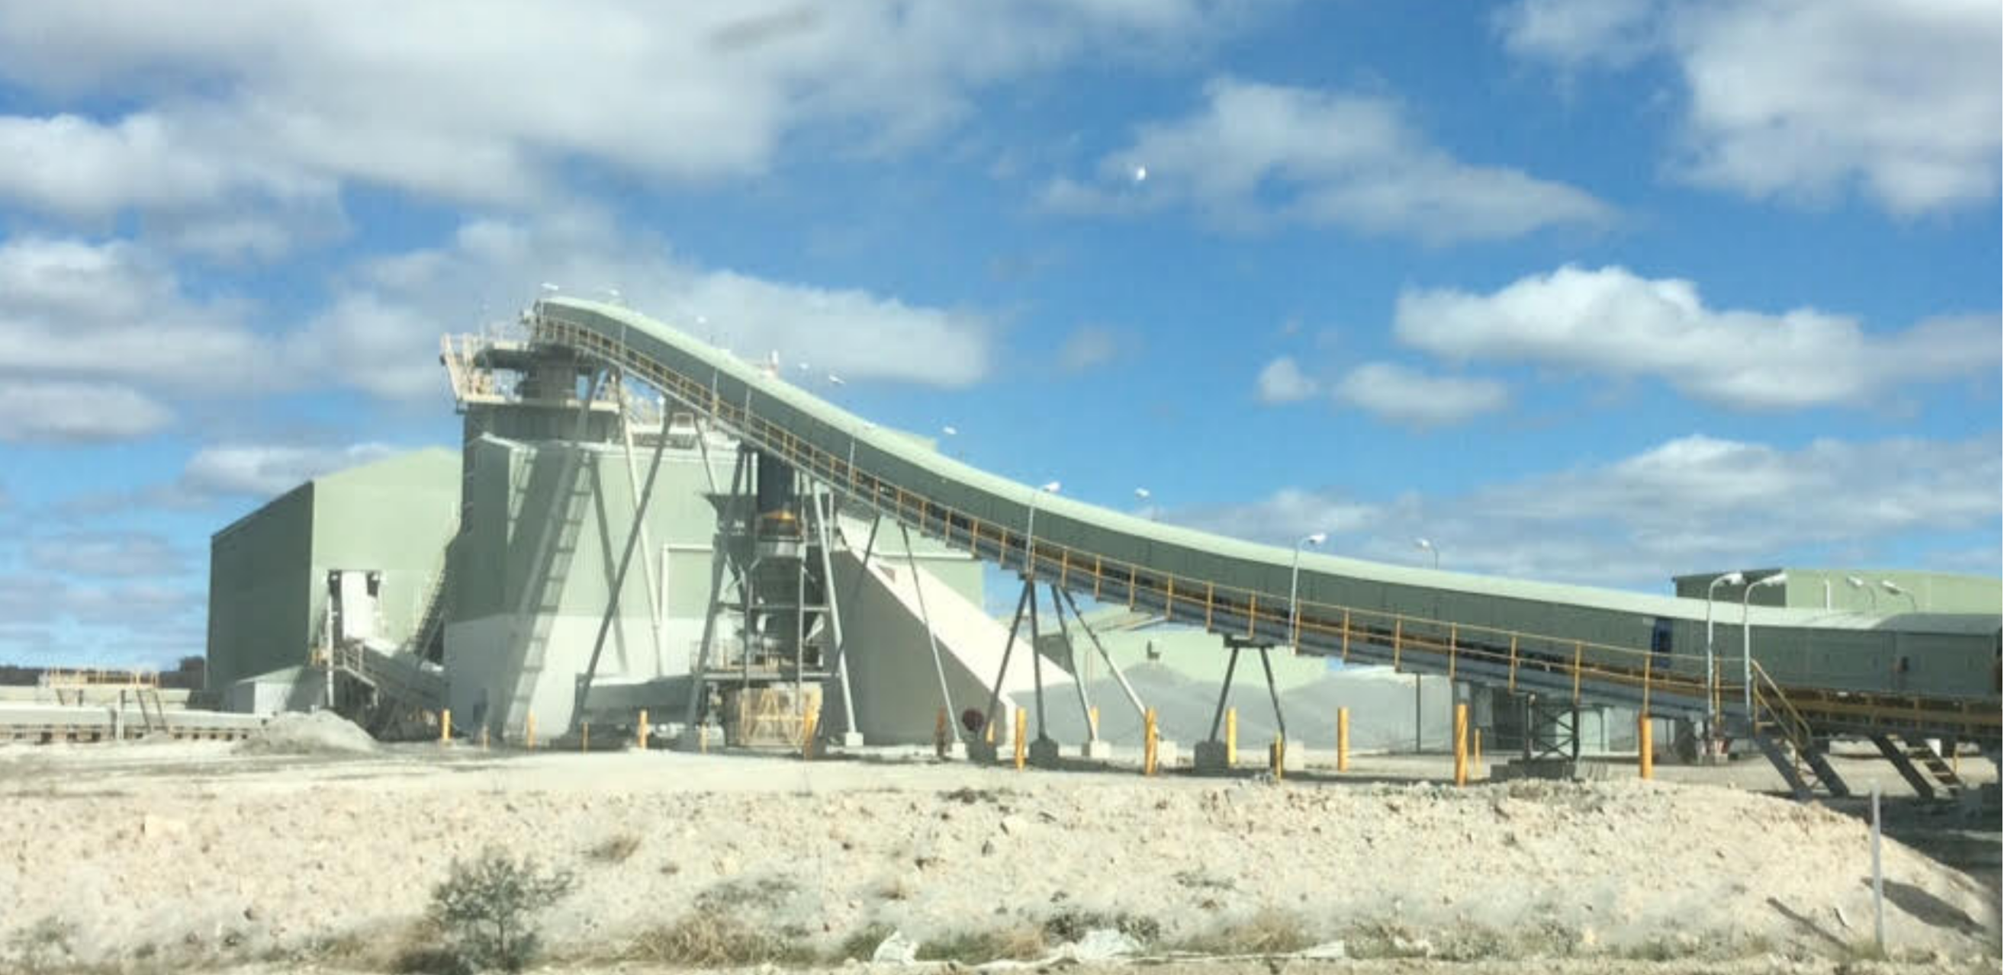
When the quarry operation moves into a steady state and operating at best practice, with the load haul and primary crusher operating from 6.00am to 6.00pm Mondays to Saturday it has the potential to produce some 1,314,533 tpa. Whilst some of this will be consumed on site for the making of other specified secondary products, the total export quantity from the site has the potential to be in excess of 1,400,000 tpa, or more. Factor in the receivables for secondary products, fuel, explosives and stores there is the potential for total mass movement to be at or above 1,500,000 tpa.
The preliminary consent conditions provide for quantities of inbound and out bound truck movements within prescribed time frames. We are asking that as a consent condition these truck movements are all inclusive of all vehicles excluding light vehicles that enter and depart the site.
The following table looks at the distribution of truck movements as a function of product dispatch only, with an average payload of 32tonne per vehicle. It clearly shows there is over 100% surplus capacity within the system, and brings into question why the community is being required to suffer the impost of product despatch outside the 6.00am to 6.00pm time frame.

Proposed Trucking Capacity
 |  |  |  |  | Operating
Operating time | Opp. Hrs/period | Proposed Movements/hr | Outbound Trucks | Inbound Trucks | Days per Week | Weeks per Year | Days per year | Truck Capaity Tonnes | Tonnes per period | Tonnes per Year for period
5.00am-6.00am | 1 | 18 | 9 | 9 | 5 | 49 | 245 | 32 | 288 | 70,560
6.00am - 7.00am | 1 | 24 | 12 | 12 | 6 | 49 | 294 | 32 | 384 | 112,896
7.00am - 6.00pm | 11 | 60 | 30 | 30 | 6 | 49 | 294 | 32 | 10560 | 3,104,640
6.00pm - 10.00pm | 4 | 60 | 30 | 30 | Variable |  | 20 | 32 | 3840 | 76,800
 | Total trucks in |  |  | 81 |  |  |  | Total Tonnage for One year |  | 3,364,896
 | Total trucks out |  | 81
Note: The huge excess of capacity within the 7.00am to 6.00pm time slot.
With reference to the letter from Hanson to the DPIE on 11th May 2020: Demand from Sydney
Hanson is not the only quarry that is supplying products to the Sydney market. The following image shows the location of the six operating quarries in the Lower Hunter that in part share that market. Then there is Boral who operate on the Central Coast, as does Hanson at Kulnura.

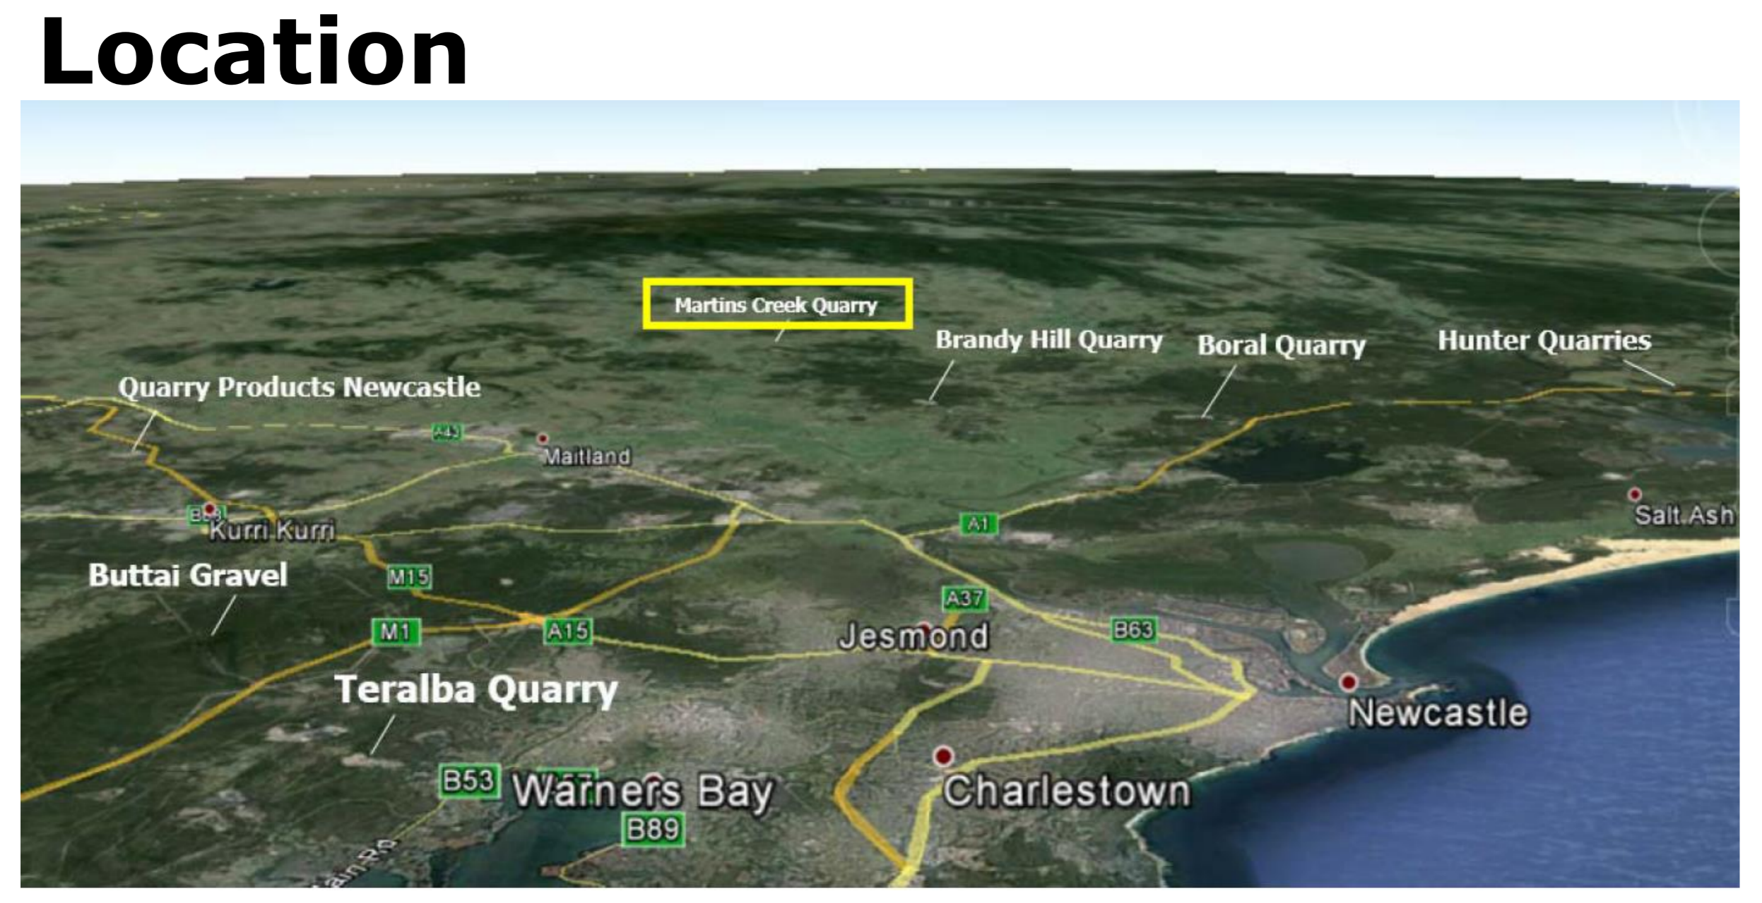

We are told that the Kulnura quarry will exhaust its reserves in the near future, hence the need for the early departure to get into the Sydney market. We ask why the Kulnura site, that is mid-way between the quarry and central Sydney, cannot be used as a transitional site, holding stock for the Sydney market, and thus negating the need for the 5.00am start and the twenty-day variable component.
Should not a condition of this development require Hanson to fully evaluate remote stock holding to mitigate the impact on the local community.
Furthermore, Product loading and despatch for Saturdays should not be moved forward. The argument is not valid and restocking if needed should be planned for and executed the previous day.

2 Traffic Impact, from proposed volume increase and resultant noise.
The sheer magnitude of the fourfold increase of material proposed to be transported to and from the quarry by road will present a significant loss of amenity and increased risk to the safety of all those who reside on
- Clarence Town Road west of the quarry, and connecting roads to Melbourne Street, East Maitland,
- Brandy Hill Drive, and local resident who must enter Brandy Hill Drive,
- Seaham Road, particularly though Nelson Plains.
There will also a significant increase in loadings upon the road infrastructure and the emissions of pollutants, notable particulates from exhaust emissions, brake linings, and tyre degradation and fine dust emissions from the vehicles themselves whether via wind flow through the covered loads or “mud” carried onto the road from all sources.
And yet there appears to be no attempt to measure this transport emission of dust and pollutants and its potential health impact on the residential adults and children on these non-arterial roads. Unless we are fearful of the outcome of such an assessment, every attempt should be made to establish the baseline prior to approval of project, and then further assessment during the early phase should production increases be approved. Consideration of this as a consent condition would be welcomed by the community.
Theses hazards can be reduced, and reduced significantly by a reduction in vehicle speed.
Further benefits from speed reduction is reduced noise emissions and reduced operating cost of the running surface, i.e. the road itself, due to a significant reduction in impact loading from the heavily laden vehicle.
It is fair to say that all the noise monitoring ends up presenting the outcome as an average over the respective period and graphically shows the peak events. The area of peak events can be very easily ignored, or include, depending upon the requirements of the customer.
One of the most intrusive noise from the heavy vehicle occurs when engine exhaust braking is used. This practice is in decline these days due to improved engine braking systems, and Hanson’s re-enforcement against the use of exhaust brakes.
A second intrusive noise occurs wnen there is a running surface join or a surface imperfection, such as a developing indentation or a hastily repaired pot hole. The amplification that arise from the empty body of the truck or trailer, and the hitching mechanism is the source that penetrates, disturbing sleep and amenity, yet is routinely ignored. This must change, and I acknowledge it is a multi-facet issue that involves more than Hanson, who I understand will provide funding for road maintenance through a tonnage levy.
There are those that argue against speed reduction as it increases travel time. A reduction of the speed limit on Brandy Hill Drive from 80km/hr to 60km/hr would see a time increase of 90seconds for the trip. Put that in perspective when hauling from the quarry to either the Pacific Highway or the New England Highway, let alone Sydney, and it fades into insignificance.
It remains my understanding that Hanson has imposed upon its own employed drivers a 60km/hr speed limit on Brandy Hill Drive, that from my perspective has had a positive effect on noise reduction, and whilst not visible, on previous mentioned emissions. To this end we want to see Hanson place this same constraint upon all heavy vehicle that enters or exists the quarry.
There are other observed safety hazards on Seaham Road in the vicinity of the “Bus Stop” at the intersection of Sophia Jane Drive and the Jacaranda Grove Pre School. I choose to mention them here, however recognise that resolution of these issues is beyond the scope of Hanson’s responsibilities.
Referring to the correspondence of 28th April 2020
Condition B39 and condition B 40. Whilst there is responsibity with the owner of the vehicle to ensure his tare weight is valid there is also a responsibly for Hanson to not allow overloaded vehicles exit the site. It is not onerous to have vehicles re-tared on a monthly basis and is good practice from a financial accounting practice.
With respect to arrival times it is possible to have recorded site entry monitoring, that will record truck arrival times. Also, it is a matter of industrial law that you must know, and manage, who is on your site, and managed through the Traffic Management Plan.
I commend Hanson on the Document “Drivers Code of Conduct”, Brandy Hill Quarry.
It is fair to say that it puts the subcontract drivers under the same conditions as Hanson drivers and offers no scope for excuses from subcontract drivers to not comply with Hanson’s standard operating conditions, particularly relative to behaviour when travelling to or from the quarry. (Item 1 General Requirements).
However, we would like consideration to the following and insertion into the “Drivers Code of Conduct” as conditions.
Section 4 Heavy Vehicle Compression Braking
Insert in second sentence …,” however when passing through or adjacent to residential area a reduction in the speed of the vehicle is recommended, and when travelling on Brandy Hill Drive a speed of 60 km/hr must not be exceeded.
Section 6 Load Covering
Third sentence change should to shall
Section 7 Vehicle Departure and Arrival
We note, and commend, the inclusion of the 2-minute interval for vehicles leaving the quarry, and acknowledge the difficulties of controlling differing arrivals. However, we would encourage mandating this arrival requirement where multiple trucks from the same supplier/contractor are involved. This would go some way to reducing the noise impact of these vehicles as they thunder up and down Brandy Hill Drive, and Clarence Town Road
Section 9 Primary Haul Routes
Insert within the last sentence what the load limit is individually on each of the three historical bridges. Make sure there is no misunderstanding of this limit, both for the drivers understanding and the public’s understanding.
As a side note why would Hanson not, in a supportive role to the community’s efforts, lobby the responsible authority to reapply the load limits signage that in the past was display at each approach to these bridges,
Section 11 Compliance Measures and Monitoring.
There is no doubt that a compliance (or rather a noncompliance) register is required for the orderly management of such issues.
I fail to see why an authorised member of the Community Consultant Committee (CCC) would not be included in the list to whom the register is made available. Should there be a concern about confidentiality then a precursor could be that the CCC member(s) are invited by Hanson join one of the other approved parties.
Getting credible noncompliance information on vehicle movements on the public road system has proved near impossible. Community members have experience extreme difficulty in identifying a specific vehicle due to lack of visible identification information on all faces of that vehicle. And it has not been without trying. And as a follow up when there was success, and Hanson took action against the offender there was abusive retaliatory action against BH&SAG members.
It is not the communities responsibility to be policing non-conformance by truck operators engage by them. Hanson have installed self-monitoring systems on their trucks, and have presented outcomes to the CCC. To this end then there is no reason that Hanson could not require each contractor to install self-monitoring system on their vehicle as a precursor to doing business with them, and then the issue of non-compliance in any part of the cycle becomes self-monitoring by Hanson, and presentable to required authorities and the CCC.
Yes, initially there will be push back, but insistence on Hanson’s part should prevail, and in time there will be acceptance that it is part of doing business, as it is in the long-haul interstate business.
(NOTE: For over twenty years now the mining industry has been using high precision GPS to record precise movement of vehicles and precise locating for loading and discharge and onboard weigh scales. The output from these systems has become invaluable to the industry.
I managed logistics for a number of years in the 1980’s, and whilst as not as sophisticated as today, a fleet of up to 125 trucks including many owner drivers had monitoring equipment installed as prerequisite to haul export coal.)
Section 11 Code of Conduct Induction
Dot point No12 is contradictory to previous requirements in Section 7, namely separation of departing vehicles should be retained at 2 minutes intervals.

3: Site Noise and Dust Emissions

Dust Emission – Mining and Product Despatch Operations
There are two sources of particulate emissions from the Project; those that come directly from the mining and processing operations and those previously dealt with that are generated by the offsite transportation.
The Air Quality Impact Assessment prepared by Tordoroski Air Sciences -August 2019, is commendable. At this time the report notes that there was no readily available site specific monitoring data. (Appendix 8: Air Quality Impact Assessment of the Amened Response to Submissions Report No. 968/02)
The reporting of the measurement of the particulates of interest within the dust emission from a source reverts to an average for a prescribed collection period, generally the Cumulative 24hr average.
Table 8.1 provides an oversite of “Operational dust mitigation and management measures”
The first item within the table 8.1 states:
“Activities to be assessed during adverse weather conditions and modified as required etc etc”
and item two states:
“Weather forecast to be checked prior to undertaking material handling, processing or blasting.”
Accessing and checking are inputs to decision making and not definitive control actions and consequently can result in no positive action at all.
There are times when wind speed and site circumstances present increased dust emissions that can and do present adverse impacts on vulnerable persons. It is when these circumstances arise that best practice mining operations halt their operations until the event passes. They do not take the risk of undermining their community’s confidence with the approach to take the EPA fine rather than shut down operations until the system passes. (Recorded when a complaint was lodged by local affected residents.)
To this end a condition for approval must include the establishment of a state-of-the-art metrological station that notifies the operator of arising adverse weather conditions and enables actions that will mitigate adverse emissions, even to that of shutting down the operations.
Table 8.1 provides an oversite of “Operational dust mitigation and management measures”
It is unclear which measures are currently implemented, and what are future works.
The item “Material Handling” is unclear. A definitive statement and timeline is required for the full enclosure of all fixed crushing and screening stations. And it is unacceptable that conveyor transfer points will not be fully enclosed until after stage 4
Dust control is an issue that should be very important due to health and safety concerns, EPA regulations and also to assist with productivity.
Dust emissions from haul roads and the roads throughout the product handling systems can be significantly reduce with the addition of surfactants and/or coagulants to the water trucks. Surfactants when added to a liquid, reduces its surface tension, thereby increasing its spreading and wetting properties whilst a coagulant will assist in binding the fine particles and so reduce propensity to become airborne. The offsets for the cost of these wetting agents are reduced water consumption and dust emissions, as well a significant improvement in haul road sustainability.
Given the proposal to haul overburden to the south of the site for the noise and visual bund I would strongly support a condition of consent be that Hanson fully investigate and trial such additives and report back to the regulatory authorities and the CCC.(See appendix A)

Noise Emission – Mining and Product Despatch Operations
Blast noise is the most significant source to date for the emission of mining noise from the quarry. It may always have the propensity to be so, albeit not always as a direct sound wave. Both weather conditions and the depth of mining has the potential to reflect the sound wave. With the installation of a state-of-the-art weather station it is possible to determine if a blast will have an adverse effect on the community, and be postponed until the system has moderated to predetermined conditions.
Ground vibration associated with blasting is at times thought by recipients to be direct noise. Hanson should not be dismissive of such complaints, but rather establish a register of all blast complaint for use in the community consultation process.
Referring to the correspondence of 28th April 2020
Condition A13 Construction activities
We do not support the further variations to conditions with respect to construction. As the construction for Stage 1 is primarily limited to the amenity barrier, and is an earth moving activity that is moved significantly closer to the community than the mining activities.
7.00am should be the earliest pre-start time. The use of earth moving equipment building a 20metre high earth bund is not considered an activity that is commensurate to normal plant maintenance as suggested.
Condition B4 Noise monitoring needs to be extended to road noise and be carried out at peak transport time so that the instantaneous impacts of both amplitude and frequency is measured at the “hot spots” Community should be engaged and involved in the process through the CCC
Condition B6 We are totally opposed to that which is suggested herein. The full due process must be followed to protect the integrity of all in the process.
Condition C3B It is impossible to support this request as noise and dust impacts far beyond the 1km range

Process plant dust emissions – Noise and dust emissions
Most of the time within the processing plant these two events go hand in hand and both are capable of being controlled and virtually eliminated by application of a single control. Containment.
Containment is more than a cover over a conveyor. Containment is all conveyors operating within a fully enclosed metal gantry and all processing equipment operating within a fully enclosed metal building as shown below. Gantry entry and exit points are sealed with a labyrinth generally of a stiff yet flexible rubber “gate”. Human entry doors are fitted with micro switches and timers that prevent plant operation if not closed within defined parameters. Dust that may collect within the building and gantry is washed into a solids collection sump. Hence both dust and noise are contained.
The only exception to this is the noise emitted at the primary dump hopper from impact of large burden with the hopper walls, when the hopper is at the low-level mark. This situation is controllable in normal operating situations by controlling the operating level of the hopper at the required level that protects the hopper walls. This is also recognised as best practice for longevity of Run of Mine (ROM) hoppers.
As for dust control at the ROM hopper the only proven method is a hooded and three-sided building with a rubber labyrinth and efficiently designed water curtain. Such a ROM hopper as shown below is now widely used in the coal industry and newer quarrying plants, and should be the standard for all new developments.

Dust control on stockpiles particularly fines
The manufactured sand stockpile has an extendable “sock” to minimise dust blowing from the falling material. The conditions of consent should be prescriptive on this issue to ensure best practice is applied.
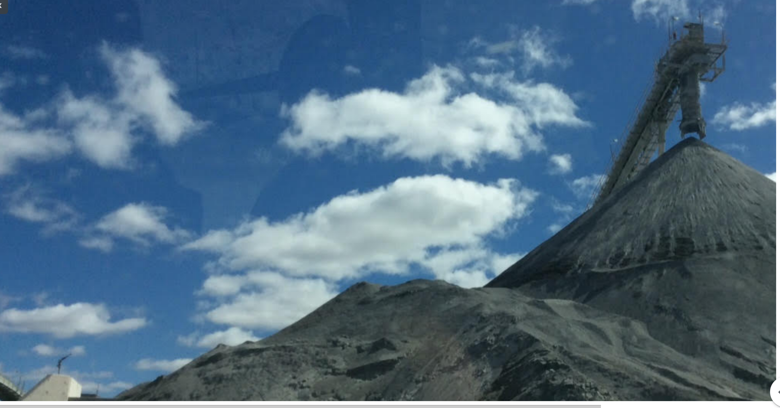

Appendix: A
Personal Belief
I would like to finish with an extract from a profound teacher Richard Rohr.
The subject is “The foundation of community”.
“We are living in absolute relatedness.
While we may not always recognise it, we are all in this together, in a web of mutual independence. A community.
A community inspired will be a community of people who treat each other as subjects not objects. We must know each one and other centre to centre, subject to subject, and never subject to object. This is why there should be no seeking of power over another, rather a sharing, a letting go and thus an infinity of trust and mutuality.
This has the power to change all relationships, even in business and community, a relationship between equal partners.”
Today with this subject it is a dream, and yet I do not believe to surrender, or to be disenfranchised, will make me happy, or make Hanson a herald member of this community. We are all in this together.

Appendix: B

What are common Dust Control problems?
RST has identified numerous Dust Control problems and problem areas within construction, civil, agriculture and mining that include, but aren’t limited to:
- Excessive Dust produced on unsealed roads from light and heavy traffic
- Reduced productivity due to excessive dust in various areas of Mine Sites
- High water usage from overwatering roads
- Health and Safety concerns for Employees and local town residents

Benefits of using our Dust Control Systems
- Reducing Dust Emissions
- Improved Grading Efficiencies
- Reduced Roll Resistance
- Protecting workers and nearby residents
- Reducing Road Maintenance
- Saving water (reducing usage by up to 40%)
- Saving costs for our clients
- Improving productivity

THIS PAGE LEFT BLANK

