Mr Peter Duncan AM
Chair of Independent Planning Commission Panel
Independent Planning Commission of NSW
Level 3, 201 Elizabeth Street
SYDNEY NSW 2000

Dear Mr Duncan,

Re: Brandy Hill Quarry Expansion Project (SSD 5899)

I refer to the above State Significant Development project currently being considered by the IPC and the assessment undertaken by the Department of Planning, Industry and Environment (DPIE), which refers to a Voluntary Planning Agreement (VPA) negotiated between Council and the applicant to mitigate the public safety impacts from the development.

During the VPA negotiations, the likely increased safety risk as a result of the development was discussed at length with DPIE officers. Even at the current quarry production rates and truck movements, the safety of pedestrians on Brandy Hill Drive has long been a concern of both the community and Council. It is has always been Council’s view that the increase in truck movements will increase pedestrian safety risk.

Nevertheless it was made clear to Council that DPIE did not believe that the pathway and bus bays the subject of the VPA negotiation were necessary to mitigate the safety impacts of the development, but was rather proposed to respond to community concerns. Because of this, DPIE maintained that a condition of consent could not be imposed requiring the applicant to construct the pathway and bus bays.

Given such a condition was unlikely, Council entered into VPA negotiations in good faith to get the best outcome for the community. The VPA offer acknowledges that the contribution sum will only build a partial length of the overall pathway, and therefore Council will need to source the remaining funding to complete the works. This was negotiated on the basis that the pathway was not inherent to the acceptability of the development.

However, following the VPA negotiation process and now that the DPIE assessment report has been published, it is reported that “pedestrian safety will be managed through the VPA” (see page 17 of the Assessment Report). As such, responsibility for managing the impacts of the development on pedestrian safety has been shifted from the conditions of consent to Council’s VPA negotiation; in particular the timing of construction of the pathway and bus bays under the VPA.

In Council’s opinion, if the pathway and bus bays are necessary to mitigate the safety impacts of the proposed development (in other words, if the impacts of the development are unacceptable but for the pathway and bus bays), then these items are not appropriate for inclusion in the VPA. This is supported by the draft Planning Agreement Practice Note, published by DPIE on 6 May 2020, which states “the approval of a development application should never be contingent on entering into a planning agreement.”

If the impact assessment in the DPIE report is correct, there is doubt that consent can be issued relying on the VPA to manage these safety impacts. If consent is reliant on the pathway and bus bays mitigating the impacts of the development, a condition of consent requiring these items to be constructed by the applicant should be imposed. The condition referring to the VPA offer should be deleted.

Conversely, if the DPIE assessment is incorrect, the IPC should acknowledge that the proposed development would not have a significant enough impact on safety to warrant such a condition, and that the VPA is seeking only to manage community amenity expectations, not safety impacts. In this instance, there would be less urgency to construct the infrastructure in line with quarry production rates and truck movements increasing. The delayed construction will allow Council time to seek other sources of funds or grants to complete the footpath.

The assertion from DPIE during the negotiation of the VPA that the proposed development would have negligible impacts on pedestrian safety has never been accepted by Council. Without the quarry, there is little to no impact on pedestrian safety as a result of the other vehicles using the rural road (for example trucks accessing poultry farms and the like). This is a common amount of traffic seen throughout the rural parts of our Local Government Area. Compare this to the impact of 600 heavy vehicles per day (in accordance with the draft conditions) and the impact is far more substantial as a direct result of the quarry.

To summarise, Council only entered into VPA negotiations on the understanding that DPIE were reluctant to consider conditioning the consent for a pathway or bus bays. However, taking into account the significant impact on pedestrian safety, as identified in the DPIE assessment report, it is considered that there is sufficient nexus that the construction of the pathway and bus bays should be conditioned and required to be constructed by the applicant in a timely manner.

Yours sincerely,
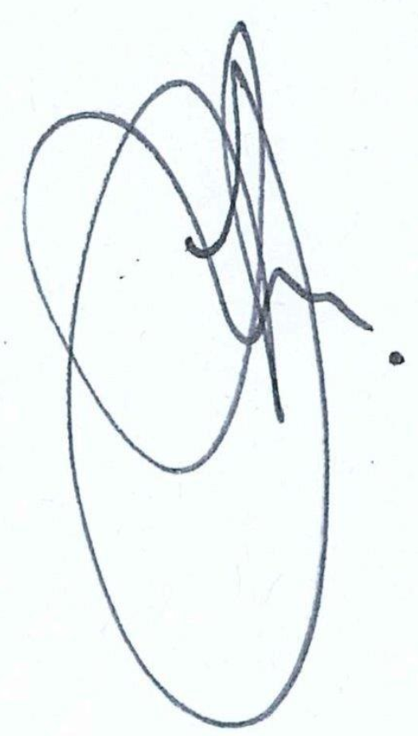

Steven Peart
Section Manager Strategy & Environment

15 June 2020
Telephone enquiries
(02) 4980 0255

Please quote file no: PSC2008-1496-736

