Thank you for this opportunity to address the Independent Planning Commission to object to the Vickery Extension Project.
I am an older Australian who has lived all my life in NSW, in rural communities as well as in Sydney. I am very aware of water and food security issues. I believe that, via these issues, the impacts of the Vickery project extend throughout NSW and indeed to the whole nation. I have 6 grandchildren and I include them in the list of those impacted. The four main areas of damage and loss which this project would give rise to - wildlife habitat loss, water loss, climate change, and loss of arable land - are all matters which should be subject to the principles of intergenerational equity.
I am disgusted that the DPIE should recommend approval of this project. In their Vickery Extension Project Assessment Report, they produce very little evidence to allay the fears of previous objectors to the project around these four areas of damage and loss. They make assertions without any evidence at all, as if assertion were enough to make something a fact.
A breathtaking example of this is to do with wildlife habitat loss. The Report states, on pp 10-11, “Surveys of the project disturbance area have identified isolated patches of native woodland that would support fauna habitat, with 11 threatened fauna species recorded in the project disturbance area [my emphasis], including 6 birds, 3 bats, the squirrel glider and Koala. None of these species are predicted to be significantly impacted”. No realistic assessment of a colony of threatened species could expect them to survive in a mine disturbance area. The DPIE apparently does expect this, however, as it “has recommended a range of conditions to manage the biodiversity impacts, including requiring Whitehaven to:
• implement its existing biodiversity strategy for the Approved Project, including required conservation bonds and security mechanisms;
• prepare and implement a Biodiversity Management Plan for the Project; and
• prepare and implement a Koala Plan of Management for the Project.”
This extract from the Report I find highly disturbing. It strongly implies that Whitehaven has so far not implemented their existing biodiversity strategy. It proves that they have no existing Biodiversity Management Plan or Koala Plan of Management for the Project, as DPIE is directing them to prepare and implement these. In other words, DPIE is recommending approval of a project with a known koala population with no Koala Plan of Management. I find it staggering, after the disastrous bushfires that we have recently experienced, in which a billion native animals were estimated to have perished, that our Department of Planning, Industry and Environment would not put the highest value on protecting every remaining colony of native wildlife, including that most iconic of Australian animals, the koala.

Against the evidence, DPIE also implies full confidence in Whitehaven’s integrity over water matters. The DPIE’s own water management division, NSW Natural Resources Access Regulator (NRAR) revealed as recently as September 2019 that they considered there to be sufficient evidence that Whitehaven had unlawfully harvested surface water to consider prosecution under the Water Management Regulation. The DPIE, however, chooses to forget Whitehaven’s reprehensible behaviour and mildly “notes that [during very dry periods] the Approved Project requires Whitehaven to adjust its operations to match its water supply. The Department recommends this condition is retained for the Project.” As well, the DPIE produces no evidence to allay fears in previous submissions over run-off of contaminated water, and simply asserts, “Whitehaven’s assessment confirms [my emphasis] that excess water can be managed on-site during extended wet periods without discharging mine water from the site”.
There are immense consequences to Whitehaven’s wastage of our precious water resources which will only be made worse by the Vickery Extension Project. They include such practices as Whitehaven pumping out of the Namoi River at the height of the drought in 2019. The Namoi is a tributary river to the Murray-Darling Basin. The DPIE recommends that the Project be given a licence to pump water out of the Namoi as well, water that should contribute to the mighty yet struggling Murray-Darling river system.

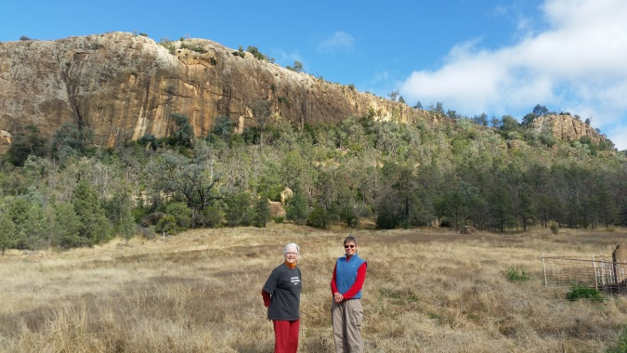
Gin’s Leap Gap, from where you look out over the fertile Namoi Valley, watered by the aquifer held by the natural underground dam.

Still on the subject of water, and extending into arable land loss, I urge the IPC to seriously consider Ken Crawford’s submissions to this Hearing regarding the Namoi Alluvial Aquifer. Drawing on his decades of experience as a hydrogeologist in the area, Mr Crawford describes how the natural constriction at Gins’s Leap Gap creates an underground dam & associated lake of precious groundwater in unconsolidated alluvial sediments, extending back to Gunnedah. Natural flooding is important to aquifer recharge & shouldn’t be interfered with by the rail spur line infrastructure. Building the rail spur as proposed would also compress the sediments in a dangerous manner & reduce aquifer capacity. The black soil, well-watered Liverpool Plains area has been classified as Biophysical Strategic Agricultural Land, and mining & mining infrastructure should be excluded from it. It should continue for thousands of years as the bread basket of the nation. 25 years of mining operations will ruin it forever.
As in the examples I give above on wildlife & water management, Mr Crawford shares my incredulity with the DPIE’s willingness to accept Whitehaven’s word that they will & can do the right thing.
“After all the representation and requests to Whitehaven Coal to provide design specifications for their built infrastructure, they have failed to do so”, he says. “Try putting your new house plans to council for approval without design specifications. Would anyone seriously expect development consent? Of course not!”

The principle of intergenerational equity is given one paragraph in the whole Report. On behalf of my grandchildren I am outraged. The global heating associated with any approvals of new fossil fuel projects cannot be countenanced. The Paris target of below 2 degrees of global heating has rapidly had to be scaled down to 1.5 degrees, which may still be too high. When we look around the planet at the damage wrought by the current 1 degree of heating - melting ice, rampant bushfires and dying coral reefs – we realise the reality of this. The more local effects of Whitehaven’s Vickery Extension Project are also extremely profound when viewed intergenerationally – that a mine in its 25-year life can ruin a region’s food –producing capacity for ever.

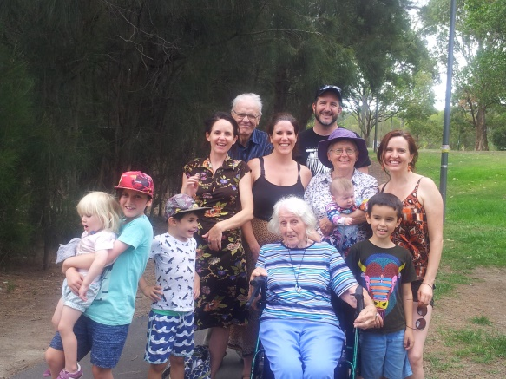
My granddaughter Neve on the day of her birth, 30th September 2014. On 23rd September, 2014, at the World Climate Summit, UN Secretary Ban Ki Moon had announced “Ladies and Gentlemen, Today we must set the world on a new course.” If Neve lives as long as her great-grandmother, she will still be alive in 2111.

DPIE has imposed a very long list of conditions for this project. Unfortunately, Whitehaven has a shocking record for constantly transgressing regulations for the existing Vickery Approved Project and its other mines in the district. Landholders and other citizen groups constantly have to hold Whitehaven to account for breaches. Narrabri Underground, a Whitehaven mine, had its exploration licence suspended in 2019. NSW EPA imposed a Clean Up order on Narrabri Mine for the dumping of hazardous waste at the Narrabri public landfill. NSW NRAR reported that mine rehabilitation at Rocglen & Tarrawonga mines was inadequate. In 2019, Whitehaven was fined $38,500 for blasting violations at Rocglen and $15,000 for dust pollution at Narrabri. Such convictions are simply the tip of the iceberg, and local groups find it exhausting to try to document breaches that are occurring on a very regular basis. I have personally heard complaints from farmers ever since I started visiting the district in 2014. There is no trust in Whitehaven’s intention to do the right thing.

The development conditions themselves often seem to be a pointless exercise in self-deception by the DPIE. On page 21 of the Development Consent conditions, there is set out a “(v) Groundwater Management Plan that includes:
• a program to monitor and evaluate: …….
the likelihood of any indirect impacts from the development on nearby alluvial aquifers”.
Again, NSW NRAR, DPIE’s own water agency, has already objected to Whitehaven’s plan to dump saline mine spoil on top of the alluvial Namoi aquifer. They are worried that water seepage will carry contaminants into the aquifer underneath. It is obvious to me that NSW NRAR has already identified the likelihood of impacts on nearby alluvial aquifers and all that the DPIE has suggested is more monitoring and evaluating, not prevention of damage.

I deeply disagree with the DPIE’s Final Assessment Report, concluding as it does that “the Project achieves a reasonable and appropriate balance between [coal mining and] “minimising the potential impacts on surrounding land users and the environment as far as is practicable.” Whitehaven Coal is not a benevolent neighbour or a good corporate citizen trying to do the right thing by its host community or state. It is a massive corporation trying to rip out as much profit for itself and its shareholders as it possibly can with no regard at all for surrounding land users & the environment. I draw this increasingly obvious conclusion with a feeling of great anger and sadness that the DPIE has not done the same.

I profoundly hope that the Independent Planning Commission will review the evidence with a different eye, and will conclude that the Vickery Extension Project should not be allowed to proceed.

