6 July 2020

Department of Planning and Environment

GPO Box 39

SYDNEY NSW 2001

Dear Sir/Madam,

Re: Landholder Submission in Response to the EIS for the
Proposed Vickery Col Mine Expansion Project DA No SSD 7480

We are landholders living and working immediately adjacent to the proposed mine and rail spur. We object in the strongest possible terms to the proposed project.

We purchased our property due to the great location to both Gunnedah and Boggabri. We have extensively improved the property since 2010 with long terms plans for our property. Upon purchase of the property we had no idea of the mine plans otherwise we would not have purchased the property.

Since finding out the plans for the Vickery Extension Project many improvements have been put on hold due to the unknown. We do not want to spend our time improving a property that is no longer what we want. There has been extensive pressure but on our mental health as our future is uncertain. The stress has been horrible and being told repeatedly that it won’t affect us just frustrates us immensely.

We have been told of Whitehaven offering to pay for double glassed windows and air-conditioners, that’s all good and well but if I wanted to live in a box I would move to the city!!

Along with our personal objections there is also the effect of a mine being so close the river. It is ridiculous to think that the mine will not impact the river and surrounding properties. Several Maules Creek properties are proof that your computer generated information is not correct.

Yours faithfully

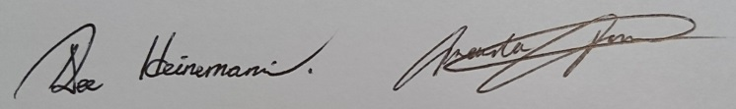

Dee and Amanda Heinemann

