MARCH 5 2020 - 9:00AM

Narrabri Shire Council passes rescinded motion not to support Whitehaven Coal's proposed Vickery Coal Mine Extension project

Billy Jupp

Latest News
Comments
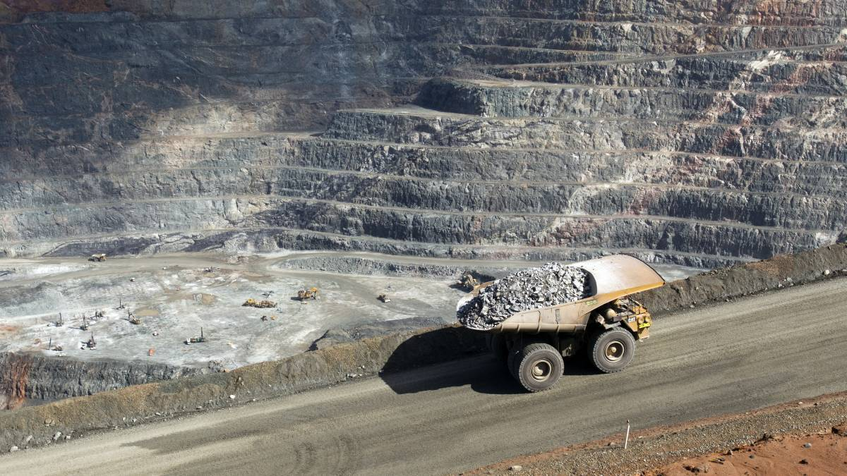
OBJECTION: Narrabri Shire Council will make a submission to the IPC after a rescinded motion not to support the project was passed. Photo: File photo
NARRABRI Shire Council has passed a rescinded motion not to support Whitehaven Coal's proposed Vickery Coal Mine Extension project on the grounds it is not in the public interest.
The motion, which will prompt the council to make a submission to the NSW Government and the Independent Planning Commission objecting to the project, was passed at the council's February meeting.
Councillor Maxine Booby put forward the motion, which was initially raised by councillor Ron Campey at the council's December meeting.
"[Executive planning and environment manager] Mr [Daniel] Boyce pointed out areas of concern to Whitehaven to address and those concerns relate to water, employment figures, population mobility and social-community infrastructure," Cr Booby said.
"Regardless of the outcome of the approval of the Vickery Mine Extension Project, Narrabri Shire Council, in particular the Boggabri community, need answers to these questions.
"It is council's duty to seek the best possible outcome in all areas from Whitehaven in a VPA."
Read More:
- Whitehaven forced to reduce Vickery by 11 million tonnes due to oversight
- Council pulls support for Vickery mine due to inflated job figures
- Council rejects Whitehaven's mining money and writes to govt
- Mining boss 'earns more in a year' than company's 25-year offer to town

The council has raised the issue of supporting the project at several of its past meetings, dating back to a community consultation meeting hosted by Whitehaven in December 2018.
The council's new resolution regarding the project is to not only make a formal submission, but to formally request Whitehaven respond to the council's concerns.
As well as to only review its position once it's satisfied the concerns have been addressed and to seek an independent mediator, not the state government, to try and achieve an outcome that is in the public interest.
At the meeting, deputy mayor Cameron Staines moved to make an amendment to the motion, which stated the council's submission outline its concerns with the project, but not object to it.
Support the local news that keeps you informed - subscribe today.
However, the amendment was not passed due to a lack of a seconder.
"All my amendment is, is excluding the first option - the rest is all for it," Cr Staines said.
"Last meeting, Cr Campey moved a motion from the floor to object to the Vickery Mine Extension Project proposal, which I do not believe is right as we have a process moving forward and I believe we have now shut the door on any VPA discussions.
"This was sprung on us and we were blindsided.
"This was a new notice of motion brought from the floor, which is illegal (sic) at Narrabri Shire Council not an amendment.
"The possibility of losing $3m of a VPA doesn't sit well with me.
"I know some of the Boggabri community said all or nothing, but I can assure you that the Bellata community would love $3m if they had a chance to improve their social fabric."
Have your say, send a letter to the editor.
Cr Campey defended the successful motion, saying it seemed "the logical way to go".
"You have to draw a line in the sand somewhere and I think the council's done that," Cr Campey said.
"Whitehaven don't seem to be able to negotiate with anybody at all.
"The $3m, as we have discussed many times, is really nothing and Cr Staines saying Bellata would love $3m, they probably would, but they wouldn't want a coal mine 10km away for $3m, I assure you of that."

