5 August 2020
To the Independent Planning Commission
Re: Narrabri Gas Project

My name is Arielle Gamble. I grew up on a property called “Teralba” adjacent to the Warrabah National Park, a 2 hour drive from the proposed site of the Narrabri gas project.

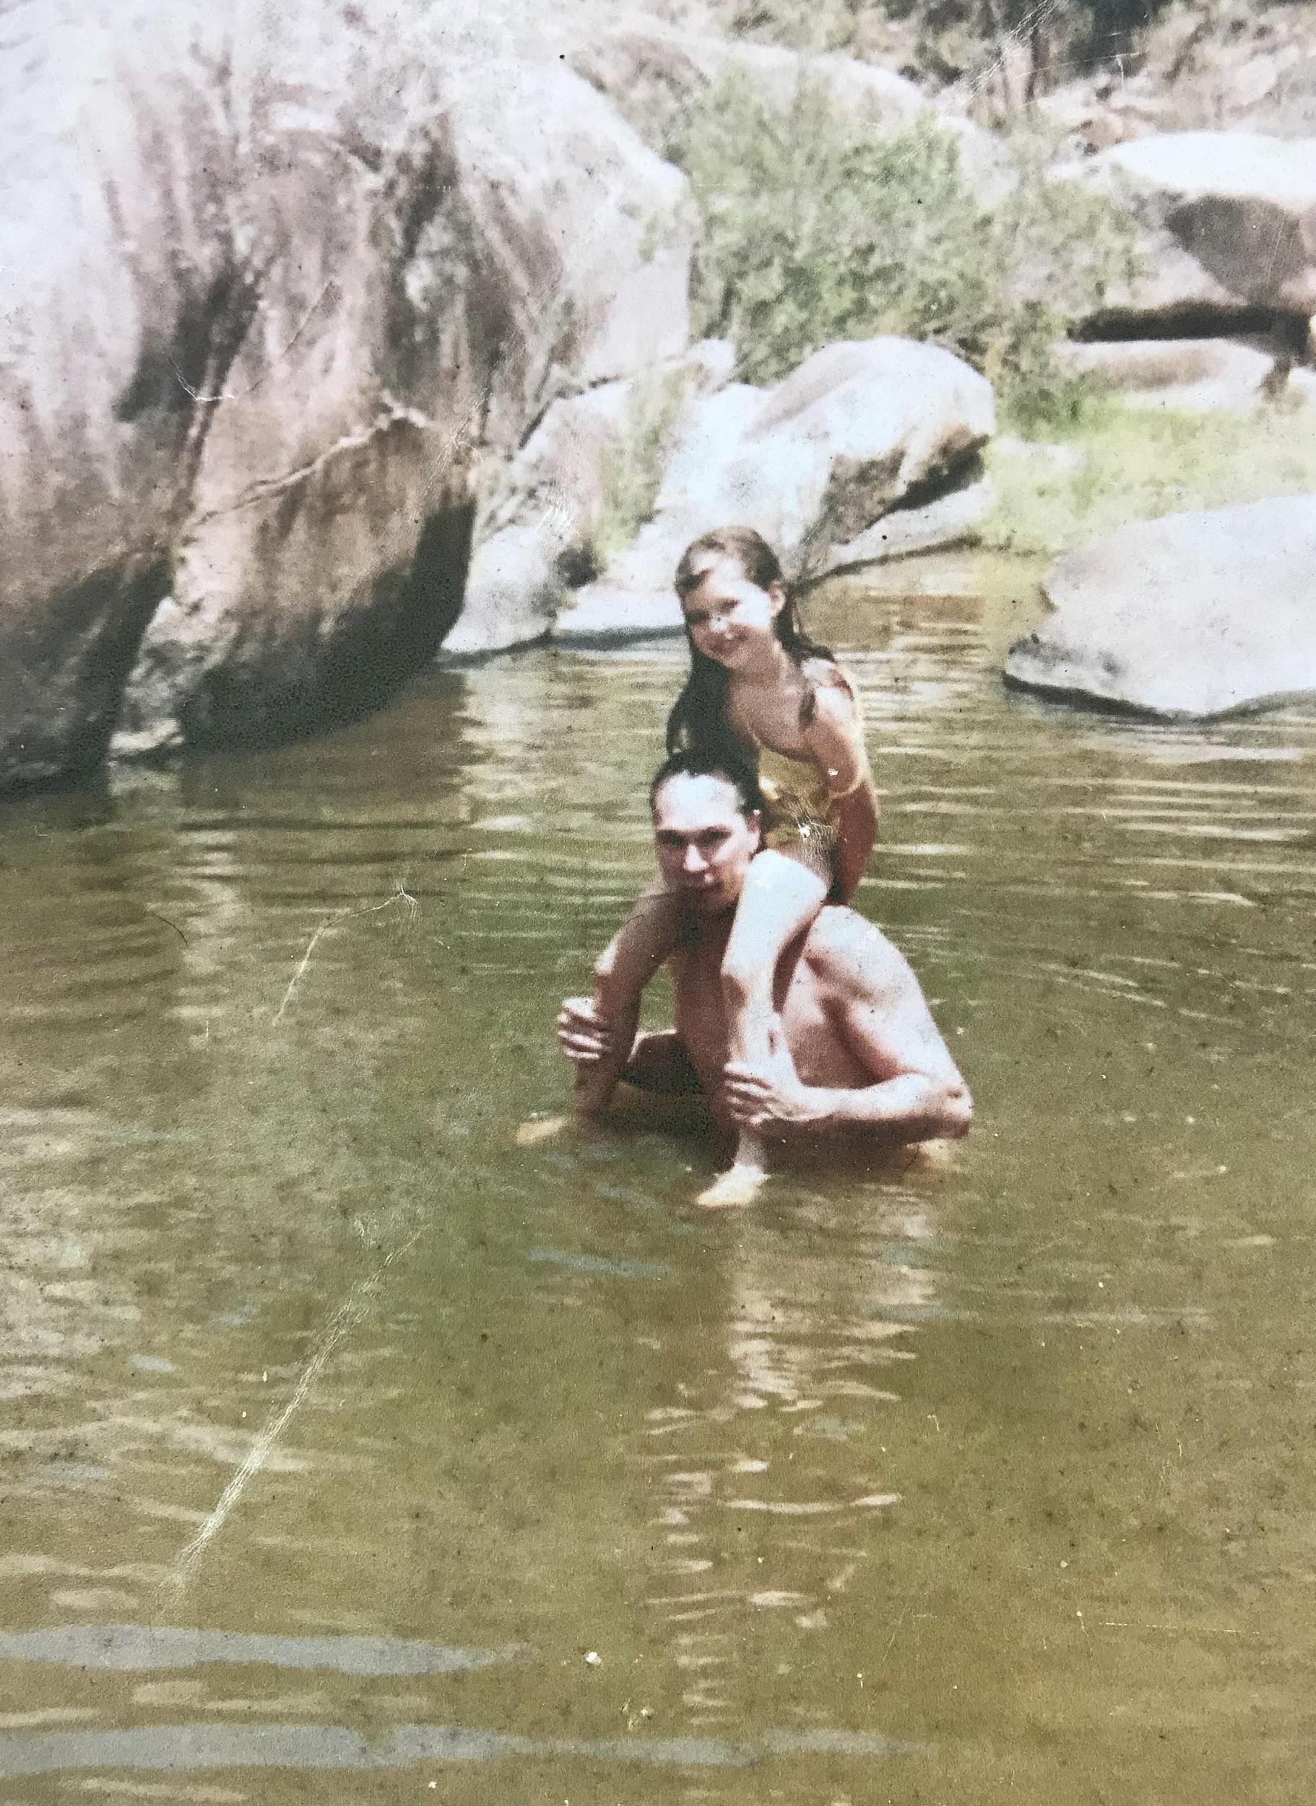
Below is a photo of me swimming in the Namoi River with my father Kim when I was a child. This area has been, and continues to remain, very special in my life. I now work for an environmental organisation called Groundswell.

My concerns about the Narrabri gas project are based not just on my family’s personal connection to the region, but also my understanding of the risk the Narrabri gas fields pose to climate, water and Aboriginal cultural heritage.

I have outlined my concerns for each area below:

Water
In a drought-impacted region like the Liverpool Plains it’s unthinkable that a project would be approved that puts our most precious resource – water – at risk. The Northwest has been in crippling drought for as long as I can remember – impacting farmers, communities, local economies and the mental health of the region. We cannot risk the water security of the Liverpool Plains – the economic, health and agricultural future of this area is dependent upon it.

Climate
Gas is a fossil fuel. Burning and producing gas drives climate change. A recent major scientific study demonstrated that gas is 86 times more polluting than coal in the short term.

Burning gas will only lock in further climate disruption and increase the severity and frequency of droughts, heatwaves and natural disasters, which will in turn claim more lives and livelihoods.

It makes no sense to be expanding fossil fuels at a time when renewable energy is the lowest cost form of electricity creation and offers massive long-term employment opportunities that gas cannot. New gas projects risk locking in huge investment and job losses, stranded assets and devastating environmental harm.

Aboriginal cultural heritage
The Pilliga is a hugely significant landscape for Gomeroi people with 90 known Aboriginal cultural heritage sites identified during its cultural heritage assessment by Santos.

We have a legal and moral responsibility to uphold the cultural heritage of this country, and to respect the wishes of the Traditional Owners who have cared for the land and waters sustainably since time immemorial.

Thank you for considering this objection to the Narrabri Gas Project.

Sincerely

Arielle Gamble

