Objection to the Narrabri Gas Project, Independent Planning Commission
I pay my respects to the Gomeroi people, whose sacred lands in the Pilliga the Santos project will desecrate if it’s allowed to proceed.
As an older Australian I have had time to develop many ties to rural communities in NSW. I am acutely aware of the crucial role that the Great Artesian Basin plays in many of these communities such that they would not exist without it. I am also acutely aware that if these communities ceased to exist as a result of the destruction of the GAB, Australia’s food security and its whole economy would be greatly damaged.
On the 23rd September, 2014, my attention was caught by UN Secretary Ban Ki Moon announcing, at the World Climate Summit, “Ladies and Gentlemen, Today we must set the world on a new course.” A week later, my first granddaughter Neve was born, and pretty soon after that I joined the Knitting Nannas whose determination it is to protect the land, air & water for the kiddies - in other words, to uphold the principle of intergenerational equity. I will continue to fight for this principle for the rest of my life.
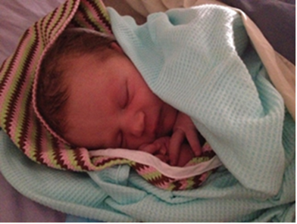
For many years now the Sydney Knitting Nannas have been appalled by the destructive potential of the Narrabri CSG Project, and have been talking to the public about it in Martin Place every Friday.
As an ex-Infants’ school teacher, I thought a good way to inform people would be through pictures. I drew a poster following closely the diagram in the 2017 GISERA Factsheet “Impacts of CSG depressurisation on GAB flux”. A top light blue arrow shows the normal flow of water through the Pilliga Sandstone, and a lower dark blue arrow shows the flow of water expected to be diverted downwards by CSG depressurisation. The lower arrow looks to me as if the water table would drop quite steeply out of reach of farmers’ bores.
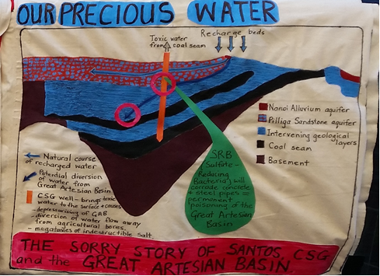
The associated text clearly states: “Due to the resulting pressure reduction in the coal seams over a period of many years, some water may flow from the GAB into deeper formations…
There are thick layers of rock formations between the GAB aquifer and coal seams that generally have low permeability. However, lowered pressures in the coal seams resulting from CSG development has the potential to lead to some flow of water from the GAB”. *
I wondered how I could find out about what would happen to the water table once that water dropped into the deeper formations, as my Factsheet had said unhelpfully “We don’t deal with drop in water table in our report … This information will be available through the Bioregional Assessment Program, which assesses cumulative water impacts from CSG and coal mines.” However, an examination of the Bioregional Assessment Program for the Namoi region reveals that, since there is not yet any commercial production of CSG in the region, it is deemed that no assessment can be made of cumulative water impacts from CSG & coal mines.
I continued to be intrigued by the apparent contradiction of water which flowed down through impermeable rock layers. My search led me to GISERA research project W 19 entitled “Assessment of faults as potential connectivity pathways” https://gisera.csiro.au/wp-content/uploads/2020/04/Water-19-Progress-Report-January-2020.pdf .
Its project summary began, “ In the Narrabri region, there are conflicting views on whether faults extend to the surface in the Surat Basin, and whether they …could potentially allow… connectivity between deep coal seam gas target formations, GAB formations and shallow aquifers or surface water systems.”. The project summary promised answers to my all questions, and concluded, “[T]he on-going community concern and uncertainties relating to the presence of faults suggest that it is an issue worthy of more research.”

I heartily concurred. Fault zones can be potential pathways for the migration of fluids or gas – a huge risk for contamination or wastage of pure GAB water. However, imagine my dismay when I realised that, far from being complete, this research has hardly begun, and its proposed completion date, 31/12/2020, seems unlikely to be achieved. This is only one piece of investigation that should have been done long before this truly awful project came anywhere near the approval process.
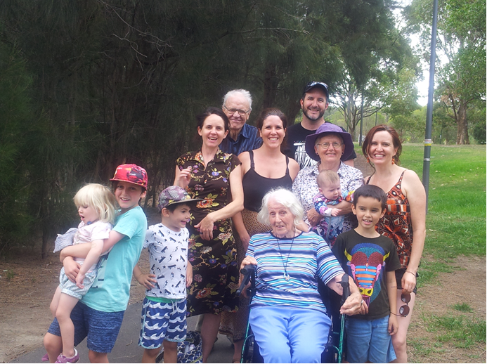

Commissioners, I profoundly hope that you will reject this Project outright. You will be helping to ensure that in 2111 when Neve is as old as her great-grandmother, there is still a Great Artesian Basin to feed her, her brother, their 4 cousins and all their peers. That would be true intergenerational equity.

*As part of my written submission I have attached a PDF of this Factsheet, GAB Flux2pp_WEB_171020_2 Gisera, since it is no longer online.

