Submission Narrabri Gas Project
I object to this project
I read a comparison of the 2015 Santos document Water quality Parameters for Produced Water and World Health Organisation drinking water standards: potassium is 6 times World Health Organisation recommendation; Strontium is 17 times higher; aluminum 5 times ; ammonia 80 times; arsenic 3 times; Chromium 4 times; phenol 6 times; and most concerning cadmium 100 times higher than WHO drinking water guidelines. There is also carcinogenic Total Petroleum Hydrocarbons present.
There does not appear to be any evidence that Santos tests of the reverse osmosis water from the Leewood for heavy metals is made public.
Excerpt from the meeting with Santos and IPC-
Produced water will be treated to a suitable standard for a variety of beneficial uses, including irrigation. Santos will treat the water we extract so approximately 80 per cent of it can be beneficially used for this purpose.
Santos used the Leewood water to irrigate a crop at Leewood in 2018. I viewed the crop in February 2018 and would describe it as crop failure. There was a lot of bare ground, and a weak pale crop of Lucerne.
The IPC must reject the Narrabri Project, any approval must mandate independent water testing is essential.

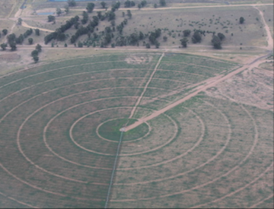
Photo Santos lucerne crop 2012

