References [3]
re
Submission to the IPC re the Narrabri Gas Project

[42]

https://reneweconomy.com.au/fluence-proposes-two-big-batteries-to-upgrade-victoria-nsw-transmission-line-65208/

RENEW ECONOMY
Giles Parkinson – 20200602

Fluence proposes two big batteries to upgrade Victoria-NSW transmission line

US battery storage technology company Fluence is proposing two big batteries – each of 250MW and 30 minute storage – could be installed as a faster and potentially cheaper solution to solve the transmission limits between the two biggest electricity markets in Australia, NSW and Victoria.
The proposal by Fluence – which built the 30MW/30MWh Ballarat Energy Storage System in Victoria, (pictured above) one of two big batteries that operate in the state – is revealed in a series of submissions made to the Australian Energy Market Operator as it canvasses options to increase the capacity of transfers between NSW and Victoria.

Fluence – a joint venture between Siemens and AES – is proposing two 250MW/125MWh battery-based energy storage systems (one in Wagga Wagga and the other in Morang) that it says will help AEMO and TransGrid address transmission network congestion issues.

It argues that the two batteries – which could operate in unison, with one charging at one end while the other discharges at the other end, and so increase the transmission flows – could be up in running within 18 months, far quicker than any traditional “network option” which would likely only be completed in 2027/28. And it can be scaled.
“Operating BESS units at Wagga Wagga and South Morang in tandem to create a virtual transmission line (one system discharging, the other charging) can help both import and export capability between New South Wales and Victoria,” it says.
“This additional support on either end of the transmission interconnector will enable more efficient use of the existing lines, alleviating current and future limitations.”
The batteries as proposed would be significantly larger than the large-scale batteries currently deployed in Australia, including Neoen’s Hornsdale Power Reserve in SA – aka the Tesla big battery – which is being expanded to 150MW/194MWh from its current world-leading capacity of 100MW/129MWh.

Neoen, however, is proposing an even bigger alternative for the Victoria transmission link issues, submitting a proposal for a 600MW “Victoria big battery (with an as yet unspecified storage time) to be installed near Geelong as part of a separate process launched by the Victoria government to by-pass the sometime convoluted and drawn out regulatory investment test process that the market operator must normally follow.

Fluence makes reference to this proposal – although not specifically the Neoen submission – suggesting that the two differing proposals and programs could be compatable.
If Neoen’s Victoria big battery, or a similar addition, went ahead on the Victoria side of the transmission line, for instance, then Fluence’s proposal could apply only to Wagga Wagga on the NSW side, before more such “pairs” could be considered in other upgrades or new links, such as the new VNI West line favoured by AEMO.
Fluence says its proposal for a “virtual transmission line” solution will add much needed capacity to the Victoria-NSW interconnector, “widening the highway” to facilitate more large-scale electricity transfers between NSW and Victoria.
It also sees it as a blue-print for the future, with battery storage now touted as a more efficient and scaleable way to expand and augment existing transmission lines as networks assess needs moving forward. The regulator has already supported this idea after approving a traditional network upgrade to the main link between NSW and Queensland.
“The speed of installing and commissioning BESS assets is a significant advantage to planning, building and commissioning network assets,” it says.
“Fluence believes that BESS of these scale and sizes could be installed and commissioned within in a 14-18 month timeframe – likely faster than network assets and requiring far less effort in securing easements and rights-of-way – which can bring significant benefits for the overall network. No other traditional transmission option can be implemented in such a short timeframe to provide additional dispatchable capacity.”
Fluence says its proposal also offers both scale and flexibility, as well as speed.
“Our proposal for two 250MW BESS of 30-minute duration can be deployed, and in 2023, 2025 and 2027 expansions can be evaluated that may eventually provide the same (traditional transmission) capacity increases illustrated in the options below,” it says.
“If the network flows change significantly by 2023, it may be that none of the options below would be adequate and a larger investment would be needed, and BESS deployment offers that flexibility.
“Alternatively, the BESS investment today enables AEMO and TransGrid to then evaluate a more “right-sized” upgrade of the transmission line, while receiving the benefits of the already installed BESS until and after the upgrade of the transmission line is completed.”
[43]

https://onestepoffthegrid.com.au/how-your-household-battery-can-keep-the-grid-stable-and-prices-down/

ONE STEP OFF THE GRID
Sophie Vorrath – 20200402

How your household battery can keep the grid stable and prices down

New data has shown that households solar batteries can be used to help run the national electricity grid, including to provide critical system security services and to respond to price signals to help push down costs for all consumers.
The data, supplied by Tesla, has been analysed in a knowledge sharing report published by the Australian Energy Market Operator, the first fruit from AEMO’s virtual power plant demonstrations – in this case a South Australia trial with Energy Locals, in a consortium with Tesla.
The Tesla Energy Locals VPP, which ultimately aims to include up to 50,000 households, is currently at phase two of its roll-out, with 1100 installed home energy systems comprising solar PV and a Tesla Powerwall battery.
As Energy Locals explains here, phase two is also about testing the systems operating together and their ability to generate enough to cheaply power an 320 Housing SA households whose properties are not suitable for the installation of a home energy system.

For AEMO – whose draft Integrated System Plan assumes significant uptake and participation of VPPs in the National Electricity Market between now and 2040 – the South Australia data offers its first real glimpse at how the coordination of distributed energy resources might work on the National Energy Market.
And as the AEMO report notes, the verdict is resoundingly positive. On one hand, it demonstrates that VPPs can benefit participating consumers by sharing the value earned through participating in FCAS or responding to energy market prices.
On there other, it shows that VPPs can benefit all other consumers by creating more competition to reduce prices and even potentially defer or displace the need for large-scale generation assets.
AEMO comes to these conclusions based on the data collected around five separate examples of the VPPs response to different events on the grid.
They include the October 2019 unexpected failure of the largest generating unit at the Kogan Creek power station, taking out 748MW of capacity and power system frequency down to 49.61 Hz, which is below the normal operating range.
On that occasion, the SA VPP detected this frequency excursion and responded immediately to inject power into the system and aid frequency recovery, as illustrated in Figure 1 below.
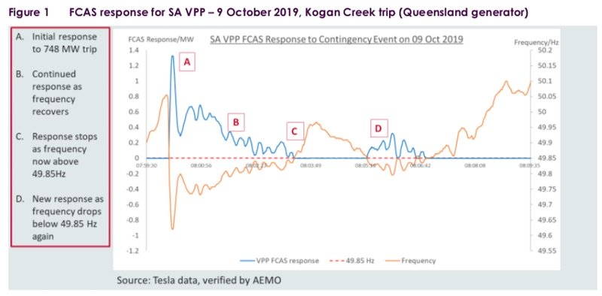

Another example documented is the response to the November 16, 2019, Victoria and South Australia regional separation event, which left South Australian islanded from the rest of the NEM power system for nearly five hours.
In this case, the data shows that while the VPP responded to the initial, it under-delivered on the 1MW of FCAS it was expected to deliver.
As Energy Locals and Tesla explain in the report, this was because fewer systems than expected had the appropriate frequency support settings enabled, resulting on only 83% of the expected response, or 828 kilowatts (kW) rather than 1 MW bid.
But as Tesla and Energy Locals go on to explain, another benefit of VPPs is that “once identified, this issue was fixed immediately by remotely reconfiguring the non-compliant systems.
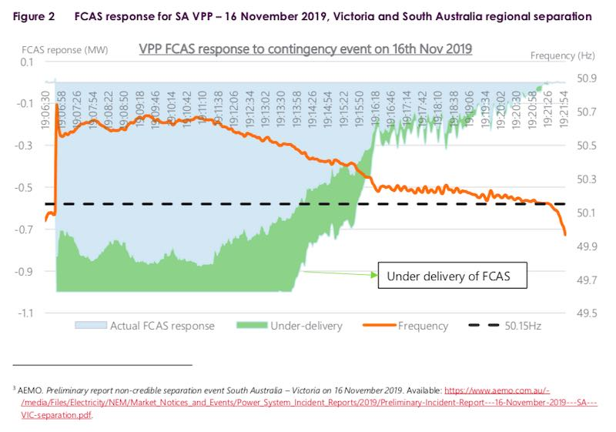

“Since this event, Tesla informs AEMO that it has introduced daily checks on all systems to ensure they are responding according to the expected configuration requirements. It is expected that this approach will mitigate the risk of any future under-delivery.”
A third example looks at the VPPs response to a December 10 2019 event, where the NEM experienced both high (>50.15Hz) and then low (<49.85Hz) frequency events within 45 minutes of each other.
In this case, the report shows that the SA VPP responded immediately – first to charge the batteries to lower system frequency, and then to discharge the batteries to raise system frequency, shown in Figure 3 below.
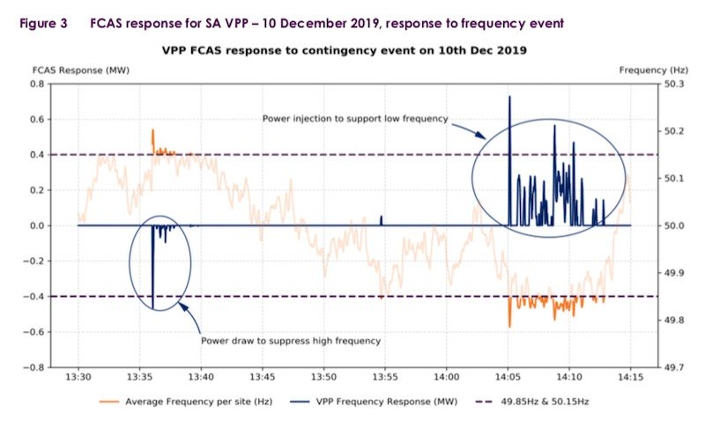

Of course, there is a fair bit of work to do, yet. As AEMO notes, these are early lessons learnt from just one of the planned VPP Demonstration trials, and used to inform next steps.
Among those next steps will be consideration of a number of regulatory arrangements for amendment, particularly around potential changes to frequency control ancillary services (FCAS) control on the NEM.
In its own feedback on the trial so far, Tesla said the South Australia VPP had provided significant opportunities to demonstrate the capability and revenue earning opportunities for aggregated distributed energy resources on the NEM.
“Specifically, the capability of aggregated assets to rapidly respond to frequency deviations and provide critical system security services,” Tesla said.
“This has also meant VPPs are able to access revenues from markets that aggregated assets, particularly smaller aggregated assets, have traditionally been excluded from.”
[44]

https://onestepoffthegrid.com.au/ausgrid-launches-phase-two-of-nsw-vpp-trial-casts-net-to-thousands-of-participants/

ONE STEP OFF THE GRID
Sophie Vorrath – 20200528

Ausgrid seeks thousands of homes to take part in expanded virtual power plant
New South Wales electricity network company Ausgrid has launched the second phase of its household battery-based virtual power plant, bringing two new project partners on board – ShineHub and Evergen.
The new phase of the VPP scheme follows up on the success of an initial trial which ran for four months in 2019 and established a VPP of 1MW in capacity from 270 customers across 170 suburbs in Sydney, the Central Coast and the Hunter region.

The aim of the Ausgrid program – one of several VPPs being trialled around the country – is to establish whether specialised aggregators of behind-the-meter energy storage can provide a commercially and technically viable demand management service to the grid, while also offering customers an additional income from their home batteries.
The results of the first phase of the trial, which was conducted with Reposit Power acting as the aggregator, were pronounced “very encouraging” in a report published by Ausgrid in November last year.

The more than 200 Reposit customers involved in the trial provided a combined solar storage capacity of 2.4MWh and, more importantly, an aggregated dispatch power capacity of 1MW.
That sort of dispatchable capacity is expected to be particularly useful to networks in the evening peak, when rooftop solar systems stop generating at that same time as household demand kicks in.
Customers were happy with the result of the trial too, with Ausgrid estimating that participating households earned up to $200 for the year for participating in the VPP, on top of already significant bill savings from generating and storing their own power.
“The results suggest that residential battery systems without VPP control … typically reduce grid electricity demand during evening peak periods, suggesting that the wider rollout of residential batteries will have a positive benefit on the network,” the Ausgrid report said.
“Results highlight the significant potential for the orchestration of residential batteries to support Ausgrid’s network needs, above and beyond typical ‘business as usual’ operation, suggesting that VPPs can offer both a cost-effective source of demand reductions for Ausgrid and additional income for customers.”
For the second part of the trial, Ausgrid has signed up two more “aggregators,” ShineHub and Evergen, and expects to sign hundreds – perhaps even thousands – more households up to the scheme.
“The VPP allows households to collect solar energy, store it safely locally and then feed it into the network when required during peak demand,” said Ausgrid chief customer officer, Rob Amphlett Lewis in comments last week.
“(It gives participating households) more control over how they use their energy. Not only will they personally reap the benefits of their solar and battery system, they can also support the wider energy network and earn money for doing it.”
On top of earning customers money, it also works to share excess clean power with those who need it, Amphlett Lewis added. “It’s going to help the environment and lower power bills.”
The money earned by households participating in VPPs could also serve to boost home battery uptake, by improving the return on investment for home storage, which remains a good deal behind solar panels in terms of ROI.
ShineHub – which has been active in the Australian market for years working to find solutions to issues of energy poverty and inequitable access to rooftop solar – says the Ausgrid VPP offers an exciting solution to community power saving.
“Power-saving technology is improving all the time and the VPP means when the network is screaming for more energy, hundreds of residential batteries start feeding power back into the grid,” said ShineHub co-founder and CEO Alex Georgiou.
Shinehub is also participating in major VPP trials in South Australia, of which there are now seven that have been established off the back of the state government’s highly successful home battery subsidy scheme, which has facilitated the uptake of more than 12,000 discounted home batteries in that state.

And in Victoria, the state government there just last month flagged plans to expand its own battery storage incentive, to pave the way for the establishment of virtual power plants.

In its latest notice to market, the government body in charge of the state’s generous rooftop PV and battery rebate, Solar Victoria, said it would begin encouraging the aggregation of batteries funded under the Solar Homes Program to broaden the reach of the benefits of battery storage.

As it stands, Victoria’s solar battery rebate currently offers a rebate of $4,838 on a range of CEC approved battery systems for households in more than 250 postcodes across the state.
[45]

https://onestepoffthegrid.com.au/solar-for-strata-lpe-teams-with-allume-to-offer-fair-access-to-solar-for-apartments/

ONE STEP OFF THE GRID
Sophie Vorrath – 20200528

Solar for strata: LPE teams with Allume to offer “fair access” to solar
The bid to extend the benefits of rooftop solar to Australia’s millions of apartment dwellers has gained new ground this week, with the announcement of a new partnership between electricity retailer LPE and solar sharing pioneer Allume Energy.
LPE, which specialises in selling electricity to “strata communities” – at this stage in Queensland and New South Wales – said on Thursday that it had joined forces with Allume, to provide its customers with a “shared solar solution.”
Allume has made a name for itself as the developer of the solar ceiling-smashing SolShare technology, which works within an apartment building’s existing metering infrastructure, or “behind the meter,” to allow solar to be distributed and billed to individual apartments.
The technology, first rolled out commercially at a mixed residential and retail building in the Melbourne Bayside suburb of Highett, was most recently showcased on an apartment block in the Melbourne suburb of Preston, where 70kW of solar and 54kWh of battery storage is being shared between 52 apartments.

The ASX-listed LPE, which pin-pointed “solar for strata” as a substantial addressable market in its April investor presentation, said it had partnered with Allume to service communities that had “struggled for years” to get access to fair solar solutions.
According to LPE, roughly 9 per cent of Australia’s population live in apartments or strata communities. These communities, it notes, tend to yield “highly loyal, sticky” retail electricity customers, with high switching costs.
“(Allume’s SolShare) is the most cost-effective option yet, and one that presents no risk to residents or body-corporates,” the company said in a statement.
“There is also a range of social benefits – such as giving access to solar and clean electricity to all apartment complexes including those in lower socioeconomic communities that otherwise couldn’t afford it”.
The idea would be for LPE to supply and maintain the Allume-engineering shared solar system at no capital cost to the body corporate or residents, offering “much less costly” electricity for residents than that sourced entirely from the grid.
Each system would be designed to generate enough solar to support a strata community’s daytime electricity needs, and distributed in real-time across all residents within the complex, thereby maximising on-site solar usage and savings for residents.
And LPE is confident that demand for the shared solar solution will be high, with more than 1.5 million residents of apartments within strata schemes located throughout Queensland and New South Wales able to access the solution.
“This is the first time strata apartment communities have had a decent solution that allows all residents to access a shared solar solution with one rooftop installation that gives them fair access to the savings generated from solar and allows them to become a sustainable community,” said LPE CEO Damien Glanville.
“LPE is looking forward to providing an accessible solution for all communities to become sustainable and reduce costs.”
[46]

https://onestepoffthegrid.com.au/tesla-community-batteries-extended-to-more-w-a-suburbs-in-shared-storage-trial/

ONE STEP OFF THE GRID
Sophie Vorrath – 20200211

Tesla “community batteries” extended to more W.A. suburbs in shared storage trial

Western Australia has kicked off phase two of a ground-breaking trial that uses grid-connected Tesla batteries to provide “virtual” energy storage for households in areas of high rooftop solar uptake.
The PowerBank 2 trial, a joint effort of state government-owned network operator Western Power and retailer Synergy, has installed 116kW/464kWh Tesla battery systems on the grid in both the north-eastern Perth suburb of Ellenbrook and in Falcon, a southern suburb of Mandurah.
Solar households that participate in the 24-month trial can choose to access either 6kWh or 8kWh of virtual storage, at a cost of $1.60 or $1.90 per day respectively, to store the excess power from their PV systems.
This allows those homes to draw electricity back from the PowerBank during the afternoon and evening peak – when their solar systems stop generating – without having stump up thousands of dollars for their own behind-the-meter battery storage system.
The new battery installs follow up on an initial trial in late 2018 in Meadow Springs – another suburb of Mandurah which, as we have reported on One Step before, is one of Australia’s top solar postcodes, thanks to a huge uptake among the city’s households and small businesses.

Western Power and Synergy said this week that the Meadow Springs community battery had proven a great success, saving residents a collective $11,000 off their power bills and prompting the installation of a second battery in the neighbouring suburb of Flacon in November last year.
A further third grid-connected Tesla battery has now extended the offer to residents of Ellenbrook, in Perth – and there will be more to come.
For Synergy and Western Power, the PowerBank trials have proven invaluable for their insight into the different ways battery storage technology can be used to benefit both consumers and the grid, particularly as more and more households switch to rooftop solar.
Not only does it allow access to solar storage for households that can’t afford to buy their own home battery – or have nowhere to install it – but it takes pressure off the grid during times of peak demand, by encouraging households to used their stored solar power.
“There is so much to learn about how to integrate battery storage technology into the sector, as we move away from the traditional centralised generation and network model, to a future that increasingly incorporates distributed energy resources, such as battery storage deployed at individual customer and community-scale levels,” said Synergy CEO Jason Waters.
“We know more of our customers want to know how they can benefit from battery storage technology in the future and want Synergy to partner with them directly to find solutions,” he said.
“There is a natural link to their requirements, as they are already effectively selling their excess
solar PV electricity output to Synergy through the Renewable Energy Buyback Scheme and buy electricity from the grid when their solar panels are no longer generating.
“We know those customers are seeking an alternative to store and use that excess energy, to help them manage their household energy consumption more efficiently.”
Western Power acting CEO Dave Fyfe said the investment in grid-connected community batteries was delivering benefits beyond just solar energy storage.
“Community batteries don’t only provide immediate, cost-effective solar storage options, they also have a collective benefit of smoothing out power supply to all customers in the area and opening up the capacity for more solar to be installed in the future,” Fyfe said.
“We are in the process of identifying several locations that will deliver almost immediate benefit from the installation of a community battery and we are working to roll out batteries to these areas by the middle of this year.”
The power companies note that there are no lock-in contracts for homes that opt to take part in the trial. Customers are billed monthly and are offered seasonal updates on any savings they are making, and handy tips on how they can improve their energy use.

[47]

https://onestepoffthegrid.com.au/w-a-community-virtual-power-plant-confirms-50m-swiss-investment/

ONE STEP OFF THE GRID
Joshua S. Hill - 20191122

W.A. community virtual power plant confirms $50m Swiss investment
Swiss investment firm SUSI Partners last week confirmed it would invest $A50 million into a residential solar-plus-battery storage project being developed by Perth-based Starling Energy Group, which it boasts will be the world’s largest Virtual Power Plant (VPP).
The investment was first announced back in July after the two companies reached an agreement to fund the project, but SUSI Partners announced confirmation of the $50 million last week. The asset manager is aiming to build Australia’s largest portfolio combining rooftop solar PV and battery storage systems.
“This new investment exemplifies our holistic approach in financing the energy transition,” explained Matteo Zanni, Director at SUSI Partners.
“By combining a community-focussed solution with the optionality of a VPP configuration, we place people at the center of the energy transition, while delivering fully contracted returns.”
The July announcement also revealed Starling Energy as SUSI Partners preferred global developer for VPP projects, installation manager, and VPP operator. In turn, SUSI Partners will be the sole financier to the projects.
“We’re really excited by what this agreement means. It will allow everyday West Australians to transform our energy system as fast as it takes to sign up online,” said Brian Innes, Starling Energy’s Managing Director, speaking in July.
“Our planet is at crisis point – we must act now. By ending our reliance on traditional fossil power that contributes drastically to climate change, we now have a viable cleaner option by harnessing the energy of the sun.”
“We worked closely with Starling Energy and our advisors to reach this milestone,” Matteo Zanni added in July.
“This architecture represents a new and exciting way of supporting the energy transition, enabling local communities to benefit from clean energy, while providing contracted revenues for our investors.”
The specific project to be funded by the confirmed $A50 million is Starling’s Plico Energy Virtual Power Plant system, which is designed to “[put] communities at the centre of the energy transition, with plans to expand the scheme to other parts of the country from mid-2020.”
The Plico Energy system will provide clean energy to W.A. households through a fully managed energy service, to be managed by Starling Energy, which will include home-installed solar panels and battery storage.
Participating residents will be provided with rooftop solar systems and battery storage – along with maintenance and management services – which will in turn link together to create a Virtual Power Plant with the objective of supporting the local grid.
According to Plico, the VPP would theoretically be able to provide 6.5MW of solar at peak, 7.2GWh of energy per year, and displace 7 kilotonnes of carbon emissions every year, allowing all community members to achieve 90% renewable energy consumption.
However, these figures are based on 1,000 systems being linked together – in practice, it is unclear whether there will be any variability to these figures. Each standard installation would include a 5 KVA Redback Inverter System, a 6.6kW Suntech 275-watt solar PV system, and a 7.2kW Pylontech battery.
[48]

https://onestepoffthegrid.com.au/arena-backed-rooftop-solar-power-station-switched-on-and-playing-both-sides-of-meter/

ONE STEP OFF THE GRID
Sophie Vorrath – 20200521

ARENA-backed rooftop solar “power station” switched on and playing both sides of meter

A 1.7MW “urban solar plant” built with ARENA backing to demonstrate the “tens of gigawatts” of potential for solar power generation on Australia’s industrial rooftops, has been completed and commissioned in Sydney’s west.
Epho Commercial Solar said on Thursday that the Bright Thinkers Power Station (BTPS) had been fully installed across 31,457 square metres of new warehouse rooftop owned by logistics giant DHL at Goodman’s Oakdale Industrial Estate in Horsley Park.
A key difference to this rooftop system, however, is that Epho’s BTPS technology gives it the ability to direct the solar energy generated either partially or fully to the consumer on site, or to trade directly on the National Electricity Market (NEM).
The “switching technology,” developed in partnership with Siemens works to segregate electricity through two separate channels. It does this dynamically using an algorithm based on solar PV output, electricity wholesale market and tenant demand.
Epho’s hopes to use the technology to unlock what it says is a “massive tens of gigawatt potential” solar energy generation resource currently sitting unused on industrial roofs – both for the occupants beneath the rootops and for the benefit of the greater grid.
The NSW-based company believes that installing these sort of urban power stations near metropolitan areas, where energy is needed, will play a big part in building a low-emission Australian economy.
The concept last year won interest and backing of the Australian Renewable Energy Agency, which allocated $497,000 in funding towards the design and construction of the Horsely Park demonstration plant.

At the time, ARENA CEO Darren Miller said a key potential advantage of the project would be to allow for more “smart” rooftop solar capacity to be installed on Australia’s increasingly congested grids.

Making distributed solar “smarter” and more compatible with the rest of the NEM is becoming an increasingly urgent task, including a push by the Australian Energy Market Operator – confirmed last month – for improved inverter standards for new rooftop solar PV systems, to help it gain more visibility over the increasingly hefty resource.
As RenewEconomy editor Giles Parkinson reported in April, AEMO warned that it was also seeking the ability to “curtail” rooftop solar output when needed, such were the current levels of penetration on parts of the NEM – including up to 64 per cent in South Australia.

While this push for more visibility and control over this behind-the-meter resource – via new inverter standards – has been well flagged by AEMO, it continues to be used as a flash-point in the mainstream media, when painted as a battle between average Australia suburban solar households and “the man.”

But as AEMO CEO Audrey Zibelman has explained, not having visibility or some degree of control over Australia’s millions of rooftop solar generators makes things increasingly difficult for the market operator – like having a bunch of small aeroplanes flying around in your air space but not communicating with air traffic controllers.
Solutions need to be implemented, and preferably these solutions will work for both the grid and the consumer.
With the DHL solar power station successfully commissioned in April, Epho says the BTPS has already successfully demonstrated two out of three of ARENA’s milestone funding requirements: to deliver the rooftop solar power to the building tenant under a power purchase agreement, and to distribute it via the separate connection into the wholesale market.
A third and final milestone is due in 12 months in order to review the performance of the technology over one year of operation and to complete the knowledge sharing with the wider energy and property community, the company says.
“It was absolutely wonderful to experience how a vague idea scribbled onto a whiteboard over two years ago turned into one of the most exciting new development in the distributed energy resources sector,” said Epho managing director Oliver Hartley in a statement on Thursday.
“Epho developed the BTPS concept to allow large roof-top solar systems to be connected both behind-the-meter as well as independent, market registered power stations.
“Epho’s innovation allows the entire roof area to be utilised and that the roof can be turned into a market participating urban power station,” he said.
Saul Resnick, the CEO of DHL Supply Chain Australia & New Zealand said the Epho system was primarily installed as part of a company-wide goal to achieve net-zero logistics-related emissions by 2050.
“This warehouse, purpose-built for the healthcare industry, has complex energy requirements and this system allows for flexibility. …Solutions like this one contribute to that goal and provide the best green outcomes for our customers and the community,” he said.
“Industrial solar can be rolled out quickly, grid connections can be completed in a reasonable timeframe and marginal loss factors are not an issue,” added Matt Scaddan, Epho’s head of business development.
“The question always was how we can unlock this potential and, potentially, Epho’s BTPS technology could be the key, because the technology facilitates a low-risk win/win/win situation between the customer, the landlord and the solar asset developer.”
[49]

https://reneweconomy.com.au/regional-nsw-town-to-host-large-scale-hydrogen-energy-storage-project-states-first-79334/

RENEW ECONOMY
Michael Mazengarb – 20200311

Regional NSW town to host large-scale hydrogen energy storage project – state’s first

Renewable hydrogen will be used for large-scale energy storage for the first time in New South Wales, after securing government support for the integration of Australian developed technology at a community solar farm.
With the support of a $3.5 million grant provided by the NSW government to the Manilla solar project under the Regional Community Energy Program, the project will be integrated with the UNSW developed H2Store energy storage system.
The H2Store technology has been developed by a team of researchers at the UNSW Sydney campus, led by Professor Kondo-Francois Aguey-Zinsou, and offers the production and storage of hydrogen that is scalable and portable.
“The H2Store technology is a compact and transportable hydrogen storage solution. It’s an effective way to store and generate renewable energy, mitigate the fluctuation of renewable generation and increase confidence in the security of supply,” Professor Aguey-Zinsou said.
The H2Store technology uses metal hydrides to store hydrogen gas, which allows for higher density and lower pressure storage of the renewable fuel, which can then be re-released as hydrogen gas when required.
It also allows hydrogen to be stored at smaller scale, and can achieve energy densities, the amount of energy stored per unit of space, that are greater than conventional lithium-ion batteries.
The hydrogen storage technology has previously attracted investment from Providence Asset Group, which had provided an initial investment of $3.5 million to explore the development of the hydrogen energy storage in a residential context.
“This state government grant is very welcome and a great endorsement for this project, and we thank them for seeing the enormous potential for regional economies, and the state’s energy requirements and demands into the future,” Providence Asset Group CEO Henry Sun said.
“The funding will greatly expand the potential of this project, assisting with the provision of cutting-edge ‘hydrogen’ technology to support the solar farm and its storage capacity.”
The hydrogen plant combined with a solar and battery storage facility will be the first of its kind in New South Wales, and according to NSW state energy minister Matt Kean, will help accelerate the state’s shift to cleaner energy sources.
“In a NSW first, a hydrogen energy storage system will be installed at Manilla alongside a solar-battery system to store renewable energy,” Kean said.
“Hydrogen has the potential to transform our economy and energy mix. World leading green hydrogen initiatives like the Manilla Community Solar project will play a critical role in developing this technology.”
“These innovative renewable energy projects will help to make electricity more reliable and affordable for our regional communities,” Kean added.
The community energy project will see 4.5MW of solar PV capacity combined with a 4.5MW/4.5MW battery storage system and will be located near the town of Manilla, around 45km north-west of Tamworth.
The project has been led by a group of community members and has attracted the support of over 100 local residents, as well as the Tamworth Regional Council and the local branch of the CWA>
The hydrogen energy storage system will provide an additional 2MW/17MWh of energy storage using renewable hydrogen and will be stored across several 20-foot shipping containers co-located at the Manilla solar farm.
“This initiative will also provide the community with the means to store solar energy and sell it on the electricity market during peak demand when the sun doesn’t shine,” Professor Aguey-Zinsou added.
“I am very excited to see the technology we developed in the lab here at UNSW scaled up and used in real-world applications. It will prove the feasibility of hydrogen storage at scale and position Australia to become a major player in transitioning to renewable energy.”
The Manilla solar project is one of seven solar projects that have been awarded funding under the NSW government’s $20 million Regional Community Energy Program and has been funded through the state’s Climate Change Fund.
Construction at the Manilla solar project is expected to commence in the second half of 2020, with the storage component to be installed at the project during 2021.
[50]

https://reneweconomy.com.au/mining-giants-bhp-anglo-and-fortescue-join-forces-for-green-hydrogen-48061/

RENEW ECONOMY
Sophie Vorrath – 20200318

Mining giants BHP, Anglo and Fortescue join forces for “green hydrogen”

Mining industry majors Anglo American, BHP, Fortescue and Hatch have joined forces to “de-risk and accelerate” the production of renewable hydrogen, as the resources sector works to decarbonise operations.
In a joint announcement on Wednesday, the companies said the new consortium’s main goal was to help to eliminate the obstacles to the adoption of green hydrogen technologies and encourage innovative applications.
“The goal is to identify opportunities to develop green hydrogen technologies for the resources sector and other heavy industries,” a statement said.
The consortium would also provide a mechanism for suppliers and operators to contribute to and engage with a range of development activities, including research, technology, supply chain development, and piloting green hydrogen technologies.
A fact sheet accompanying the announcement described green hydrogen as produced using electrolysis powered by renewable energy, as opposed to traditional carbon-intensive production methods used to split water molecules into hydrogen and oxygen.
But the fact sheet also noted that the member companies of the Green Hydrogen Consortium were “technology agnostic” and considering a range of options to progress decarbonisation of their operational greenhouse gas emissions.
“At this stage, green hydrogen is costly, technically challenging and can be hazardous,” the fact sheet says.
“As a Consortium, the group of heavy industry participants hope to reduce costs and increase technical capabilities through scale and shared learnings.
“Hydrogen’s many different applications make it an ideal technology to collaborate on and, through collaboration and innovation, the group hopes to accelerate cost reductions and technology readiness of green hydrogen and work through some of the current challenges to try to solve or eliminate them.”
The companies say some of the Consortium members are considering producing green hydrogen onsite, while others are more likely to source it from a provider.
The pursuit of green hydrogen is rapidly gaining momentum around the world and Australia, with a recent report from McKinsey foreshadowing the “decade of hydrogen” and predicting costs of production could halve over the next 10 years. “2020 marks the beginning of a new era for energy: as the potential for hydrogen to become part of our global energy system becomes a reality, we can expect fewer emissions and improved security and flexibility,” CEO of Air Liquide and Co-chair of the Hydrogen Council Benoît Potier said.

“A clean energy future with hydrogen is closer than we think, because the industry has been working hard on addressing key technology challenges. This report shows the path forward to scale-up to fully achieve hydrogen competitiveness and deliver the decarbonisation we urgently need.”
In Japan, the Fukushima Hydrogen Energy Research Field (FH2R) project was this month completed by Toshiba Energy Systems & Solutions Corporation, powered by a 20MW solar farm and some power from the grid.

It was the fourth green hydrogen project to be announced this year alone, following the January unveiling of a green hydrogen project in the port area of Ostend, Belgium, to be developed by Port of Oostende, offshore engineer DEME Concessions, and financier PMV.

In late February, the British government committed £7.5 million to fund the next phase of Gigastack, a new project which will use electricity generated from the world’s largest offshore wind farm to produce renewable hydrogen.

And locally, the Queensland region of Gladstone was announced as the host of a new green hydrogen production hub.

The new Australian Consortium would be based in W.A., and has been welcomed by the state government there.
“We welcome this industry collaboration to help decarbonise mining operations and cement WA’s place on the world stage as a green hydrogen innovator and producer,” said the minister for regional development Alannah MacTiernan.
“Green hydrogen provides a real opportunity to reduce diesel consumption and decarbonise mine site operations, with potential for fuel cells to power fixed and mobile plants, mining vehicles and feedstock,” she said.
BHP and Fortescue had already made heavy commitments to lift the amount of renewables in their energy mix. BHP has chosen to go 100 per cent renewables, and cancel long term coal-fired generation contracts, to power its two big copper projects in Chile, while Fortescue has turned to solar and battery storage to help power its major iron ore mines in the Pilbara.

