Nords Wharf Concept Plan – Modification 1 (MP 10_0088 MOD 1)
Following the public meeting I now provide my comments.
Generally I support and agree with the recommendations made by :
The delegate of the Minister for Planning, modifying the Concept Approval referred to in Schedule 1, specifically;
“1.2A MP 10_0088 MOD 1 approves an indicative subdivision layout for 96 lots. The proposed changes to intersection upgrades and removal of the contribution are not approved”
My concerns to various sections are;
1.14 In preparing the staging plan identified in condition 1.13 as it relates to the $5 million allocation, the proponent is to must:
a. consider revising the proposed footpath to the Nords Wharf school to provide access to Gathercole Park.

My Comment
In the above at a. the word “consider” is not firm or a definite requirement and foot paths is one of the very high priorities of the Nords Wharf community.
b. update the schedule to note that the upgrade of parking could be for the Branter Road and/or Cams Wharf Road boat ramp.
Note: The schedule of contributions outlined in the Statement of Commitments is subject to final approval by Lake Macquarie Council, and the initiatives, funding and staging may be altered.
My Comment
While I understand and agree that Lake Macquarie Council hold the funds I am concerned that too much control of how the funds are spent is implied in the recommendations. I would like to see more emphasis on mandatory consultation with the Nords Wharf community in the utilisation of the funds.
Traffic and transport
1.25 The detailed design for the upgrade of the Pacific Highway / Awabakal Drive intersection must be prepared in accordance with RMS’s requirements (outlined in the advice provided to the Department, Reference: 252DA144:1, dated 16 December 2010 and as amended by Condition 1.25A). In designing the upgrade the Proponent should consider opportunities to provide a pedestrian phase in consultation with council and the RMS
My Comment
I support this recommendation however again the use of the words “should consider” are inadequate and must be a definite requirement. In other areas of the recommendation the word “must” is used there by making it mandatory.

General comments
- Reinforced at the Public Meeting Nords Wharf residence support the keeping of the currently approved Awabakal Drive and Pacific Highway recommendations.

Minimising traffic flow through Nords Wharf is critical for community safety. As mentioned at the meeting there are numerous locations with blind spots, blind hill crests and narrow roads that require cars and heavy vehicles to drive over the centre lines when cars are parked at the curb.

- Concerns were also raised in regard to issues with sewer management. There is a history of sewer flowing across Baxter Park and children’s’ playground where the pumping station is located. One resident advised of issues at their home when power failure at the pumping station caused problems, other homes in that area must have similar issues.
Currently when a power failure occurs the pumping station fails to operate. With the addition of 96 homes this situation will only increase health risk and environmental damage.

- At the meeting it was mentioned that in about 2012 Peter Garratt made a statement that before any work commences that traffic management be implemented including the Awabakal Drive and Pacific Highway upgrade. I fully support this and in addition all construction traffic must only travel in and out of Awabakal Drive.

- Nords Wharf Development Company is a business so it stands to reason their role is to make profit. Their attitude, as stated by them, is profit before safety and has been demonstrated by their modifications to the currently approved development eg cost cutting regardless of safety of local roads and highway intersections as well as ignoring the impact on bus and similar services. Right through the whole process Nords Wharf Development Company have demonstrated a total disregard for the Nords Wharf community requirements.

- The comment by RMS that either intersection could work safely with signalised controls may well be true however, must be considered with caution. As understood the extent of RMS responsibility is restricted to the highway and does not consider safety implications of local roads.
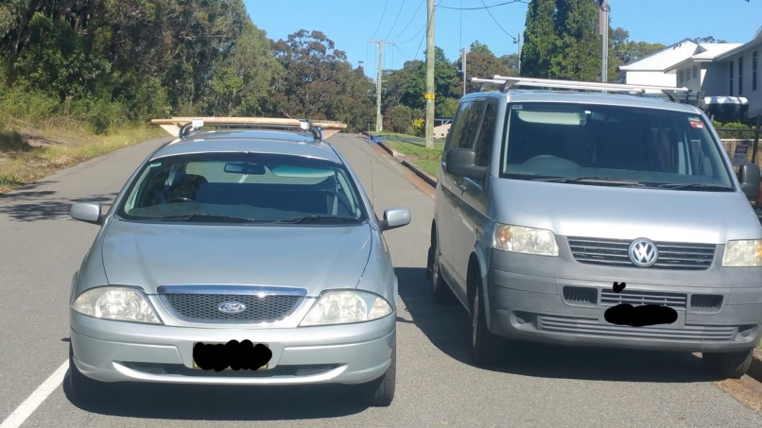

Government Rd Nords Wharf
Note: vans wheels are parked in the gutter so maximum space.
Narrow road make passing dangerous particularly for buses etc.

