Submission to IPC on the Vickery Extension Project (SD_7480). Review of merit of EIS amd RtS in relation to biodiversity matters

12 February 2019
David C. Paull MResSc
ethical ecology
www.ethicalecology.com

Dear Commissioners,

I objected to the approval of this mine in the submissions to the EIS. None of these issues was addressed adequately in the Response to Submissions by the proponent. Some of the key shortcomings of the EIS are summarised below:
- The assessment of impacts on landscape connectivity is the EIS does not take into account the scale of development and does not account for the extent of removal of paddock trees over a large area (500 ha). It states that all the vegetation in the BAR Footprint has been modified/degraded mainly by grazing and historic clearing, however as most vegetation on private land is in some form of degraded condition, any remnant vegetation should be regarded as important, particularly as it still provides habitat for threatened species. The EIS’s biometric assessment of the impact shows that all vegetation in the footprint has a high degree of connectivity in terms of patch size (>1000 ha) notably Vickery State Forest. Yet these factors have not been considered adequately.

- The EIS places little ecological importance on the derived grassland with scattered trees for threatened species. While it acknowledges potential use of scattered trees by the Regent Honeyeater and Swift Parrot, but not by the Koala. This is despite the fact that Koalas in this environment can range widely in the landscape and commonly use scattered trees as several recent studies have shown. No account of the impact on the Koala of the removal of 500 ha of scattered trees has been dealt with in the EIS, nor any attempt to offset this loss. Other categorisations of Koala feed tree preference in the EIS are also outdated by the scientific literature and needs third party verification.
- Impacts on the Koala have also been understated because of insufficient consideration of impacts upon the full extent of suitable habitat within the Approved Mine area. Cumulative impacts have been dealt with poorly in the EIS. There does not seem to be any limit of the extent of impact being considered and matters in relation to landscape impacts have not been considered adequately. Koala habitat affected by the existing approval has not been considered.

- The EIS states that none of the native vegetation in the BAR Footprint is listed as threatened under the Biodiversity Conservation Act 2016. However, Vickery SF supports White Box Yellow Box Red Gum Woodland EEC and a pervious mining consultant identified this EEC during a survey for the existing approval. This has been subsequently denied by other consultants Whitehaven has used. While in a degraded state, some of the communities in the Project area may also be this community. The correspondence with Box Gum Woodland for any community within the Project and Approved Mine footprints requires a third-party assessment.

- Impacts on the surface water environment as a result of changes to the local hydrology particularly at the various crossings are unclear. Whitehaven’s categorisation of the GDEs affected by the rail spur also warrant independent verification, namely, the River Red Gum forest along the edge of the Namoi River is recognised by the proponent as being a groundwater dependent ecosystem, it is not identified as being a High Priority ecosystem as defined under the Risk Assessment Guidelines for GDEs because the vegetation is not listed as being endangered under the BC Act. In fact it should be because of its occurrence on a major 9th Strahler order stream and its condition descriptions are not consistent.
- While not a listed EEC, the vegetation community NA201 is a sensitive wetland ‘Mixed shrub Sedgeland’ and will suffer a loss of some 4 ha. This community is an over-cleared type (>75% removed over its range) and so would warrant classification as an endangered community, given levels of ongoing threats. While Whitehaven have claimed this community has been offset, no equivalent type exists in the proposed offset areas. No recognition that this community is mapped as a moderate potential GDE (mapped as such under the Australian GDE Atlas)

- Biodiversity credits which are expected to be generated for mine rehabilitation should be restricted to 25% of the benchmark value reflecting the expected outcomes for other recent major projects. Whitehaven’s track record in this department has not been trans[parent, with little evidence that successful rehabilitation of the landscape has occurred.

- Whitehaven’s claims that all offsets can be managed need to be treated with caution, given the lack of offset finalisation for the Maules Creek Mine after five years, Whitehaven’s track record on this matter is not good and should not be relied upon. The December 18 2018 deadline has passed for Whitehaven to finalise their offset strategy for Maules Creek Mine, but after 7 years since approval, these have not been finalised. This outcome is a NET LOSS for the biodiversity of the region.

NSW Assessment

Under the NSW assessment, the additional land disturbance footprint for the Project over the life of the mine (25 years) is 775.8 hectares (ha) in size for the mining area and rail spur, comprising:
- exotic grassland or land with no vegetation cover (196 ha),
- derived native grassland (some scattered trees) (502 ha).
- The remaining 10% (77.8 ha) contains fragmented patches of native woodland/forest in a number of scattered patches.

Koala impact assessment
Koala feed trees impact has not used the latest scientific information on this topic, claiming that River Red Gums are the only primary tree. This is not considered accurate now according latest reviews by OEH and for the updated SEPP44. Many of the trees being removed in the mine and pipeline footprint (including White Box, Pilliga Box and Bimble Box) are preferred food trees for the Koala in this region. Most of the scattered trees in the footprint are of these species and would certainly be utilised by dispersing Koalas. To rely on the NSW Koala Recovery Plan as the key reference for which trees are important for the Koala is poor science as the Plan is no longer current and the current SEPP44 is being updated.
The EIS states that the Koala has not been recorded in the BAR Footprint associated with the mining area, though Koala records in the Project locality include one record within the footprint of the Project rail spur, one record within 500 m of the Project rail spur and two records within 1 km of the Project mining area (within vegetation along the Namoi River). However, a closer look at the six records depicted in the EIS show that only 3 of the 6 shown are associated with the riparian vegetation. To suggest that Koala movement is largely confined to the river as contended in the EIS does not reflect current understanding of the movement and dispersal of this species.
The overall impacts on this species have been poorly dealt with in the EIS and if taken in context with the existing approval (none of the vegetation covered by the existing approval has been removed), Koalas will see the removal of at least 80 ha of native vegetation communities containing preferred tree species and a large area of scattered trees covering over 1,780 ha over the next 25 years.

Connectivity
Assessments of connectivity are now undertaken using the biometric system, the FBA was the one in use at the time of the EIS submission. It uses a ‘connectivity value score’ attributed to a development site to account for any removal of any biodiversity links that may occur. The FBA defines state significant biodiversity links as:
◼ An area identified by the assessor as being part of a state significant biodiversity link and in a plan approved by the Chief Executive, OEH; or
◼ A riparian buffer 50 m either side of a 6th order stream or higher; or
◼ A riparian buffer 50 m around an important wetland or an estuarine area.
The inadequacy of this approach is evident that if you consider that there are no identified ‘state significant biodiversity links’ in NSW (despite 10 years that this category has been present in the biometric methodology). Combined with the existing approval and the proposed rail spur the entire area from the Namoi River to the Vickery Forest in fact will be disrupted. This is pertinent for species such as the Koala. While Koalas may be able to cross a railway line, it is not clear how the construction of this line will facilitate fauna movement.
Whitehaven will impact a number of streams with a order of 6 or higher including the Namoi River (Rail spur) and Driggle Draggle Creek (Borefield and pipeline) where 0.2 ha of riparian vegetation will be removed at each. Two fifth order streams will also be crossed by the rail spur, but it is stated that no native vegetation occurs here. Another unnamed fourth order stream with is affected by the mine development with approximately 1 km of the unnamed 4th order stream is within the NSW Assessment Footprint. This will result in approximately 4 ha of disturbance for a 40 m buffer. Together these disturbances constitute an considerable burden on the local stream ecology.
The EIS states that connectivity for the Koala habitat along the Namoi River will be retained allowing for movement. Whitehaven contend they have taken into account the impact of this sensitive area by having a quick construction time, selecting an area where the trees are sparse, making sure they don’t knock over trees with Koalas in them and planting River Red Gums as an offset. However, it is still unclear just how well the finished crossing will allow Koala movement. Even if some movement under the bridge is retained along the bank there can be little doubt that the dispersal of Koalas will be severely impeded by this proposal.
The proposed groundwater borefield and pipeline would include a pipeline up to 100 mm in diameter (predominantly above ground). This is a considerable barrier to the movement of ground fauna, mainly smaller species, but also perhaps animals such as the Koala, which are unlikely to cross this barrier which could channel movement into the mine area – a disastrous outcome.

Cumulative Impact
Cumulative Impacts have been dealt with poorly in the EIS. This has not been assisted by the fact that there are currently no cumulative impact guidelines in NSW.

Whitehaven have stated they have dealt with direct and indirect cumulative impacts. Existing or proposed mines in the region has been considered. Data from the EIS shows that if all considered together, the total of cumulative clearance of native vegetation as a result of mining activity will amount to 4,190.5 ha of wooded vegetation along with another 2,327 ha of derive d native grassland and isolated trees, if the Vickery Extension Project is included.

However, Whitehaven have only dealt with cumulative impact in terms of whether or not individual projects have been offset. No assessment of cumulative impact of the loss of vegetation on the dispersal and usage of fauna at a landscape level has been attempted. Whitehaven have also tabulated the positive cumulative impact of the mine development in the region, however most of these offset lands were in fact existing prior to mining.

In particular, the combined impact of all the Approved Vickery Mine and the Extension Project will effectively severe movement of fauna on the across the area in question and substantially reduce the extent of native vegetation outside the Vickery State Forest boundary. The Approved Mine will clear approximately 1,748 ha of native vegetation (of which approximately 464 ha of woodland/forest and 1,284 ha of secondary/derived grassland). The proposed Extension will add 77.8 ha of wooded vegetation and 502 ha of derived grassland and trees to the cleared total. Apart from an existing offset next to Vickery Forest, this is nearly all native vegetation between the forest and the Namoi River.

However, Whitehaven consider considered to be minimal because of the localised nature of the Project compared to the “wider distribution of the species (their habitats) and communities”. What geographic limit us placed on this kind of assessment in not clear.

The EIS considers the potential cumulative indirect impacts on the Vickery State Forest (from the Project and the Rocglen Coal Mine) are unlikely to materially impact fauna within the State Forest. However, the Approved Mine impacts are not mentioned and are likely to be more substantial given the close proximity of Vickery SF.

Aquatic Ecology /groundwater ecosystems

The EIS states that Driggle Draggle Creek, mapped as a 7th order stream, was found to be dry during the aquatic ecology surveys and it was determined that Driggle Draggle Creek did not have any areas that are likely to create deep pools when surface water flows through the site (Eco Logical, 2018). The situation is different of course for the Namoi River.
But how will the altered surface flows affect the stream environment in the vicinity of the bore field and railway spur crossings?
Whitehaven states that the rail spur and groundwater borefield would be designed to allow flows in the Namoi River, Driggle Draggle Creek, and other relevant watercourses, to be maintained, thereby minimising the potential impact on surface water flows and therefore having “no material impact on terrestrial ecosystems from changes to surface water”.
Both these infrastructure proposals constitute significant surface barriers to surface flow, given Whitehaven are intending to direct flows into the relevant streams, what affect this concentrated flow would have on the surface hydrology of the streams and the floodplain area do not seem to have been addressed in the biodiversity sections of the EIS.
The GDE assessment is questionable. Whitehaven have classed the Namoi River riparian woodland as not being a significant GDE because of its poor condition and because it is not listed as being an endangered community.
The riparian vegetation along the Namoi River and Stratford Creek is identified as being River Red Gum Riparian Tall Woodland (NA193). Consultants FloraSearch (2018) found the riparian woodland to have a “low plant species richness and midstorey cover which may reflect high levels of grazing in this community and high competition from introduced groundcover species favoured by the highly fertile alluvial soils. Overall, remnants of this community within the Project rail spur are considered to be in poor to moderate condition.”
The FBA methodology however does not classify plant communities this way, as they are either classified as being in a ‘low’ or a ‘moderate to good’ condition. Presumably some parts this community within the railway spur footprint therefore or in a moderate to good condition for the purposes of the biometric assessment.
Despite being a degraded condition, the fact that this riparian woodland borders a regionally significant 9th order stream with substantial surface flows and associated alluvial groundwater system would suggest it meets the criteria as being an important GDE as per the criteria guidelines used by Whitehaven.
Impacts on alluvial groundwater systems from the construction and changes to the local hydrology associated with these crossings groundwater has been dismissed as being significant in the EIS. Whitehaven are claiming that the alluvial groundwater in the area of the Namoi River crossing is discontinuous unlike in other parts of the river. If this is true, Then this does not seem to be a fair assessment, in fact if the alluvial system here is fractured that would mean this location is likely to be more sensitive than other parts of the river as questions arise as to how water flow occurs in these conditions.
While not identified as such in the EIS or RtS, the Mixed Sedgeland community (NA201) is likely to be a GDE. This and other ephemeral water bodies have been mapped as being a moderate potential GDE (mapped as such under the Australian GDE Atlas)

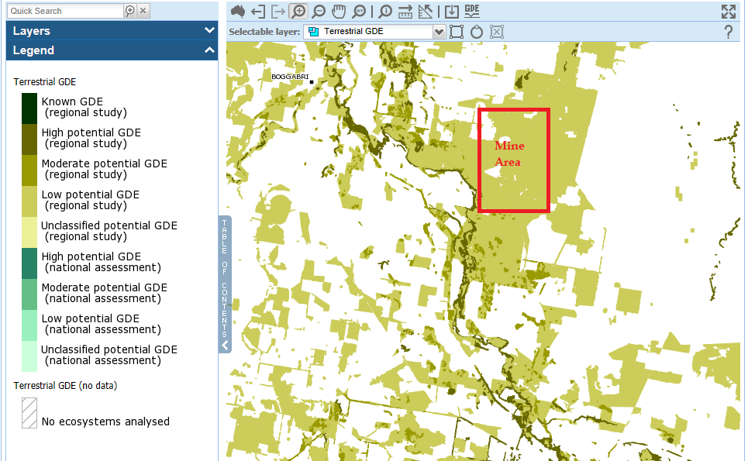

Offsets
The result of running the OEH Credit Calculator is that the Project requires a Biodiversity Offset Strategy which accounts for a total of 16,401 ecosystem credits and 6,654 species credits. Impacts on the Koala are said to be 50 ha giving a credit liability of 1,308, though ignores the loss of scattered trees.
To offset this loss, Whitehaven have proposed to update their existing Biodiversity Offset Strategy for the Approved Mine, to include an ecological outcome. Whitehaven have also proposed a range of other land -based offsets as indicated in Table 46, though in fact the retirement of credits for NA185, NA324, NA201 and NA193 have not been finalised. We are re-assured by Whitehaven that suitable offsets are available, however, the Mixed Sedgeland community (NA201) does not appear in any of the proposed offset areas where details are available. There also does not appear to be any offset for the River Red Gum (NA193).

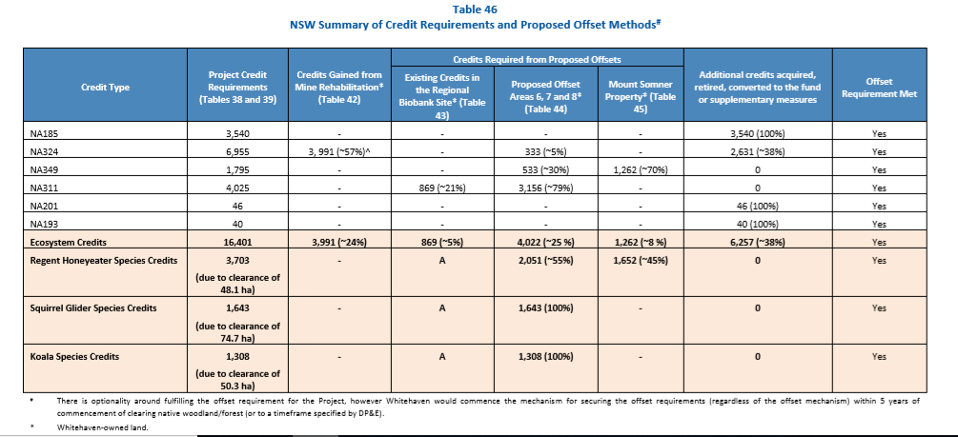

Key to this is the generation of credits from mine rehabilitation now proposed to be made into woodland and forest, particularly plant community type NA324. The ecosystem credits generated by this component of the offset requirement is said to be about ¼ of the total ecosystem credit requirement for the project.
In order to generate so many credits for the rehabilitation, Whitehaven have assumed a maximum credit generation from the proposed works in their biometric calculations. This has been justified because Whitehaven state that;
“Rehabilitation monitoring at the former Canyon Coal Mine, Rocglen Coal Mine and Tarrawonga Coal Mine undertaken by Eco Logical (2015; 2016; 2017a; 2017b), shows that rehabilitation of woodland in these areas is successful. Given this, Whitehaven considers it is feasible to establish woodland/forest vegetation types on the post-mine landform.“
However, the studies cited do not represent any examples of mature vegetation communities. Given that expected outcomes for mine rehabilitation include a total diversity of 50 % of the benchmark diversity credits gained from mine rehabilitation should be no more than 50% to that which is being requested by Whitehaven. 25% of the benchmark value would be consistent with other mining projects.

Commonwealth assessment
The original referral for the Vickery Coal Project (EPBC 2012/6263) was considered not to be a controlled action by the Commonwealth mainly because the Koala was not listed as a threatened species and because there was no EEC stated to present (even though this appears to be contentious).

The Commonwealth decision stipulated measures to be undertaken to avoid significant impacts on the Winged Peppercress (Lepidium monoplocoides), a listed threatened flora species but no other measures. This include translocation of an affected population and the establishment of an offset area for this species.

Whitehaven state that the present referred action does not include the components and operations of the Vickery Coal Project (EPBC 2012/6263) but is different from the area covered by the NSW assessment because, “… a portion of the Approved Mine (previously assessed under the State) is being assessed as part of the Commonwealth Assessment because it was not previously referred.”

Whitehaven also state for the Koala, as it is now a listed species under the EPBC Act, has meant that the loss of habitat for this species under the Commonwealth assessment has increased from about 50 ha to 80 ha, or there was 30 ha under the previous approval which had not been referred. As no clearing has occurred in relation to the Approved Mine, this may not seem consequential, however it is not clear exactly how much of the vegetation in the existing approval in total was Koala habitat.

As the Koala was a listed species at the time of the submission of the EIS, the assessment provided for the current EIS should have included all the Koala habitat covered by the previous approval, given four communities covered by this approval support potentially suitable Koala habitat, Community 2: White Box – White Cypress Pine Shrubby Woodland; Community 3: White Box Grassy Woodland; Community 7: Silver-leaved Ironbark – White Box – White Cypress Pine Woodland; and Community 20: Poplar Box Grassy Woodland. Niche (2012) in their ecological assessment for the Vickery Mine, estimated that potential Koala habitat in the mine area covers at least 86 ha, not including the large area of White Box Pine regeneration and semi-cleared areas (~180ha).

Another issue is that for the Winged Peppercress, Whitehaven state that it is not inside commonwealth assessment area, but the Commonwealth’s conditioned consent for the Approved Mine states that some are to be translocated because they are in a mine footprint. This seems to be somewhat contradictory.

