Shell Cove Boat Harbour Precinct Concept Approval
MP 07 0027 MOD1- D541-18
Comments and Contentions by Peter Messer

SUMMARY
The Approved Concept Plan (Approved Plan) has general community support up to 4 storeys and acceptance that the Hotel building could be as high as 9 storeys (even though this precedence is causing widespread concern).
The Modified Concept Plan Proposal (Modified Plan) to increase building heights up to 6 storeys and to increase GFA within the Marina Precinct is not supported by the Shell Cove community because of view loss from public and private spaces, inadequate parking, unnecessary traffic congestion and the fact that the proposed bulk/height is not in keeping with the low rise suburb because it unnecessarily forms an imposing physical barrier between the suburb and the sea.
These matters are expanded below. A particular mention is made of Dr. Lamb’s report whose conclusions support the Modified Plan. I contend that these conclusions are unsafe because it is strongly suspected that the building heights used to create the Approved Plan’s montage have not been cross checked because the engineering/survey data used in the construction of the montage has not been made public. In addition, a main conclusion of the report is that there is insignificant view loss when comparing the Approved Plan with the Proposed Plan. This does not make sense when one considers the difference is at least 6 metres and every one of these metres cuts water views from many residents views which are considered significant in terms of personal enjoyment and property values.
The Key Success Factor (KSF) for the Marina Precinct is to successfully attract high levels of destination tourists and other non-resident shoppers and visitors from the surrounding areas. The Proposed Plan is not justified by any analysis of this KSF because, as demonstrated below, there is no significant causal link between The Proposed Plan and the KSF.
At least one published report analyses surrounding retail space within the Shellharbour Council area (and nearby Illawarra suburbs and Centres) and it concludes that there is excess retail supply through to at least 2031. This illustrates the importance of attracting outside visitors to the Marina Precinct. It is highly probable that increasing building heights in particular will not improve visitations to the Marina Precinct.

Comments & Contentions
1 The community does not have sufficient know-how to prosecute their concerns because they do not have sufficient access to expert resources. This means that cross-examination of Fraser’s proposal is doomed to be inadequate except, perhaps, in the Land & Environment Court.
No further comment is required.

2 There is no community benefit, nor is there an operational benefit for the Hotel or the Marina Precinct, to allow the Hotel building to be raised from 9 to 11 storeys.
The sole purpose of increasing the height of the Hotel building is to make the build more attractive for the developer because top-level residential apartments increase profit more than lower-level apartments. Whilst the developer is entitled to maximise their profit it should not be at the expense of and further view loss or precedent creating overdevelopment which leads to unacceptable bulk and height.
What community benefit is derived by allowing an extra 2 levels on the already precedent creating 9-storey apartment block. There would have to be a very strong case put to justify this and there is none.

3 There is no justification to increase any building height in the Marina Precinct above what is already approved.
Apart from the Marina Precinct, Shell Cove is a predominantly a low-rise residential community and this it is likely to remain the same after the Marina Precinct is fully built. The Marina Precinct’s success largely hinges on the success of the restaurants and The Tavern. Increasing the GFA of the Marina Precinct and increasing building heights by 50% (4 to 6 storeys) will unnecessarily increase the population density without significantly increasing the visitation to these restaurants. Visitation can only be increased significantly if the Marina becomes a destination for outside visitors including tourists. This success has no link to increased GFA as per the Proposed Plan

4 There is no retail shopping justification for increasing GFA of the Marina Precinct.
Projecting demand to 2031, the 2014 floor space for retail is oversupplied in Shellharbour and development of retail space in the Marina Precinct will increase this oversupply. This simply means that, purely in the sense of retail shopping, the Marina Precinct has to become a “destination shopping precinct” in order to be viable. Said another way, no matter how many residences are built in the Marina Precinct, the viability of retail shopping will depend on shoppers who are attracted to that retail shopping centre from outside the Marina Precinct.
Reference: “Review Of Illawarra Retail Centres” Dept Of Planning & Environment. June 2014 (SGS Economics & Planning)
A direct quote from this report
“Across the Illawarra, our modelling has showed that there is sufficient current and planned floor space to accommodate the anticipated levels of demand” (to the year 2031) “for retail floor space if using the lower range demand estimates, and mostly low levels of undersupply in the test case of higher demand, which when considering floor space alone, could be accommodated given capacity in each centre. In general, then, it would not be recommended to encourage further increases above the current and planned supply of floor space. The DP&E might want to consider how retail proposals currently in the early planning or assessment stages align with these results, which might throw a different light on the economic impact assessments supporting proposals for additional retail in centres estimated as being oversupplied with retail floor space in future.”
Hence, increasing GFA in the Marina Precinct has no significant retail shopping benefit.. This specifically means that the proposed increase in height and density of the Marina Precinct has no retail shopping justification.

5 It has not been demonstrated how increasing the GFA will significantly improve the amenity and vibrancy of the development or improve visitations to the Marina Precinct for convenience or destination shopping, or for the purposes of congregation, relaxation and enjoyment.
Residents of Shell Cove and surrounds already choose convenience and destination shopping/relaxation at Shell Harbour City, Warrawong, Warilla and Shellharbour Village. How will increasing the GFA or building height significantly alter this situation over the already approved Marina Development? The answer is, clearly, they won’t. The Marina will receive visitations from destination tourists for the almost exclusive purpose of dining out at restaurants, cafes and The Tavern that have direct frontage to the marina. Local residents will do the same except they will also convenience shop at the supermarket.
Increasing GFA will not significantly alter the outcome but it will cause view loss from public areas (including Shellharbour Road) and many private residences. It will also exaggerate traffic issues because our community depends on the motor vehicle. We are a young and growing community where numbers of motor vehicles per household are increasing.
To demonstrate further the issue of nearby shopping, convenience and destination visitors, I refer to the 2008 report on the very close neighbour Shellharbour Village “Shellharbour Retail and Commercial Centre Studies 2008” by Hill PDA Land Economists and Valuers.

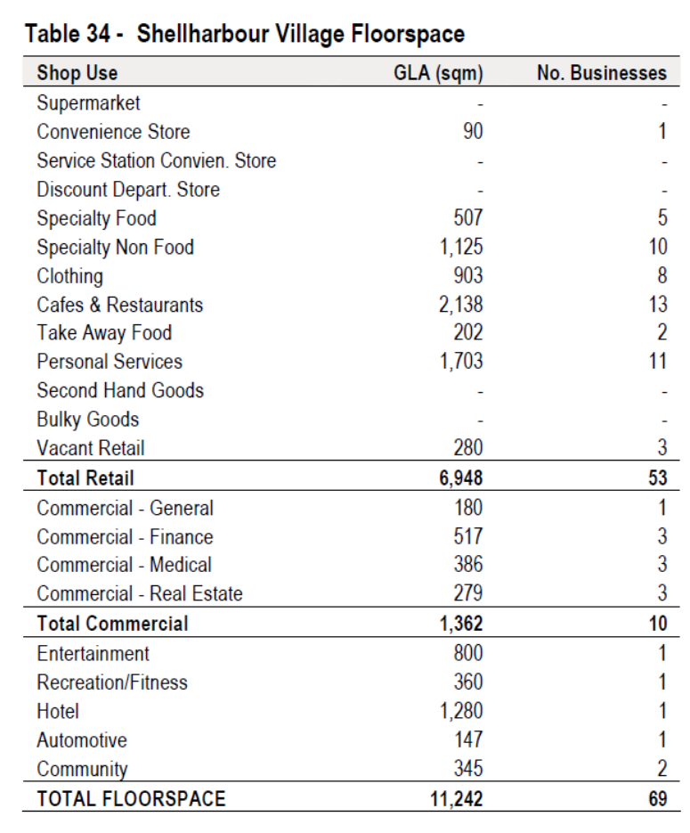
This information demonstrates that the Marina Precinct will cohabit with a substantial, diverse, attractive destination in Shellharbour Village. Only the direct waterfront establishments in the Marina Precinct are likely to draw destination shoppers and tourists away from Shellharbour Village (already it has a vibrant café society character). Increasing GFA in the Marina Precinct will not alter this situation.

6 View sharing and view loss was analysed by Dr Lamb using data that has not been independently examined and verified and hence the photomontage conclusions are unsafe.
Heights for buildings within the Marina Precinct were, and are, not approved in the 2011 view, which is used as the base view for comparison with the Proposed Plan. Therefore the montage of the 2011 view is probably totally incorrect and furthermore, we do not have any report or other documentation that we can use to cross-examine Frasers as to the reasonableness or correctness of their 2011 view montage.
Therefore the photomontage conclusions are unsafe and the report by Dr Lamb should be considered with caution.

7 The image of the view from 27 Ragamuffin Circuit Shell Cove does not truly represent the eye view despite the process employed and the professional execution and analysis by the author. I conclude that the true visual quality of views enjoyed by many residents and the values of these views are not represented by the images provided in the report
The two images shown below compare the view using two positions and the similar processes (fixed prime on full frame camera cf telephoto set to 50mm on dx camera).
The day Dr Lam took his photo was perhaps the poorest day with respect to visibility and hence image quality. However, the difference in view quality can still be seen by the reader despite the “day” difference. It is also the writer’s contention that the “eye” view is not well represented by a 50mm lens.

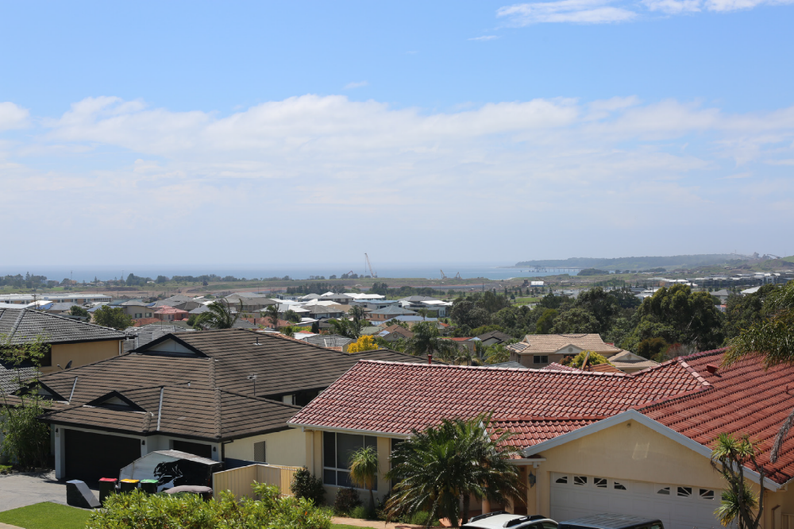

Photo from Dr Lamb’s report from 27 Ragamuffin Circuit using full frame camera and 50mm prime lens.

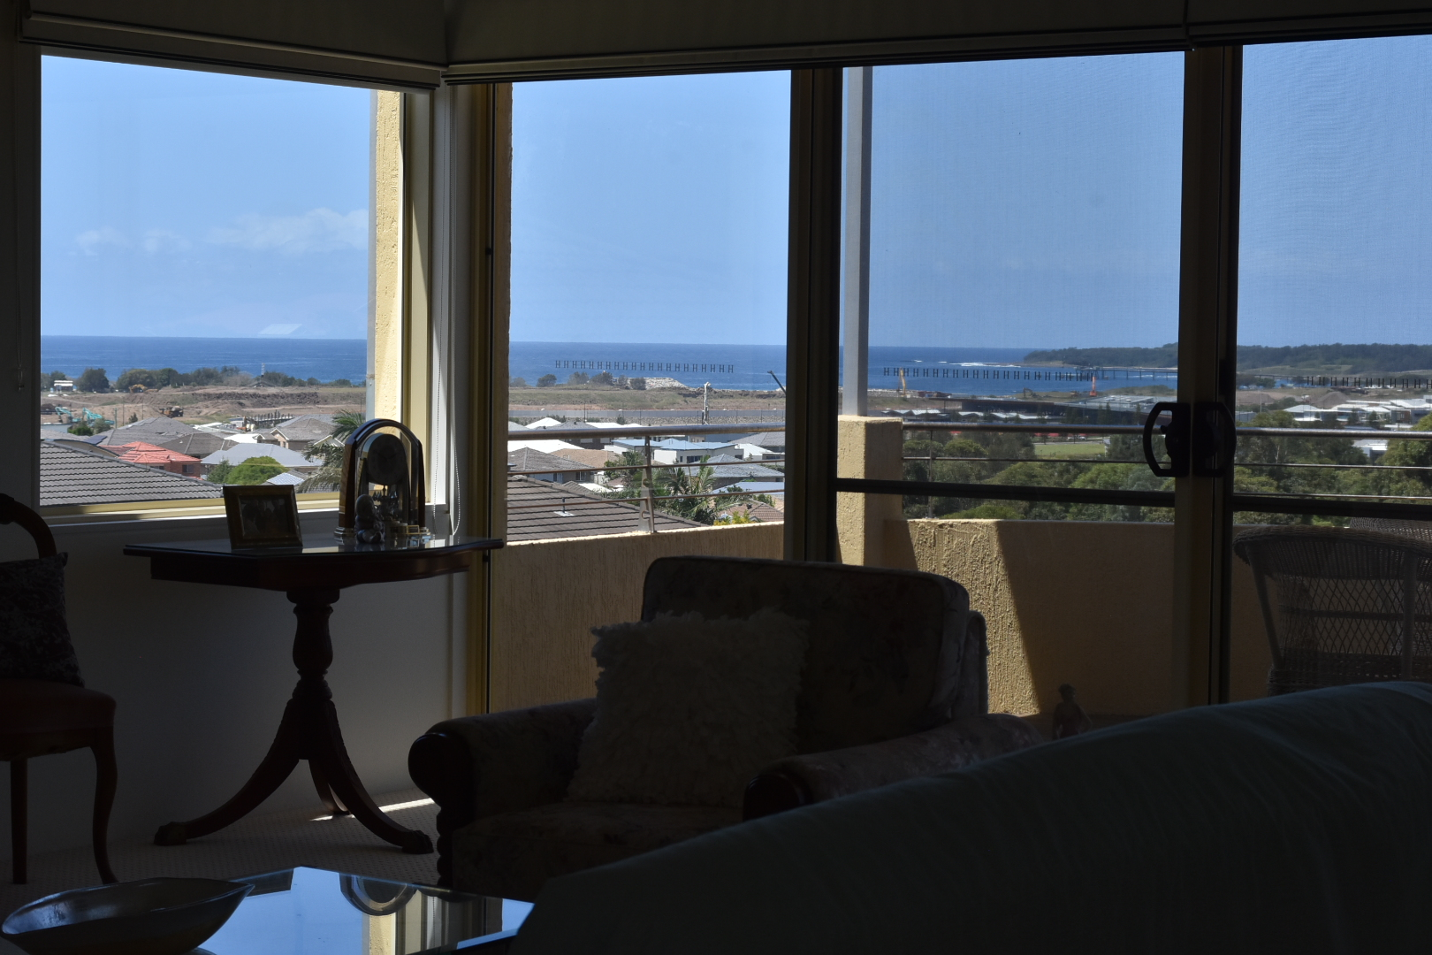

Photo 14-02-2019 from lounge room using D7200 Nikon with 18-55mm lens set to 50mm from 27 Ragamuffin Circuit demonstrating qualitative difference with Dr. Lamb’s photo.

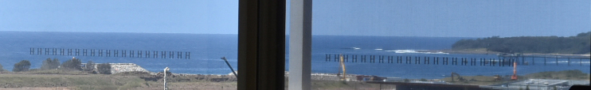

Close-up view of photo above – towards Bass Point

